Name ________________________
PHY2049C, Quiz 1

A- Read all the quiz once, or twice, before beginning to write. Make sure to comprehend all questions and start with those you feel most confident.
B – Be clear and concise. There are no extra points for being verbose or writing extra.
C –Only use the white pages that I will provide. You have 50 minutes to answer the quiz.
---------------------------------------------------------------------------------------------------------------------------
Problem 1
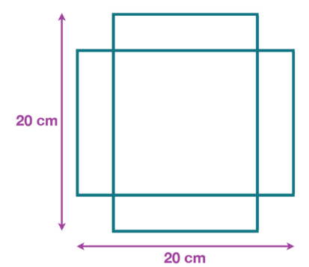
You can make an open box from a 20 by 20 cm piece of paper by cutting out four squares and folding the flaps. What is the biggest volume of box you can make this way?

Problem 2 (Halliday, Resnik, Walker)

Figure 1 shows four situations in which five charged particles are evenly spaced along an axis. The charge values are indicated except for the central particle, which has the same charge in all four situations. Rank the situations according to the magnitude of the net electrostatic force on the central particle, greatest first.
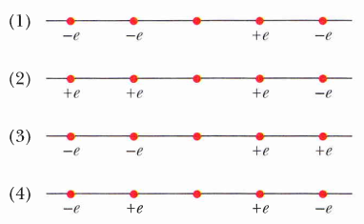

Figure 1

Problem 3

In Figure 2, a nonconducting rod of length L = 0.12 m has charge q = -1.23 mC uniformly distributed along its length. At point P, a distance a= 0.10 m away from one of its ends, lies the center of a ring with radius R = 0.2 m and with charge Q = 1.23 mC uniformly distributed along its circumference. What is the force of the rod on the ring?

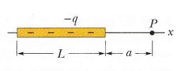
Figure 2
+Q
R

