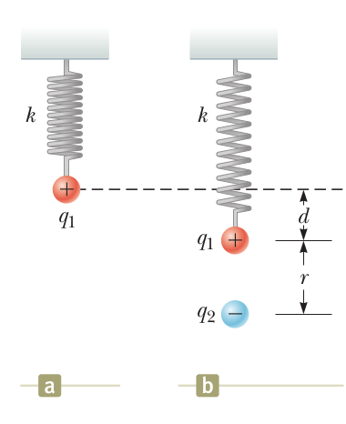
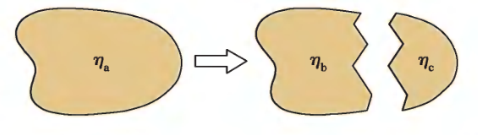
Name ________________________
PHY2049C, Quiz 1

A- Read all the quiz once, or twice, before beginning to write. Make sure to comprehend all questions and start with those you feel most confident.
B – Be clear and concise. There are no extra points for being verbose or writing extra.
C –Only use the white pages that I will provide. You have 60 minutes to answer the quiz.
---------------------------------------------------------------------------------------------------------------------------
Problem 1

A small sphere of charge q = 0.800 mC hangs from the end of a spring as in Figure a. When another small sphere of charge q = 600 mC is held beneath the first sphere as in Figure b, the spring stretches by d = 3.50 cm from its original length and reaches a new equilibrium position with a separation between the charges of r = 5.00 cm. What is the force k constant of the spring?

Problem 2

At a Cafeteria, 25% Sandwiches for sale are chicken sandwiches. The remaining sandwiches are tuna sandwiches and turkey sandwiches. At first, the ratio of tuna sandwiches to turkey sandwiches is 5:4 and there are 152 more tuna sandwiches than chicken sandwiches. Then, 14 chicken sandwiches are sold. How many Chicken, Turkey and Tuna sandwiches are left?

Problem 3
A piece of plastic is uniformly charged with surface charge density -η_{a}. The plastic is then broken into a large piece with surface charge density -η_{b} and a small piece with surface charge density -η_{c}. Rank in order using <,>, or =, from largest to smallest, the surface charge densities.

