Name ________________________
PHY2049C, Quiz 2

A- Read all the quiz once, or twice, before beginning to write. Make sure to comprehend all questions and start with those you feel most confident.
B – Be clear and concise. There are no extra points for being verbose or writing extra.
C –Only use the white pages that I will provide. You have 50 minutes to answer the quiz.
---------------------------------------------------------------------------------------------------------------------------
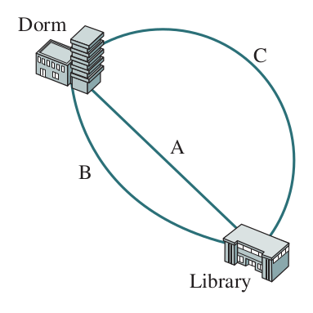
Problem 1 (Physics A)

Alice (A), Bob (B), and Carrie (C) all start from their dorm and head for the library for an evening study session. Alice takes a straight path, while the paths Bob and Carrie follow are portions of circular arcs, as shown in the figure. Each student walks at a constant speed. All three leave the dorm at the same time, and they arrive simultaneously at the library. Rank in terms of total displacement of each, total distance travel of each and average velocity.

Problem 2

A hemispherical surface with radius r in a region of uni form electric field E has its axis aligned parallel to the direction of the field (for instance, if the field is considered to be in the z direction, then the flat part of the hemisphere lies in the x-y plane). Calculate the flux through the surface.

Problem 3
Find the r-dependence of the spherically symmetric charge density ρ(r) such that the field is r-independent.

