Name ________________________ PHY2049C, Quiz 2

A- Read all the quiz once, or twice, before beginning to write. Make sure to comprehend all questions and start with those you feel most confident in.
B – Be clear and concise. There are no extra points for being verbose or writing extra.
C –Only use the white pages that I will provide. You have 50 minutes to answer the quiz.
---------------------------------------------------------------------------------------------------------------------------
Problem 1
A particle with charge Q 5 5.00 mC is located at the center of a cube of edge L 5 0.100 m. In addition, six other identical charged particles having q 5 21.00 mC are positioned symmetrically around Q as shown in the left figure. Determine the electric flux through one face of the cube.

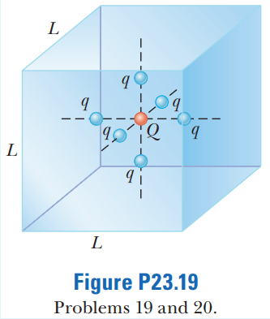
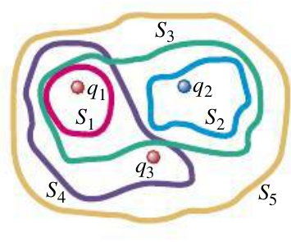

Problem 2

The three small spheres shown in the figure to the right carry charges q1 = 4.00 nC, q2 = - 7.80 nC, and q3 = 2.40 nC. Ranks the surfaces S1 to S5 in order of electric flux through them.

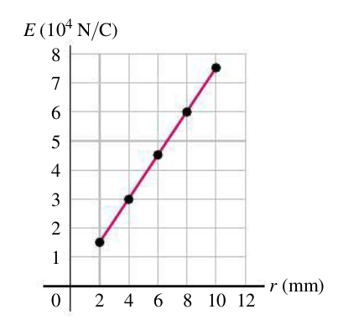
Problem 3
The electric field is measured for points at distances r from the center of a uniformly charged insulating sphere that has volume charge density ρ and radius R, where r < R. Calculate ρ.

