Name ________________________ PHY2049C, Quiz 6

A- Read all the quiz once, or twice, before beginning to write. Make sure to comprehend all questions and start with those you fell most confident.
B – Be clear and concise. There are no extra points for being verbose or writing extra.
C –Only use the white pages that I will provide. You have 50 minutes to answer the quiz.
---------------------------------------------------------------------------------------------------------------------------
Problem 1 (Wolfson and Passachoff)

Part (a) of the figure shows a side view of a conducting loop of area A = ab. The loop is pivoted at O. The center point of the left side of the loop is attached to the upper end of a spring of force constant k. The lower end of the spring is attached to a rigid support. The loop is in a magnetic field of magnitude B directed toward the right. When a current I exists in the loop, the loop rotates to a new equilibrium position at angle θ, as shown in part (b) of the figure. Find an expression
for the spring constant k of the spring.
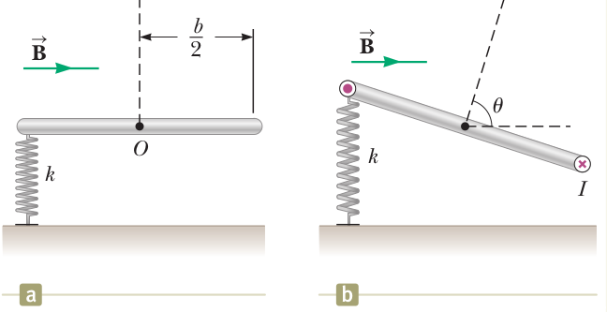

Problem 2
A rod of mass m and radius R rests on two parallel rails that are a distance d apart and have a length L. The rod carries a current I in the direction shown and rolls along the rails without slipping. A uniform magnetic field B is directed perpendicular to the rod and the rails. If it starts from rest, what is the speed of the rod as it leaves the rails?
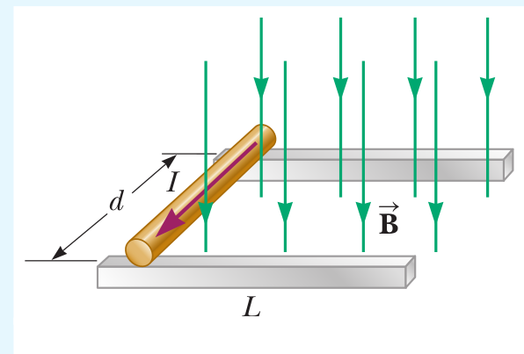
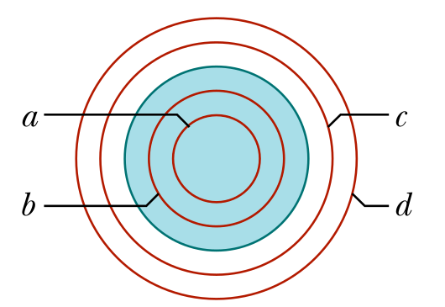

Problem 3
The Figure in the right shows four circular Amperian loops (a, b, c, d) concentric with a wire whose current is directed out of the page. The current is uniform across the wire. Rank the loops according to the magnitude of the magnetic field.

