Name ________________________ PHY2049C, Quiz 6

A- Read all the quiz once, or twice, before beginning to write. Make sure to comprehend all questions and start with those you feel most confident.
B – Be clear and concise. There are no extra points for being verbose or writing extra.
C –Only use the white pages that I will provide. You have 70 minutes to answer the quiz.
---------------------------------------------------------------------------------------------------------------------------
Problem 1 (Wolfson and Passachoff)

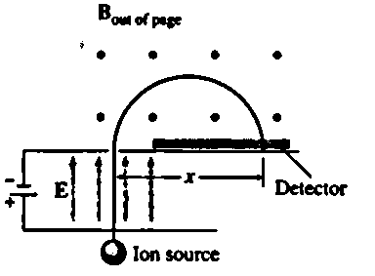
Figure 1 shows a simple mass spectrometer, designed to analyze and separate atomic and molecular ions with different charge-to-mass ratios. In the design shown, ions initially at rest are accelerated through a potential difference V, after which they enter a region containing a uniform magnetic field. They describe semicircular paths in the magnetic field, and land on a detector a lateral distance x from where they entered the field region. (a) Show that x is given by:
$$x=\frac{2}{B}\sqrt{\frac{2V}{q/m}}$$
where B is the magnetic field strength, V the accelerating potential, and q/m the charge-to-mass ratio of the ion. (B) Now consider that instead of accelerating the ions these come with a range of velocities $Δv$ and you use a velocity filter with cross electric and magnetic fields field E_{f} and B_{f.} Show that x is given by:

$$x=\frac{2E_{f}}{\frac{q}{m}BB_{f}}$$
Figure 1
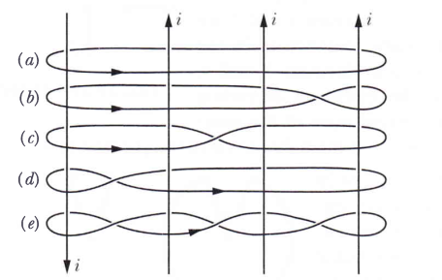
Problem 2 (Halliday, Resnik)

The figure on the right shows four identical currents i and five Amperian paths encircling them. Rank the paths according to the value of ∮B⋅ds, most positive first.

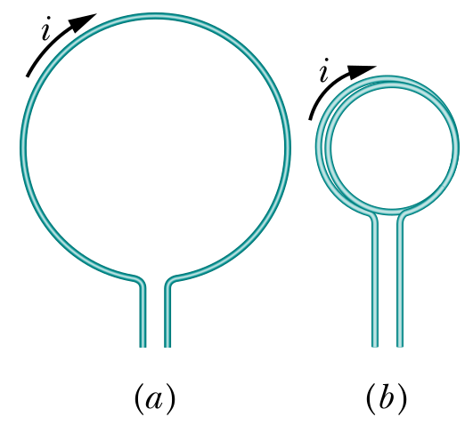

Problem 3 (Halliday, Resnik)
The Figure on the left shows a length of wire bent into a circular coil of one turn (on the left), and the same length of wire bent into to give a coil of two turns, each of half the original radius. (on the right). They both have the same current i flowing. What is the ratio of the dipole moment magnitudes?

