Name ________________________ PHY2049C, Quiz 6

A- Read all the quiz once, or twice, before beginning to write. Make sure to comprehend all questions and start with those you fell most confident.
B – Be clear and concise. There are no extra points for being verbose or writing extra.
C –Only use the white pages that I will provide. You have 50 minutes to answer the quiz.
---------------------------------------------------------------------------------------------------------------------------

Problem 1
The Figure below shows a metallic, rectangular solid that is to move at a certain speed v through the uniform magnetic field B. The dimensions of the solid are multiples of d, as shown. You have six choices for the direction of the velocity: parallel to x, y, or z in either the positive or negative Rank the six choices according to the potential difference set up across the solid, greatest first.
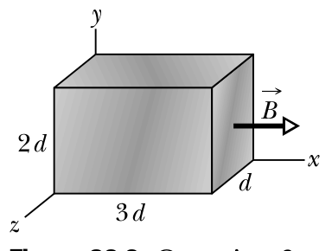

Problem 2
A long, straight, solid cylinder, oriented with its axis in the z-direction, carries a current whose current density S is J. The current density, although symmetric about the cylinder axis, is not constant but varies according to the relationship
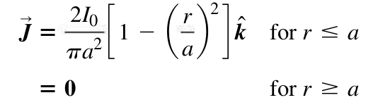
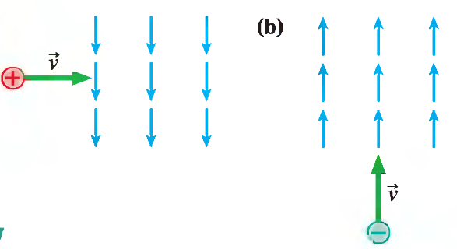
derive an expression for the magnitude of the magnetic field B in the region r ≥ a.

Problem 3
What is the initial direction of deflection for the charged particles entering the magnetic fields shown in the figure to the right?

