Name ________________________ PHY2049C, Quiz 7

A- Read all the quiz once, or twice, before beginning to write. Make sure to comprehend all questions and start with those you feel most confident in.
B – Be clear and concise. There are no extra points for being verbose or writing extra.
C –Only use the white pages that I will provide. You have 60 minutes to answer the quiz.
---------------------------------------------------------------------------------------------------------------------------
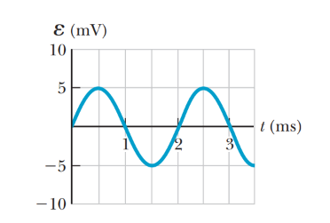
Problem 1

Auroras are caused by charged particles from the sub. These particles travel following the magnetic field lines of Earth towards the pole. 10 particles per cubir meter traveling at 10 km/s (this is a realistic estimate) travel towards the magnetic north pole. If we place a coil in the North Artic circle (that represent a latitude of 66.5°), what would the induced emf be? (radius = 6300 km)

Problem 2

The figure above is a graph of the induced emf versus time for a coil of N turns rotating with angular speed v in a uniform magnetic field directed perpendicular to the coil’s axis of rotation. Copy this sketch (on a larger scale) and on the same set of axes show the graph of emf versus t (a) if the number of turns in the coil is doubled, (b) if instead the angular speed is doubled, and (c) if the angular speed is
doubled while the number of turns in the coil is halved.

Problem 3

A helicopter has blades of length 3.00 m, extending out from a central hub and rotating at 2.00 rev/s. If the vertical component of the Earth’s magnetic field is 50.0 mT, what is the emf induced between the blade tip and the center hub?

