Name ________________________ PHY2049C, Quiz 7

A- Read all the quiz once, or twice, before beginning to write. Make sure to comprehend all questions and start with those you feel most confident in.
B – Be clear and concise. There are no extra points for being verbose or writing extra.
C –Only use the white pages that I will provide. You have 60 minutes to answer the quiz.
--------------------------------------------------------------------------------------------------------------------
Problem 1
The figure shows three loop models of an electron orbiting counterclockwise within a magnetic field. The fields are nonuniform for models 1 and 2 and uniform for model 3, Rank (a) the magnetic dipole moment of the loop and (b) the magnetic force on the loop (up direction is positive), greatest first

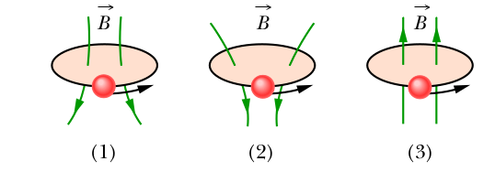
Problem 2
The figure shows three situations in which identical circular conducting loops are in
uniform magnetic fields that are either increasing (Inc) or decreasing (Dec) in mag-
nitude at identical rates. In each, the dashed line coincides with a diameter. Rank the
situations according to the magnitude of the current induced in the loops, greatest first.
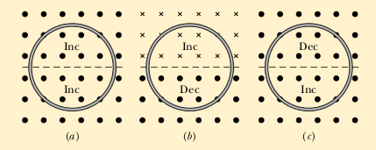

Problem 3
In the figure, two straight conducting rails form a right angle. A conducting bar
in contact with the rails starts at the vertex at time t = 0 and moves with a constant velocity of 5.20 m/s along them. A magnetic field with B = 0.350 T is directed out of the page. Compute the induced emf.
