Name ________________________
PHY2048C, Homework 5

A- Upload a handwritten version of the solutions (clearly readable) via Canvas.
---------------------------------------------------------------------------------------------------------------------------

Problem 1 (Wolfson and Passachoff)

You are to build the oscillation transfer device shown in Fig. 1. It consists of two spring–block systems hanging from a flexible rod. When the spring of system 1 is stretched and then released, the resulting simple harmonic motion of system 1 at frequency f_1 oscillates the rod. The rod has mass M=400g, length L=0.25m, and it can itself be modeled as a spring of k = 1600 N/m. The rod then exerts a driving force on system 2, at the frequency f_2, which is the frequency at which the rod responds to the forcing. You can choose from four springs with spring constants k of 1500, 1400, 1200 N/m and 400 N/m, and four blocks with masses m of 800, 500, 400, and 200 kg. Determine which spring should go with which block in each of the two systems to maximize the amplitude of oscillations in system 2. (Hint: consider that to maximize an amplitude, you want oscillators to be in resonance)

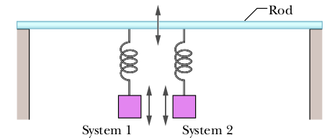

Figure 1
Problem 2 (Wolfson and Passachoff)

It’s not possible to breathe through a snorkel from a depth greater than a meter or so. Why not?
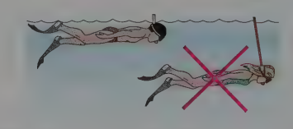

Figure 2

Problem 3
Three children, each of mass=40 Kg, make a log raft by lashing together logs of diameter 0.30 m and length 1.80 m. How many logs will be needed to keep them afloat in fresh water? (Hint: for this, you need to estimate/Google the density of a log).

Problem 4

Canal effect. Figure 3 shows an anchored barge that extends across a canal by distance d = 30 m and into the water by distance b = 10 m. The Panama Canal (at the Culebra Cut) has a minimum width D = 152 m, a water depth of H = 13 m. Assume an uniform water-flow speed of v_{i} = 1.5 m/s. Assume that the flow around the barge is uniform. As the water passes the bow, the water level undergoes a dramatic dip known as the canal effect. If the dip has depth h = 0.80 m, what is the water speed alongside the boat through the vertical cross-sections at (a) point a and (b) point b? The erosion due to the speed increase is a common concern to hydraulic engineers.
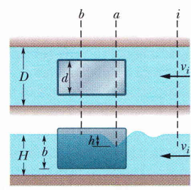

Figure 3

Problem 5

Blood is flowing through an artery partially clogged by cholesterol (assume no viscosity for the blood). A surgeon wants to remove enough of the cholesterol to double the flow rate of blood through this artery. If the original diameter of the artery is D, (a) what should be the new diameter (in terms of D) to accomplish this for the same pressure gradient?

(b) Now allow for viscosity, and use Poiseuille’s equation for the flow rate. (Notice how sensible is blood pressure to the artery diameter)

