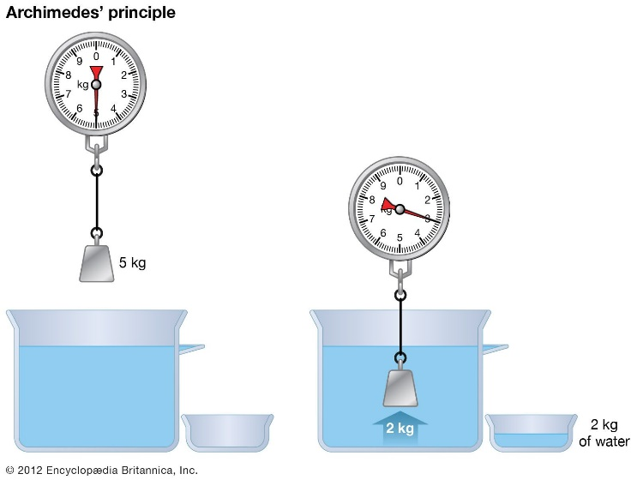 

**Manual to Lab 4: PHY2048C.**

**Florida State University**

**Archimedes**

**About labs in this class**

The labs in this class will have general instructions, and many things need to be figured out by the students. I will be answering any specific questions the students may have without completely giving away the key to the puzzle. **Answer the questions and record your measurements in your lab notebook and then submit the notebook at the end of the activity.**

**About this lab**

In this lab you are provided with tools with which you can devise up to **five** **methods** to determine the density of objects using the Archimedes principle. Archimedes invented this method to measure the density of gold vs. fake gold. (Hint: note these springs are the ones for which you already know the spring constant $k$. Use that knowledge. Also, the density of water is 1 g/cm3)

**Question 1.** Draw a free-body diagram of the submerged coin in figure 14.23 of your book, which is at equilibrium.

**Activity 1.** Measure the density of the provided weights to a 10% accuracy (at least a 10% error bar). Use at least three different methods.

**Question 2.** Compare your results of the different methods. Can you explain the discrepancies between them? Identify sources of measurement and systematic errors in these experiments.

**Question 3.** Why do certain things float, and certain things don’t float.