

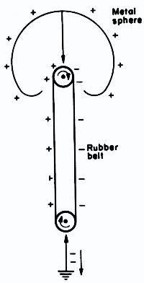

**Manual to Lab 2: PHY2049C.**

**Florida State University**

**Electrostatic Generator**

**About labs in this class**

The labs in this class will have general instructions, and many things need to be figured out by the students. People will be grouped (normally 4 groups in total), but groups can communicate with each other as well. I will be answering any specific questions the students may have without completely giving away the key to the puzzle. **Answer the questions and record your measurements in your lab notebook, and then submit the notebook at the end of the activity.**

**About this lab**

The goal of this lab is to develop an intuition on how the electric force operates in the real world. Students will analyze two Van de Graaff generators (one broken and one operational) and figure out how they operate. Your findings will be recorded in the lab notebook.

**Activity 1.** Turn on the Van de Graaff generator that works. Draw a diagram explaining how the metallic end gets charged.

**Activity 2.** Estimate the force felt by the wool yarn. First, draw a free-body diagram and create a simple model for the system. Make any measurement you think you will need to figure this out. All the potentially required measuring tools are provided.

**Question 1.** Estimate the charge on the ball. How would you increase the charge count on this apparatus?