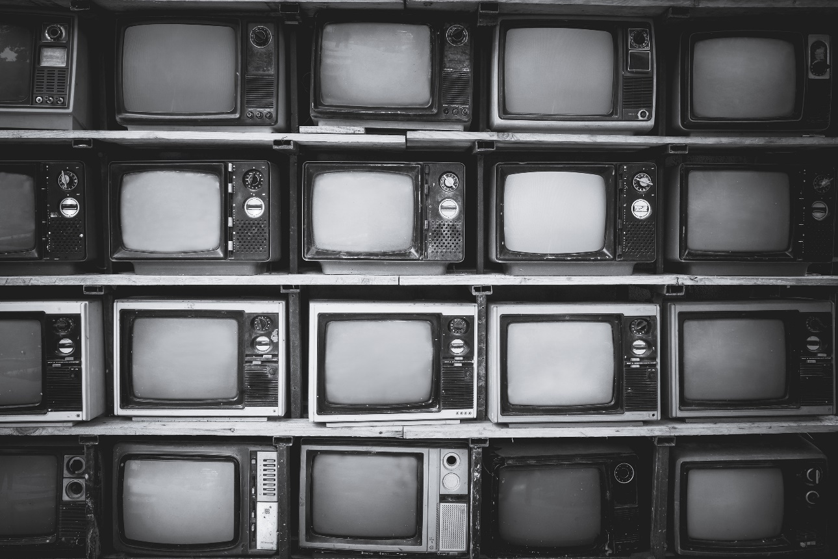 

**Manual to Lab 6: PHY2049C.**

**Florida State University**

**Cathode Ray Tubes**

**About labs in this class**

The labs in this class will have general instructions, and many things need to be figured out by the students. I will be answering any specific questions the students may have without completely giving away the key to the puzzle. **Answer the questions and record your measurements in your lab notebook, and then submit the notebook at the end of the activity.**

**About this lab**

In this lab, you are asked to explore the functioning of a cathode ray tube (CRT). Cathode Rays Tube powered all the displays of the past and are still used in   
X-ray medical imaging and by video gamers looking for a retro feel for their games, and zero motion blur. We will learn some aspects of how they work in this lab through experimentation. Figure 1 shows the panel you will be working with. DO NOT TOUCH THE “INTENSITY” AND “FOCUS” CABLES. You will uniquely be working with the B+, B- cables, and the COM and GROUND Cables on the other side of the panel. **Whoever is handling the cables should be wearing the electrician gloves provided and have shoes with rubber soles for extra safety.**

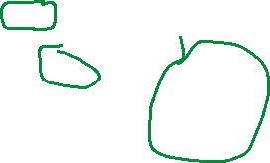

Figure 1: CRT Circuit. Crossed out are the parts of the circuits you should not touch/experiment with. Circled in green are the things you will experiment with.

**Activity 1:** Cautiously plug in the CRT.

**Question 1**: Does a circuit element become visibly hot? Does it happen immediately? Explain this phenomenon.

**Activity 2.** Now that the chamber contains an electron beam, we will change certain parameters of the system to investigate its behavior. First, with the multimeter, measure the AC voltage through the resistance below the number 17. This circuit feeds the B+ terminals. Do you get a reading or is the voltage DC?

**Question 2:** Why is the voltage related to the magnetic field Alternating?

**Activity 3:** Now unplug the B+ cable. What happens? Describe it in your notebook.

**Activity 4:** Now plug it to the B- terminal. What happens? Describe it in your notebook. Plug the cable back to the B+ terminal.

**Activity 5:** Using the cables on the other side of the panel (always with one side of the cable in COM or ground), test what the HORZ and VERT terminals do. What is the voltage between GRND and VERT, and between GRND and HORZ when they are disconnected?

**Question 3** What is the nature of the voltage on this side of the panel?

**Activity 6** Move the electron beam significantly upwards. Move the electron beam significantly downwards. Only manipulate the DC side of the board.

**Question 5** Draw your best guess of a circuit diagram for this side of the board.

**Question 6:** Estimate the strength of the electric field that deflects the electron vertically inside the tube

**Question 7:** Estimate the strength of the electric field that deflects the electron vertically inside the tube

**Question 8:** Recall your initial experiments with the magnetic field (Activities 2 3, and 4). What is the function of the magnetic field in this CRT?