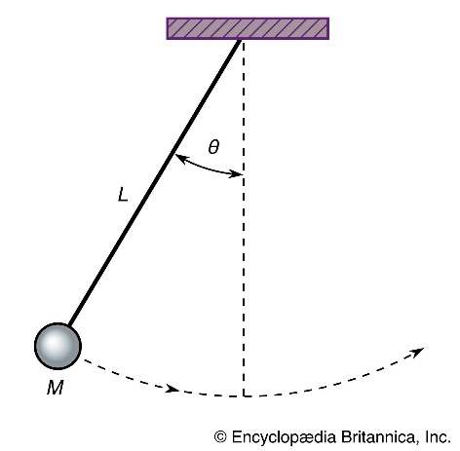** Manual to Lab 2: PHY2048C.**

**Florida State University – Republic of Panama**

**Measurements and dimensions**

**About labs in this class**

The labs in this class will have general instructions, and many things need to be figured out by the students. I will be answering any specific questions the students may have without completely giving away the key to the puzzle. **Answer the questions and record your measurements in your lab notebook and then submit the notebook at the end of the activity.**

**About this lab**

In this lab, you measure the gravitational acceleration at sea level, in Panama City. Always report your measured values with error bars. You are provided with the tools required to build the experimental setup. You will also need to use the stopwatch on your phone. Describe the setup in your notebook. Perform the following experiments:

**Activity 1.** Explore the relationship between mass and period. When releasing the pendulum, make sure that $θ<15°$ always to respect the small angle approximation done in class.

**Question 1.** How does the period depend on the mass? Show your data.

**Activity 2.** Compute $g$ with less than 10 percent error bar.

**Activity 3.** Compare to the theoretical value of $g$ and compute the fractional discrepancy between your value and the theoretical value. This is given by:

$$Δ=\frac{Theory-Data}{Theory}$$

**Question 2.** What sources of measurement and standard deviation error do you detect in this experiment?

**Question 3.** Does being at sea-level 9° from the equator change the value of $g$ is a way that this experiment can detect? Imagine performing this experiment on Volcan Barú or in the Arctic polar circle, how would that change the value of $g?$