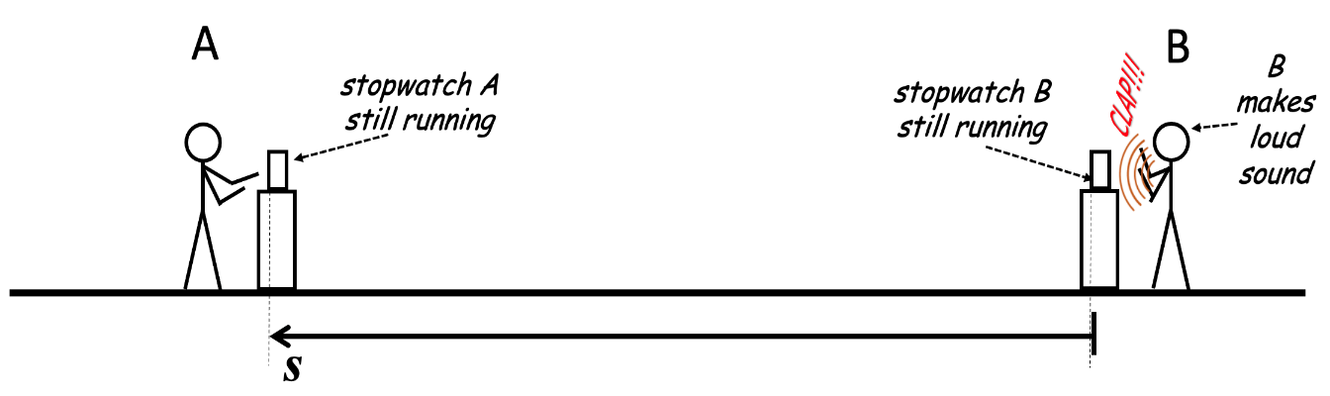 

credit:e=mcsquaredanallthat

**Manual to Lab 5: PHY2048C.**

**Florida State University**

**PhyPhox Speed of Sound Experiment**

**About labs in this class**

The labs in this class will have general instructions, and many things need to be figured out by the students. I will be answering any specific questions the students may have without completely giving away the key to the puzzle. **Answer the questions and record your measurements in your lab notebook and then submit the notebook at the end of the activity.**

**About this lab**

In this lab, you will determine if the speed of sound is different inside our classroom vs. outside, and you will attempt to explain this difference, if any.

This lab is different from others because:

1) You will be working in pairs.

2) You will be using your smartphones:

1st, download the *phyphox* *app* <https://phyphox.org>.

Second, we will watch this video in class (if you watched it before class, you have had more time to process it): <https://www.youtube.com/watch?v=uoUm34CnHdE>

**Activity 1:** Perform the experiment shown in the video in the classroom. You will need to spread out from other groups and take turns so that their claps don’t set off your stopwatch. You can go to the storage room and make the experiment there as well. At least three experiments should be able to run at the same time.

**Question 1:** identify sources of systematic error in this experiment.

**Activity 2:** get together as a class and interchange your value for the speed of sound in the classroom. Each pair then makes a histogram of the values.

**Question 2:** Is there a spread around a particular value? What is the source of this spread, if it exists?

**Activity 3**: Now go outside and perform the experiment there. Is there a difference in the value compared to inside?

**Question 3.** Can this difference be due to a systematic error, is it due to something else?

**Activity 4:** get together as a class and interchange your value for the speed of sound outside. Each pair makes a histogram of the values.

**Question 4**: is there a spread around the value? Is there a consistent difference between the two measurements for all pairs of students? What does this say regarding the source of this difference? Is it a physical difference or due to a systematic error?