**Name ________________________**

**PHY2049C, Practice Quiz 3**

**A- Read all the quiz once, or twice, before beginning to write. Make sure to comprehend all questions and start with those you feel most confident.**

**B – Be clear and concise. There are no extra points for being verbose or writing extra.**

**C –Only use the white pages that I will provide. You have 50 minutes to answer the quiz.**

**---------------------------------------------------------------------------------------------------------------------------**

**Problem 1**

Four spotted cows and three brown cows give as much milk in five days as three spotted cows and five

brown cows give in four days. (a) Which kind of cow is the better milker, spotted or brown? (b) What is the ratio between their daily milk production

**Problem 2 (Halladay, Resnik, Walker)**

In the figure, a charged particle (either an electron or a proton) is moving rightward between two parallel charged plates separated by distance d= 2.00 mm. The plate potentials are V1 = -70.0 V and

V2 = -50.0 V. The particle is slowing from an initial speed of 90.0 km/s at the left plate. (a) Is the particle an electron or a proton? (b) What is its speed just as it reaches plate 2?

**Problem 3 (Halladay, Resnik, Walker)**

The figure shows three paths along which we can move the positively charged sphere A closer to positively charged sphere B, which is held fixed in place. Rank the paths according to the work our force does, greatest first.

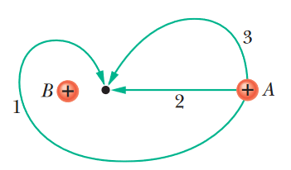

**Problem 4 (Extra, OpenStax)**

A metallic sphere of radius 2.0 cm is charged with +5.0-*μ*C charge, which spreads on the surface of the sphere uniformly. The metallic sphere stands on an insulated stand and is surrounded by a larger metallic spherical shell, of inner radius 5.0 cm and outer radius 6.0 cm. Now, a charge of −5.0-*μ*C is placed on the inside of the spherical shell, which spreads out uniformly on the inside surface of the shell. If potential is zero at infinity, what is the potential of (a) the spherical shell, (b) the sphere, (c) the space between the two, (d) inside the sphere, and (e) outside the shell?

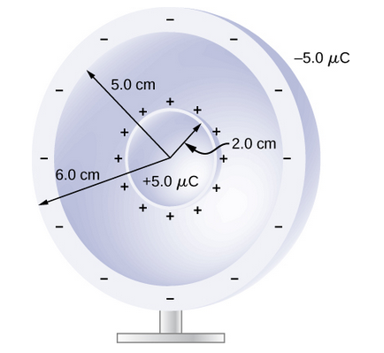

**Problem 5 (Extra, OpenStax)**

A simple and common technique for accelerating electrons is shown in the figure, where there is a uniform electric field between two plates. Electrons are released, usually from a hot filament, near the negative plate, and there is a small hole in the positive plate that allows the electrons to continue moving. (a) Calculate the acceleration of the electron if the field strength is 2.50×104N/C. (b) Explain why the electron will not be pulled back to the positive plate once it moves through the hole.