Name ________________________
PHY2048C, Final Exam

A- Read all the exam once, or twice, before beginning to write. Make sure to comprehend all questions and start with those you feel most confident in.
B – Be clear and concise. There are no extra points for being verbose or writing extra.
C –Only use the white pages that I will provide. You have 120 minutes to answer the exam.

A cue ball (a uniform solid sphere of mass m and radius R) is at rest on a level pool table. Using a pool cue, you give the ball a sharp, horizontal hit of magnitude F at a height h above the center of the ball (Figure 1). The force of the hit is much greater than the friction force f that the table surface exerts on the ball. The hit lasts for a short time ∆t.

Problem 1: For what value of h will the ball roll without slipping?

a1) Draw a free-body diagram for the ball for the situation, including your choice of coordinate axes. Note that the cue exerts both an impulsive force on the ball and an impulsive torque around the center of mass.

a2) The cue force applied for a time ∆t gives the ball’s center of mass a speed , and the cue torque applied for that same time gives the ball an angular speed . How must and be related for the ball to roll without slipping?

Problem 2: If you hit the ball dead center (h = 0), the ball will slide across the table for a while, but eventually it will roll without slipping. What will the speed of its center of mass be then?

b1) Draw two free-body diagrams for the ball in part (b): one showing the forces during the hit and the other showing the forces after the hit but before the ball is rolling without slipping.

b2) What is the angular speed of the ball in part (b) just after the hit? While the ball is sliding, does increase or decrease? Does increase or decrease? What is the relationship between
and .when the ball is finally rolling without slipping?

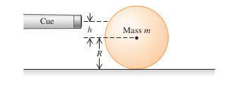

Figure 1

Problem 3

Two identical masses are attached to frictionless pulleys by very light strings wrapped around the rim of the pulley and are released from rest. Both pulleys have the same mass and same diameter, but one is solid, and the other is a hoop. As the masses fall, in which case is the tension in the string greater, or is it the same in both cases? Justify your answer.

Problem 4

In a switchyard, freight cars start from rest and roll down a 2.8-m incline and come to rest against a spring bumper at the end of the track (Figure 2). If the spring constant is k = 4.3 x 10⁶ N/m, how much is the spring compressed when hit by a 57,000-kg freight car?
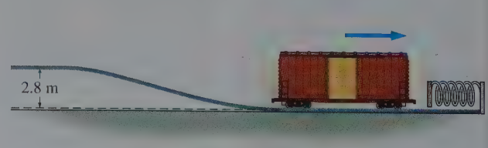

Figure 2

Problem 5

Saturn’s moon Titan has one of the solar system’s thickest atmospheres. Near Titan’s surface, atmospheric pressure is 50% greater than standard atmospheric pressure on Earth, while the density in molecules per unit volume is one-third that of Earth’s atmosphere. If Titan’s atmosphere is essentially all nitrogen (N₂), what is the sound speed compare to Earth? (Hint: Earth’s atmosphere is also mostly Nitrogen).

Problem 6

A 170-g apple sits atop a 2.8-m-high post. A 45-g arrow moving horizontally at 130 m/s passes horizontally through the apple and strikes the ground 36 m from the base of the post, as shown in Figure 3. Where does the apple hit the ground? Neglect the effect of air resistance on either object as well as any friction between apple and post.

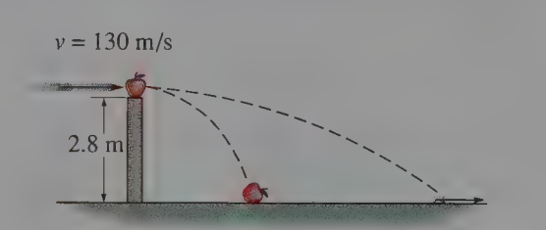

Figure 3

