Name ________________________
PHY2049C, Quiz 1

A- Read all the quiz once, or twice, before beginning to write. Make sure to comprehend all questions and start with those you feel most confident.
B – Be clear and concise. There are no extra points for being verbose or writing extra.
C –Only use the white pages that I will provide. You have 50 minutes to answer the quiz.
---------------------------------------------------------------------------------------------------------------------------
Problem 1

One city offers 4 main tourist attractions: an art museum, a zoo, an history museum, and a science museum. On a day, 15% of the tourists went to the art museum and 4% went to the zoo. The number of tourists that went to the history museum was 4/5 then number of zoo attendees. If 410 tourists went to the history museum, (a) how many total tourists were there that day? (b) what is the proportion of tourists that went to the zoo to tourist that went the art museum? (c) how many tourists went to the science museum? (b) what percentage of tourists went to the science museum?

Problem 2 (Halliday, Resnik, Walker)

Figure 1 shows four situations in which charged particles are fixed in place on an axis. In which situations is there a point to the left of the particles where an electron will be in equilibrium?
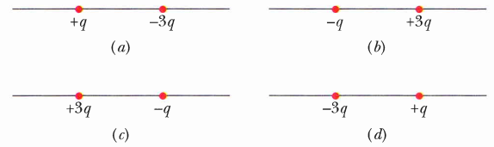
Figure 1

Problem 3 (Halliday, Resnik, Walker)

Figure 2 shows four situations in which five charged particles are evenly spaced along an axis. The charge values are indicated except for the central particle, which has the same charge in all four situations. Rank the situations according to the magnitude of the net electrostatic force on the central particle, greatest first.
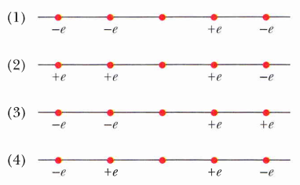

Figure 2

Problem 4
How many electrons would have to be removed from a coin to leave it with a charge of +2.0 x 10 -7 C?

