Name ________________________
PHY2018C, Quiz 2

A- Read all the quiz once, or twice, before beginning to write. Make sure to comprehend all questions and start with those you feel most confident.
B – Be clear and concise. There are no extra points for being verbose or writing extra.
C –Only use the white pages that I will provide. You have 50 minutes to answer the quiz.
---------------------------------------------------------------------------------------------------------------------------

Problem 1

(a) Tara, Nico, and Alex have 500 B./ between the three of them. Tara spent 2/5 of her money. Nico spent 40 B./, and Alex spent twice the amount Tara spent. If all three friends end with the same amount of money each, how much money did Alex had at the beginning?

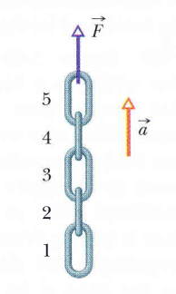

Problem 2 (From Halliday, Resnik, Walker)

In Fig. 1., a chain consisting of five links, each of mass 0.100 kg, is lifted vertically with constant acceleration of magnitude a = – 2.50 m/s2. Find the magnitude of the force on link 2 from link 3

Figure 1

Problem 3 (Sears and Zemansky)

A 40 kg skier skis directly down a frictionless slope with an angle of 10° from the horizontal. Assume the skier moves in the negative direction of an x axis along the slope. A wind force with component F_{x}, acts on the skier. What is Fx if the magnitude of the skier's velocity is constant?

