Name ________________________
PHY2048C, Quiz 4

A- Read all the quiz once, or twice, before beginning to write. Make sure to comprehend all questions and start with those you feel most confident in.
B – Be clear and concise. There are no extra points for being verbose or writing extra.
C –Only use the white pages that I will provide. You have 50 minutes to answer the quiz.
---------------------------------------------------------------------------------------------------------------------------

Problem 1 (Halliday, Resnik, Walker)

Figure 1 shows three situations in which the same horizontal rod is supported by a hinge on a wall at one end and a cord at its other end. Without written calculation, rank the situations according to the magnitudes of (a) the force on the rod from the cord, (b) the vertical force on the rod from the hinge, and (c) the horizontal force on the rod from the hinge, greatest first.
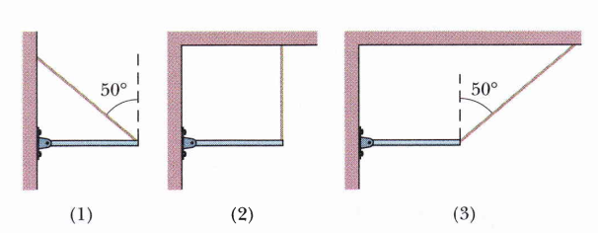

Figure 1
Problem 2

One end of a uniform meter stick is placed against a vertical wall (Figure 2). The other end is held by a lightweight cord that makes an angle u with the stick. The coefficient of static friction between the end of the meter stick and the wall is = 0.30. (a) What is the maximum value the angle can have if the stick is to remain in equilibrium? (b) Let the angle be 15°. A block of the same weight as the meter stick is suspended from the stick, as shown, at a distance x from the wall. What is the minimum value of x for which the stick will remain in equilibrium? (c) When = 15°, how large must the coefficient of static friction be so that the block can be attached 10 cm from the left end of the stick without causing it to slip?
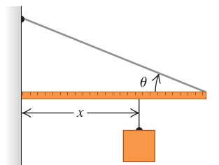

Figure 2

Problem 2

A cubical block rests on an inclined board with two sides parallel to the direction of the incline. The coefficient of static friction between block and board is 0.95. If the inclination angle of the board is increased, will the block first slide or first tip over?

Problem 3

A 4.2-m-long beam is supported by a cable at its center. A 65-kg steelworker stands at one end of the beam. Where should a 180-kg bucket of concrete be suspended if the beam is to be in static equilibrium? Draw a diagram.

Problem 4 (Sears and Zemansky)

Two uniform, 75.0 g marbles of 2.00 cm in diameter are stacked, as shown in Figure 3, in a container that is 3.00 cm wide. (a) Find the force that the container exerts on the marbles at the points of contact A, B, and C. (b) What force does each marble exert on the other?

Problem 5

The leaning Tower of Pisa currently leans at a 3.97° angle to the vertical. Treating the tower as a solid cylinder, what is the maximum angle at which it can lean before falling over? Treat the tower as a uniform cylinder 7.0 m in diameter and 55 m high, and assume the ground supports the tower’s weight but does not provide any torque. In 1990, the tower reached a peak leaning angle of 5.5° (according to florence-museum.com) which caused concerns of instability, thereby starting a stabilization project that set the tower at the current 3.97° angle. Towerofpisa.org, however, claims that the peak inclination in 1990 was 10°. Based on your calculation. Which claim has more credibility?

