Name ________________________
PHY2049C, Quiz 5

A- Read all the quiz once, or twice, before beginning to write. Make sure to comprehend all questions and start with those you fell most confident.
B – Be clear and concise. There are no extra points for being verbose or writing extra.
C –Only use the white pages that I will provide. You have 50 minutes to answer the quiz.
---------------------------------------------------------------------------------------------------------------------------
Problem 1 (Wolfson and Passachoff)

Figure 1 shows a simple mass spectrometer, designed to analyze and separate atomic and molecular ions with different charge-to-mass ratios. In the design shown, ions are accelerated through a potential difference V, after which they enter a region containing a uniform magnetic field. They describe semicircular paths in the magnetic field, and land on a detector a lateral distance x from where they entered the field region, as shown. Show that x is given by:

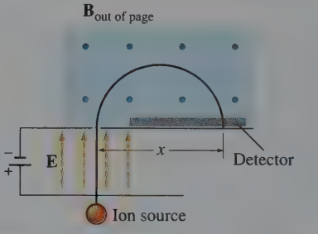

where B is the magnetic field strength, V the accelerating potential, and q/m the charge-to-mass ratio of the ion. By counting the number of ions accumulated at different positions x, one can determine the relative abundances of different atomic or molecular species in a sample.

Figure 1
Problem 2
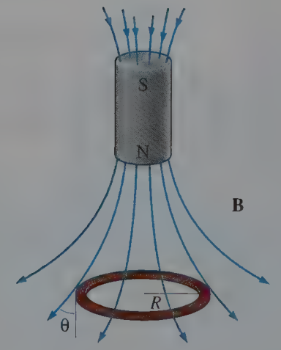

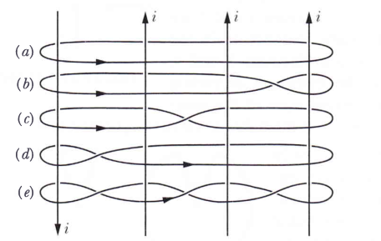
A circular wire loop of mass m and radius R carries a current I. The loop is hanging horizontally below a cylindrical bar magnet, suspended by the magnetic force, as shown in the Figure. If the field lines crossing the loop make an angle with the vertical, show that the strength of the magnetic force is:

Problem 3 (Halliday, Resnik) Figure 2

Figure 2 shows four identical currents i and five Amperian paths encircling them. Rank the paths according to the value of f B, most positive first.

