Name ________________________
PHY2048C, Homework 5

A- Submit a handwritten version of the solutions (clearly readable) at the beginning of class.
---------------------------------------------------------------------------------------------------------------------------

Problem 1 (Chapter 12, still)

Every now and then, I prompt to ChatGPT (the free version) one of the problems from this class to see it says. Here is ChatGPT’s answer for one of the problems in the last quiz.

ChatGPT
To the maximum angle at which the Leaning Tower of Pisa can lean before falling over, we can analyze it as a uniform cylinder. The key principle here is that the center of mass of the cylinder must remain over the base of support.
- Dimensions of the tower:
  - Diameter = 7.0 m, so the radius
  - Height h = 55 m.
- Center of Mass:
For a uniform cylinder, the center of mass is located at the midpoint of its height:

- Maximum Leaning Angle:
The maximum angle can be found using the relationship between the radius of the cylinder and the height of the center of mass.
The critical condition to avoid toppling occurs when the vertical projection of the center of mass falls outside the edge of the base. This can be modeled using trigonometry. The distance from the center of the base (the edge of the base when leaning) to the pivot point at the bottom edge of the cylinder is equal to (r).
As the tower leans, the distance from the center of mass to the ground forms a right triangle:
  - The height of the center of mass relative to the ground when leaning is .
  - The horizontal distance (base) from the center to the edge of the base when leaning is .
The condition that must be met to not tip over is:
[
- Using the tangent function:
Given the above relationship:
Therefore,
- Calculation:
Thus, the maximum angle at which the Leaning Tower of Pisa can lean before it falls over is approximately 82.5°.

List the errors ChatGPT made.

Problem 2 (Wolfson and Passachoff)

The three containers in Figure 1 (container (a), container (b), and container (c), from left to right) are filled to the same level and are open to the atmosphere. How do the pressures at the bottoms of the three containers compare?

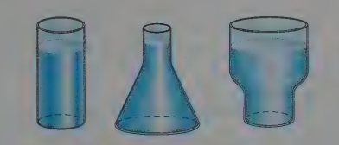

Figure 1
Problem 3 (Wolfson and Passachoff)

It’s not possible to breathe through a snorkel from a depth greater than a meter or so. Why not?
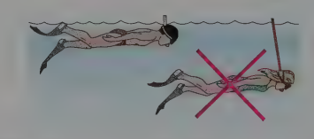

Figure 2

Problem 4

Canal effect. Figure 3 shows an anchored barge that extends across a canal by distance d = 30 m and into the water by distance b = 10 m. The Panama Canal (at the Culebra Cut) has a minimum width D = 152 m, a water depth of H = 13 m. Assume an uniform water-flow speed of v_{i} = 1.5 m/s. Assume that the flow around the barge is uniform. As the water passes the bow, the water level undergoes a dramatic dip known as the canal effect. If the dip has depth h = 0.80 m, what is the water speed alongside the boat through the vertical cross-sections at (a) point a and (b) point b? The erosion due to the speed increase is a common concern to hydraulic engineers.
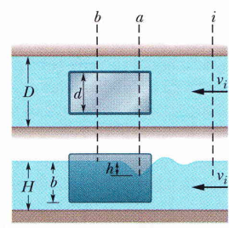

Figure 3

Problem 5

Blood is flowing through an artery partially clogged by cholesterol (assume no viscosity for the blood). A surgeon wants to remove enough of the cholesterol to double the flow rate of blood through this artery. If the original diameter of the artery is D, (a) what should be the new diameter (in terms of D) to accomplish this for the same pressure gradient?

(b) Now allow for viscosity, and use Poiseuille’s equation for the flow rate. (Notice how sensible is blood pressure to the artery diameter)

