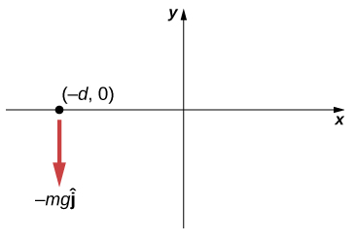
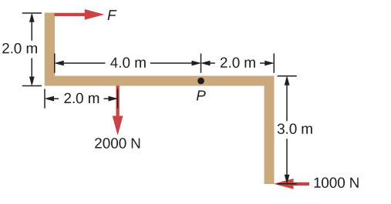
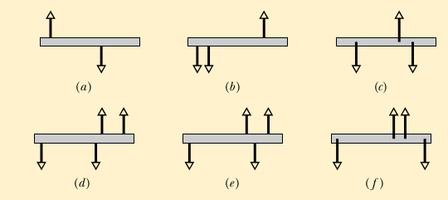
Name _________________________PHY2048C, Practice Quiz 2
A- Read all the quiz once, or twice, before beginning to write. Make sure to comprehend all questions and start with those you feel most confident.
B – Be clear and concise. There are no extra points for being verbose or writing extra.
C –Only use the white pages that I will provide. You have 60 minutes to answer the quiz.
---------------------------------------------------------------------------------------------------------------------------
Problem 1 (Halladay, Resnik, Walker)

The figure gives six overhead views of a uniform rod on which two or more forces act perpendicularly to the rod. If the magnitudes of the forces are adjusted properly (but kept nonzero), in which situations can the rod be in static equilibrium?

Problem 2 (OpenStax)
When the structure shown below is supported at point P, it is in equilibrium. Find the magnitude of force F and the force applied at P. The weight of the structure is negligible.

Figure for Problem 2 Figure for Problem 3

Problem 3 (OpenStax)

A particle of mass m is dropped at the point (−d,0) and falls vertically in Earth’s gravitational field −gjˆ. (a) What is the expression for the angular momentum of the particle around the z-axis, which points directly out of the page as shown below? (b) Calculate the torque on the particle around the z-axis. (c) Is the torque equal to the time rate of change of the angular momentum?

