Name ________________________
PHY2048C, Practice Quiz 3

A- Read all the quiz once, or twice, before beginning to write. Make sure to comprehend all questions and start with those you feel most confident in.
B – Be clear and concise. There are no extra points for being verbose or writing extra.
C –Only use the white pages that I will provide. You have 50 minutes to answer the quiz.
---------------------------------------------------------------------------------------------------------------------------
Problem 1 (From Halladay, Resnik, Walker)

Figure 1 shows three uniform spherical planets that are identical in size and mass. The periods of rotation T for the planets are given, and six lettered points are indicated—three points are on the equators of the planets and three points are on the north poles. Rank the points according to the value of the free-fall acceleration g at them, greatest first.

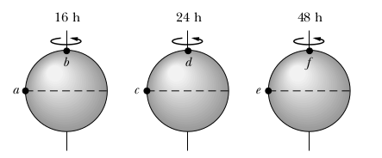

Problem 2

Space explorers land on a planet with the same mass as Earth, but they find they weigh twice as much as they would on Earth. What is the radius of the planet?

Problem 3

A 100 g steel ball and a 200 g steel ball each hang from 1.0-m-long strings. At rest, the balls hang side by side, barely touching. The 100 g ball is pulled to the left until the angle between its string and vertical is 45°. The 200 g ball is pulled to a 45° angle on the right. The balls are released so as to collide at the very bottom of their swings. To what angle does each ball rebound?

Problem 4 (extra)

On a summer camp, 30% of students are boys. When 87 of the students left the camp at the end of the 2nd day, half of the boys were remaining and the number of girls decreased by 20%. How many girls were there at the beginning of the summer camp?

Key Concept from Ch 9 and 13: (a) Newton’s law of universal gravitation.
(b) The rotational and orbital motion of planets. Center of Mass.
(c) Elastic and inelastic collisions: conservation of linear momentum
(d) Potential energy of gravity: conservation of energy.

