Name ________________________
PHY2048C, Homework 1

A- Submit a handwritten version of the solutions (clearly readable) at the beginning of class.
---------------------------------------------------------------------------------------------------------------------------

Problem 1

A cube has edges of length √3. Using vector algebra, find the angle between two diagonals that have a common vertex. Does this angle depend on the length of the edges?

Problem 2

If B is added to C = -3.0î + 4.0ĵ, the result is a vector in the positive direction of the y-axis, with a magnitude equal to that of C. What is the magnitude of B?

Problem 3

Use the deflnition of scalar product, , and the fact that to calculate the angle between the two vectors given by and

Problem 4 (Halliday, Resnick, Walker)

Curve 1 in Fig. 1 gives the height y of a catapulted object versus the angle 0 between its velocity vector and its acceleration vector during flight. (a) Which of the lettered points on that curve correponds to the landing of the object on the ground? (b) Curve 2 is a similar plot for the same launch speed but for a different launch angle. Does the object now land farther away or closer to the launch point?
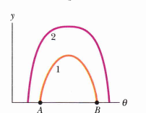
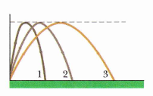

Figure 1 Figure 2

Problem 5 (Halliday, Resnick, Walker)

Figure 2 shows three paths for an American football kicked from ground level. Ignoring the effects of air, rank the paths (a) time of flight, (b) initial vertical velocity component, (c) initial horizontal velocity component, and (d) initial speed, greatest first.

Problem 6 (Halliday, Resnick, Walker)

Figure 3 shows four tracks (either half- or quarter-circles) that can be taken by a train,which moves at a constant speed. Rank the tracks according to the magnitude of a train's acceleration on the curved portion, greatest first.

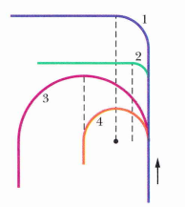

Figure 3

Problem 7

A boy whirls a stone in a horizontal circle of radius 1.5 m and at height 2.0 m above level ground. The string breaks, and the stone flies off horizontally and strikes the ground after traveling a horizontal distance of L0 m. What is the magnitude of the centripetal acceleration of the stone during the circular motion.

Problem 8 (Sears and Zemansky)

A car starts from rest on a curve with a radius of 120 m and accelerates at 1.0 m/s2. Through what angle will the car have traveled when the magnitude of its total acceleration is 2.0 m/s²?

