Name ________________________
PHY2018C, Homework 2

A- Submit a handwritten version of the solutions (clearly readable) at the beginning of class.
---------------------------------------------------------------------------------------------------------------------------

Problem 1

A rope can withstand a maximum tension force of 450 N before breaking. The rope is used to pull a 32-kg bucket of water upward. What is the maximum upward acceleration if the rope is not to break?

Problem 2 (Knight)

The four balls in Figure 1 have been thrown straight up. They have the same size, but different masses. Air resistance is negligible. Rank in order, from largest to smallest, the magnitude of the net force acting on each ball. Some may be equal. Give your answer in the form a > b = c > d and explain your ranking.
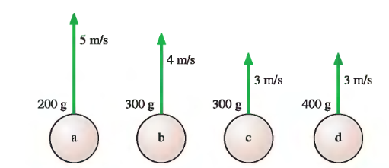


Figure 1 Figure 2

Problem 3 (Wolfson and Pasachoff)

Blocks of 1.0, 2.0, and 3.0 kg are lined up on a table, as shown in Figure 2. A rightward-pointing 12-N force is applied to the leftmost block. What force does the middle block exert on the rightmost one?

Problem 4 (Halliday, Resnick, Walker)

In three situations, a briefly applied horizontal force changes the velocity of a hockey puck that slides over frictionless ice. The overhead views of Fig. 3 indicate, for each situation, the puck's initial speed v_{i} its final speed v_{f}, and the directions of the corresponding velocity vectors. Rank the situations according to the work done on the puck by the applied force, most positive first and most negative last.
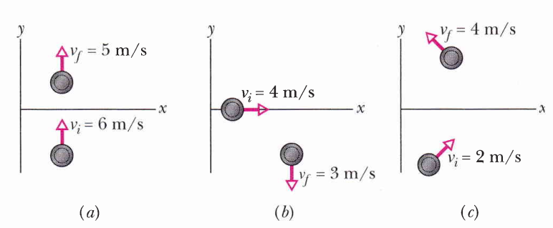

Figure 3

Problem 5

A heavy ball with a weight of 140 N (m = 14.3 kg) is hung from the ceiling of a lecture hall on a 5.5-m long rope. The ball is pulled to one side and released to swing as a pendulum, reaching a speed of 6.5 m/s as it passes through the lowest point. What is the tension in the rope at that point?

Problem 6 (Sears and Zemansky)

A wedge with mass M rests on a frictionless, horizontal tabletop. A block with mass m is placed on the wedge, and a horizontal force F is applied to the wedge (Figure 4). What must the magnitude of F be if the block is to remain at a constant height above the tabletop?
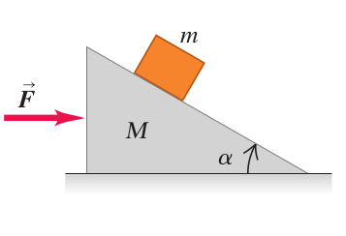

Figure 4

Problem 7

There is a rock on the top of the entrance of an igloo, as shown in Figure 5. The entrance of the igloo is spherical, and surface of the igloo is frictionless. The rock lies ar the very center of the igloo’s canopy. And begins to slide down. Show that the rock leaves the igloo when it has dropped a vertical distance one-third the radius of the igloo entrance.

Figure 5

Problem 8

The Sun’s total power output is 3.85 x 10²⁶ W. What is the associated rate at which the Sun loses mass? (Remember Einstein’s famous mass to energy equation).

Problem 9

What minimum speed does a 80 g puck need to make it to the top of a 3.5-m-long, 20° frictionless ramp?

Problem 10

Figure 6 gives the potential energy function of a particle. (a) Rank regions AB, BC, CD, and DE according to the magnitude of the force on the particle, greatest first. What value must the mechanical energy E_{mec} of the particle not exceed if the particle is to be (b) trapped in the potential well at the left, (c) trapped in the potential well at the right, and (d) able to move between the two potential wells but not to the right of point H? For the situation of (d), in which of regions BC, DE, and FG will the particle have (e) the greatest kinetic energy and (f) the least speed?
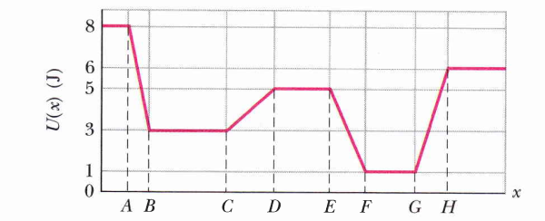

Figure 6

Problem 11 (Halliday, Resnik, Walker)

Block B in Fig. 7 weighs 711 N. The coefficient of static friction between block and table is 0.25; the angle is 30°; assume that the cord between B and the knot is horizontal. Find the maximum weight of block A for which the system will be stationary.

