Name ________________________
PHY2048C, Homework 3

A- Submit a handwritten version of the solutions (clearly readable) at the beginning of class.
---------------------------------------------------------------------------------------------------------------------------

Problem 1

A good baseball pitcher can throw a baseball toward home plate at 90 miles/h with a spin of 1800 rev/min. How many revolutions does the baseball make on its way to home plate? For simplicity, assume that the 60 ft between the pitcher mound and the home pate is a straight line path.

Problem 2 (Knight)

Figure1 shows masses that are connected by massless, rigid rods. (a) Find the coordinates of the center of mass. (b) Find the moment of inertia about an axis that passes through mass A and is perpendicular to the page.

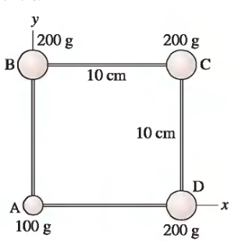

Figure 1

Problem 3

Can an object's translational and rotational motions be changed by a single force? Explain.

Problem 4

The rotational kinetic energy of a rolling automobile wheel is 40% of its translational kinetic energy. The wheel is then redesigned to have 10% lower rotational inertia and 20% less mass, while keeping its radius the same. By what percentage does its total kinetic energy at a given speed decrease?

Problem 5 (Sears and Zemansky)

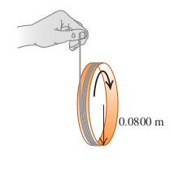
A string is wrapped several times around the rim of a small hoop with radius 8.00 cm and mass 0.180 kg. The free end of the string is held in place and the hoop is released from rest (Figure 2). After the hoop has descended 75.0 cm, calculate (a) the angular speed of the rotating hoop and 0.0800 m (b) the speed of its center of mass.

Figure 2

Problem 6

When an object is rolling without slipping, the rolling friction force is significantly lower than the friction force when the object is sliding. For instance, a dollar coin will roll on its edge significantly farther than it will slide on its flat side. When an object is rolling without slipping on a horizontal surface, we can approximate the friction force to be zero, so that ax and az are approximately zero and vz and vz are approximately constant. Rolling without slipping means vx = rωz and az = rαz . If an object is set in motion on a surface without these equalities, sliding (kinetic) friction will act on the object as it slips until rolling without slipping is established. A solid cylinder with mass M and radius R, rotating with angular speed v0 about an axis through its center, is set on a horizontal surface for which the kinetic friction coefficient is mk. (a) Draw a free-body diagram for the cylinder on the surface. Think carefully about the direction of the kinetic friction force on the cylinder. Calculate the accelerations ax of the center of mass and αz of rotation about the center of mass. (b) The cylinder is initially slipping completely, so initially vz = v0 but vx = 0. Rolling without slipping sets in when vx = rωz. Calculate the distance the cylinder rolls before slipping stops. (c) Calculate the work done by the friction force on the cylinder as it moves from where it was set down to where it begins to roll without slipping.
Problem 7
A 4.00 kg ball is dropped from a height of 11.0 m above one end of a uniform bar that pivots at its center. The bar weighs 9.00 kg and is 3.00 meters in length. At the other end of the bar sits another 4.00 kg ball, unattached to the bar. The dropped ball sticks to the bar after the collision. How high will the other ball go after the collision?

