Name ________________________
PHY2048C, Homework 4

A- Submit a handwritten version of the solutions (clearly readable) at the beginning of class.
---------------------------------------------------------------------------------------------------------------------------

Problems from a CERN (European Organization for Nuclear Research) workshop on Complex Numbers.

Problem 1
Compute real and imaginary part of

Problem 2
Compute the absolute value and the conjugate of

Problem 3
Write in the “algebraic” form the following complex numbers

Problem 4
Write in the “trigonometric” form (A(cos θ + i sin θ)) the following complex numbers

a) 8

b)

c)

Problem 6
Compute the square roots of z = −1 − i

Problem 7
Compute the cube roots of z = −8.

Problem 8
Find such that .

Problem 9

A uniform beam is suspended horizontally and attached to a wall by a small hinge (Fig. 1). What are the directions (upward or downward, and to the left or the right) of the components of the force that the hinge exerts on the beam?
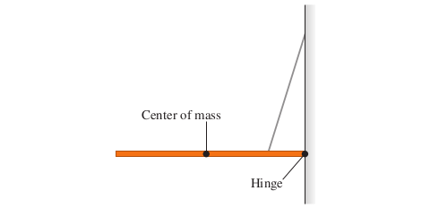
Figure 1

