Name ________________________
PHY2049C, Homework 4

A- Submit a scanned version of the solutions to Canvas before class. It can be scanned with your phone camera (a high-contrast picture) as long as it is easily readable.
---------------------------------------------------------------------------------------------------------------------------

Problem 1

If a person is struck by a bolt of lightning with these properties, the current will pass through her body. We shall assume that her mass is 65 kg, that she is wet (after all, she is in a rainstorm) and therefore has a resistance of 1.0 kΩ, and that her body is all water (which is reasonable for a rough, but plausible, approximation).

(a) How much charge is transferred from the cloud to the earth during such a strike?

(b) By how many degrees Celsius would this lightning bolt increase the temperature of 75 kg of water?
(Hint: you need the specific hear of water)

(c) Given that the internal body temperature is about 37 C, would the person’s temperature actually increase that much? Why not?

Problem 2

The wires in the Figure are all made of the same material. Rank in order, from largest to smallest, the resistances R_{a} to R_{e} of these wires. Explain.

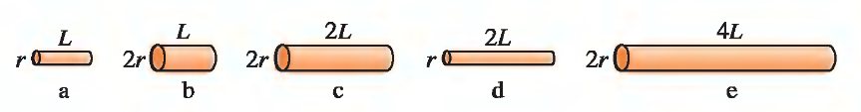
Problem 3

What is the mean free time between collisions for electrons in an aluminum wire and in an iron wire?

Problem 4

The Figure shows a 4.0-cm-wide plastic film being wrapped onto a 2.0-cm-diameter roller that turns at 90 rpm. The plastic has a uniform surface charge density -2.0 nC/cm2.
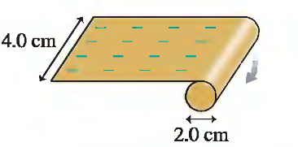
a. What is the current of the moving film?
b. How long does it take the roller to accumulate a charge of -10/uC?

Problem 5

A material with resistivity r is formed into a cylinder of length L and outer radius r_{outer}. A cylindrical core with radius r_{inner} is removed from the axis of this cylinder and filled with a conducting material, which is attached to a wire. The outer surface of the cylinder is coated with a conducting material and attached to another wire.

(a) If the second wire has potential V greater than the first wire, in what direction does the local electric field point inside the cylinder?

(b) The magnitude of this electric field is , where c is a constant and r is the distance from the axis of the cylinder. Use the relationship
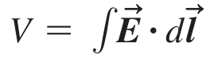

to determine the constant c.

(c) What is the resistance of this device?

