Name ________________________
PHY2048C, Homework 6

A- Submit a handwritten version of the solutions (clearly readable) at the beginning of class.
---------------------------------------------------------------------------------------------------------------------------

Problem 1

A cold block of metal feels colder than a block of wood at the same temperature. Why? A hot block of metal feels hotter than a block of wood at the same temperature. Again, why? Is there any temperature at which the two blocks feel equally hot or cold? What temperature is this?

Problem 2

We’re lucky that the earth isn’t in thermal equilibrium with the sun (which has a surface temperature of 5800 K). But why aren’t the two objects in thermal equilibrium?

Problem 3

Two containers hold equal masses of nitrogen gas at equal temperatures. You supply 10 J of heat to container A while not allowing its volume to change, and you supply 10 J of heat to container B while not allowing its pressure to change. Afterward, is temperature T_{A} greater than, less than, or equal to T_{B} ?

Problem 4 (Halliday, Resnik, Walker)

The dot in Figure 1(a) represents the initial state of a gas, and the vertical line through the dot divides the p-V diagram into regions L and 2. For the following processes, determine whether the work W done by the gas is positive, negative, or zero: (a) the gas moves up along the vertical line (b) it moves down along the vertical line (c) it moves to anywhere in region l (to the left of the line), and (d) it moves to anywhere in region 2 (to the right of the line).

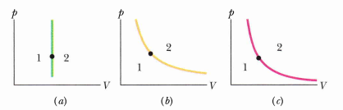

Figure 1
Problem 5

The dot in Figire 1(b) represents the initial state of a gas, and the isotherm through the dot divides the p-V diagram into regions 1 and 2. For the following processes, determine whether the change in the internal energy of the gas is positive, negative, or zero: (a) the gas moves up along the isotherm, (b) it moves down along the isotherm, (c) it moves to anywhere in region 1, and (d) it moves to anywhere in region 2.
Problem 6

The dot in Figure 1 (c) represents the initial state of a gas, and the adiabat through the dot divides the p-V diagram into regions 1, and 2. For the following processes, determine whether the corresponding heat transfer is positive, negative, or zero: (a) the gas moves up along the adiabat, (b) it moves down along the adiabat, (c) it moves to anywhere in region 1, and (d) it moves to anywhere in region 2

Problem 7

A gas, confined to an insulated cylinder, is compressed adiabatically to half its volume. Does the entropy of the gas increase, decrease, or remain unchanged during this process? Why?

Problem 8

The gas cylinder in Figure 2 is placed on a block of ice. The initial gas temperature is > 0°C.
(a) During the process that occurs until the gas reaches a new equilibrium, are (I) , (ii) W, and (iii) Q greater than, less than, or equal to zero? Explain.
(b) Draw a pV diagram showing the process.
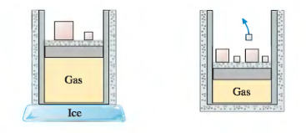

Figure 2 Figure 3

The gas cylinder in Figure 3 is similar to the cylinder described in Figure 2, except that the bottom is insulated. Masses are slowly removed from the top of the piston until the total mass is reduced by 50%.
(a). During this process, are (i) T (ii) W, and (iii) Q greater than, less than, or equal to zero? Explain.
(b) Draw a pV diagram showing the process.

