Name ________________________
PHY2049C, Homework 6

A- Submit a handwritten version of the solutions (clearly readable) at the beginning of class.
---------------------------------------------------------------------------------------------------------------------------
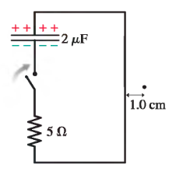
Problem 1

The capacitor in the figure is charged to 50 V. The switch closes at t = 0 s. Draw a graph showing the magnetic field strength as a function of time at the position of the dot. On your graph indicate the maximum field strength, and provide an appropriate numerical scale on the horizontal axis.

Problem 2

When a rigid charge distribution with charge Q and mass M rotates about an axis, its magnetic moment µ is linearly proportional to its angular momentum L, with µ=αL. The constant of proportionality α is called the gyromagnetic ratio of the object. We can write α= g(Q/2M), where g is a dimensionless number called the g-factor of the object. Consider a spherical shell with mass M and uniformly distributed charge Q centered on the origin O and rotating about the z-axis with angular speed ω.

(a) A thin slice with latitude measured with respect to the positive z-axis describes a current loop with width and radius as shown in Figure 1. What is the differential current dI carried by this loop in terms of Q, ω, R, and d,

(b) The differential magnetic moment contributed by that slice is dµ = A dI, where is the area enclosed by the loop. Express the differential magnetic moment in terms of Q, ω, R, and d, as shown in Fig. P28.77. Figure P28.77
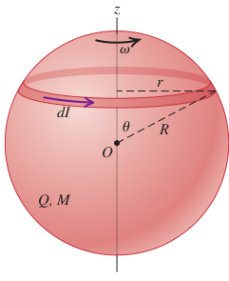
What is the differential current dI

(c) Integrate over to determine the magnetic moment µ

(d) what is the magnitude of the angular momemtum L?

(e) Determine the gyromagnetic ratio α.

(f) What is the g-factor for a spherical shell?

Figure 1

Problem 3

A cylindrical shell with radius R and length W carries a uniform charge Q and rotates about its axis with angular speed ω. The center of the cylinder lies at the origin O and its axis is coincident with the x-axis, as shown the Figure below

(a) What is the charge density ?

(b) What is the differential current dI on a circular strip of the cylinder centered at x and with width dx?

(c) Use Eq. (12.16) (see below) to write an expression for the differential magnetic field dB at the origin due to this strip. Note that on the figure, the coordinate x corresponds to the coordinate y in the equation.

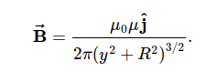

(d) Integrate to determine the magnetic field at the origin.
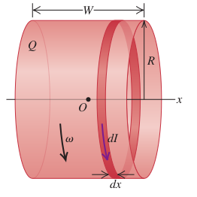

Problem 4

A rectangular loop of length and width w is located a distance a from a long, straight wire, as shown in Figure 2. What is the mutual inductance of this arrangement?
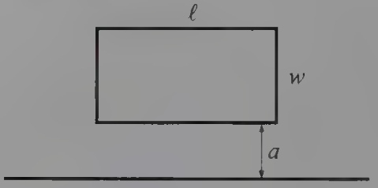

Figure 2
Problem 5 (Wolfson and Passachof)

A wire of length l and resistance R is formed into a closed rectangular loop twice as long as it is wide. It is mounted on a nonconducting horizontal axle parallel to its longer dimension, as shown in Figure 3. A uniform magnetic field B points into the page, as shown. A long string of negligible mass is wrapped many times around a drum of radius a attached to the axle, and a mass m is attached to the string.
When the mass is released it falls and eventually reaches a speed that, averaged over one cycle of the loop’s rotation, is constant from one rotation to the next. Find an expression for that average terminal speed.

