Name ________________________
PHY2048C, Practice Quiz 6

A- Read all the quiz once, or twice, before beginning to write. Make sure to comprehend all questions and start with those you feel most confident in.
B – Be clear and concise. There are no extra points for being verbose or writing extra.
C –Only use the white pages that I will provide. You have 50 minutes to answer the quiz.
---------------------------------------------------------------------------------------------------------------------------

Problem 1

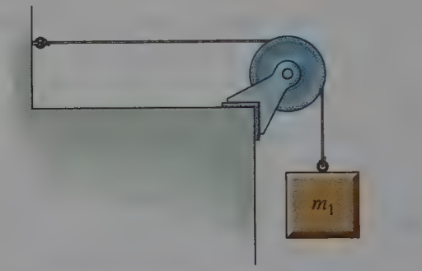
A mass m, is attached to a wire of linear density 5.6 g/m, and the other end of the wire run over a pulley and tied to a wall as shown in Figure 1. The speed of transverse waves on the horizontal section of wire is observed to be 20 m/s. If a second mass m, is added to the first, the wave speed increases to 45 m/s. Find the second mass. Assume the string does not stretch appreciably.

Figure 1

Problem 2
What variable or quantity oscillate in a sound wave? How does it oscillate?

Problem 3
The water level in a large tank is maintained at height H above the surrounding level terrain. A rounded orifice placed in the side of the tank discharges a horizontal jet. Neglecting friction, determine the height at which the orifice should be placed so the water strikes the ground at the maximum horizontal distance from the tank.

