Name ________________________
PHY2048C, Practice Quiz 6

A- Read all the quiz once, or twice, before beginning to write. Make sure to comprehend all questions and start with those you feel most confident in.
B – Be clear and concise. There are no extra points for being verbose or writing extra.
C –Only use the white pages that I will provide. You have 50 minutes to answer the quiz.
---------------------------------------------------------------------------------------------------------------------------
Problem 1 (Sears and Zemansky)

A magnetic lift uses a cylinder with radius R and width W wrapped by conducting wire, as shown in Figure 2. A uniform external magnetic field B points downward while current I flows in the sense indicated. A mass M is hung from the cylinder by a cable attached to its rim on the axis of the coil. The height above the lowest possible position of the mass is h.

(a) What is the minimum current I for M which the mass can be suspended with h > 0?

(b) What is the height of the mass h = h_{top} when the cable attachment rotates one-half turn to the top of the cylinder, in terms of R? Define a dimensionless parameter and express subsequent results in terms of and other given quantities.

Problem 2 (Sears and Zemansky)

A particle with mass m and positive charge q starts from rest (see the figure below). There is a uniform electric field E in the + y-direction and a uniform magnetic field B directed out of the page. It is shown in more advanced books x that the path is a cycloid whose radius of curvature at the top points is twice the y-coordinate at that level. (a) Explain why the path has this general shape and why it is repetitive. (b) Prove that the speed at any point is equal to (Hint: Use energy conservation.) (c) Applying Newton’s second law at the top point and taking as given that the radius of curvature here equals 2y, prove that the speed at this point is 2E/B.

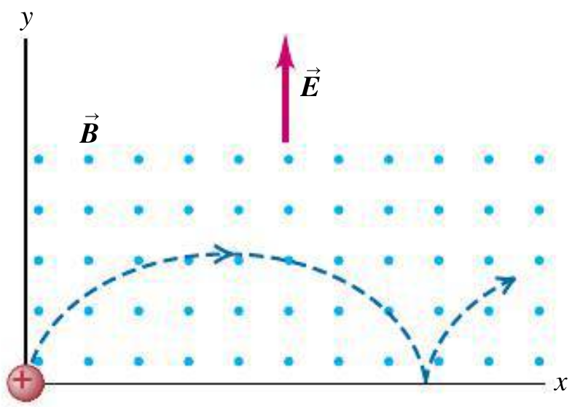

Problem 3 (Extra) (part d from above) Like we did in class with the magnetic field problem, set up the coupled differential equations of motion for this problem (note that they will be very similar to the ones we got for the magnetic field alone, just with one extra term)

