****

**Manual to Lab 2: PHY2048C.**

**Florida State University – Republic of Panama**

**Introduction to the Multimeter**

**About labs in this class**

by: iyicon

The labs in this class will have general instructions, and many things need to be figured out by the students. I will be answering any specific questions the students may have without completely giving away the key to the puzzle. **Answer the questions and record your measurements in your lab notebook and then submit the notebook at the end of the activity.**

**About this lab**

In this lab, you will learn how to make measurements for resistance, current, and voltage using a multimeter[1]; you will also learn how to read resistance values out of commercial resistors. The multimeter is the quintessential tool for any electrical and electronic task. You can check if there is a blackout in Panama City, or just a momentary drop in the Voltage in your neighborhood, for instance, by measuring the voltage out of an outlet in your house. This, you would do it with a multimeter.

Figure 1 shows a multimeter and the two terminals they come with: black & red.

*Figure 1: Multimeter and cables*

The black cable is the negative terminal, or the anode (when used to measure resistance), and the red cable in the positive terminal, or cathode. The black cable must always be connected to common ground, labeled as COM (we will see exactly what this means later in the semester); this is shown in Figure 2.

The red cable goes in one of the other three terminals depending on the function of the multimeter.For it to be a voltmeter or an Ohmmeter, the cable must be inserted as shown in Figure 3. For it to be a Galvanometer, it must be inserted as shown in Figure 4.

*Figure 2: black cable connected*

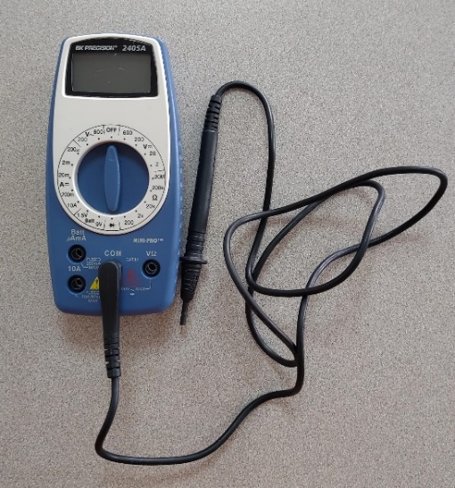

**Question 1.** What do you think is the function of the third port? What does the 200 mA mean?

*After* you have the proper cable configuration, select the function of the multimeter with the knob.

*Figure 3: configuration for Galvanometer Figure 4: Configuration for Voltmeter and Ohmmeter*

**Activity 1.** Measure the battery in the panel by touching the contact with the probes (negative with negative, positive to positive). Make sure you measure DC voltage. The battery says it is 9V, but this is the *nominal* (theoretical) voltage.

**Question 2.** What voltage does the battery read? Reverse the leads. What voltage does it read now?

Resistors’ nominal resistance are given by their color bands (see Table 1).

*Table 1: resistors color code*

**Question 3:** What is the nominal value of the two resistors in the bottom-right corner of the board (see Figure 5)?

*Figure 5: Electronic Panel. Circled are the two resistors to be measured.*

**Activity 2:** Measure the resistance of these two resistors.

**Question 3:** What is the fractional discrepancy between the nominal value and the measured value?

**Activity 3:** Connect the battery to the leftmost resistor of the two from the precious activity. Measure the current. Do this with the other resistor.

**Question 4:** Ohm’s law establishes that the current must be equal to the resistance times the voltage ().

Do these resistors obey Ohm’s law?

1. The multimeter is “multi” because it includes 3 devices that historically where separate: the Galvanometer (to measure current), the Ohmmeter (to measure resistance) and the voltmeter (to measure) volatage.