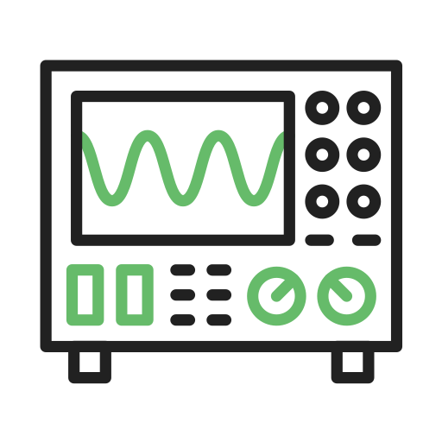****

**Manual to Lab 3: PHY2048C.**

**Florida State University**

**Introduction to Oscilloscope**

By IconBaandar

**About labs in this class**

The labs in this class will have general instructions, and many things need to be figured out by the students. I will be answering any specific questions the students may have without completely giving away the key to the puzzle. **Answer the questions and record your measurements in your lab notebook, and then submit the notebook at the end of the activity.**

**About this lab**

In this lab, you will learn how to use the PASCO Universal Interface to generate and measure signals. A Universal Interface (UI) functions both a power supply (which generates a current, DC or AC) and an oscilloscope (which can measure current and voltage continuously). For this lab, at least one person in your group must have the PASCO Capstone program used to interact with the UI.

Figure 1 shows a schema of the Universal Interface.



Figure 1: PASCO Universal Interface. Circled are the plug we are going to use in this lab.

Note that there is a cable that has two leads (similar to those of the voltmeter). These leads go into the ANALOG INPUTS ports. The USB cable does into the computer. In case your laptop only has USB-c ports, there is a provided dongle. The banana jacks (this is how the colored male-male cables are called) go into the OUTPUTS jack.

**Activity 1.** Connect all the cables and select “hardware setup” in the Capstone window (see figure 2). Place an “output voltage sensor” readout in the Output 2 plug by clicking on it.

*Figure 2: Hardware setup.*

**Activity 2**: output a 5V direct current signal. Plot the output signal by dragging the “Scope” logo on the right bar of the Capstone Window (see Figure 3) and setting up the y-axis to be “Output Voltage” (see Figure 4). Use the multimeter to verify that this is indeed the output of the machine.

*Figure 2: Click on Scope to output the graph of the Voltage*

*Figure 3: Setting the y-axis to “Output Voltage Sensor”*

**Question 1:** Do the multimeter and the Output Voltage Sensor agree? Why or why not?

**Question 2:** Does the 5V line in the plot remain perfectly straight? Why do you think that is? Identify sources of systematic errors with this measurement. Draw a sketch of the plot in your notebook.

**Activity 3:** Now use the leads of the cable you connected to ANALOG INPUTS to measure the voltage of the 9V battery.

**Question 3:** What is reading? Does it coincide with the multimeter? Is it also a straight line, or is it curved? Is it straighter than the output of the UI? Why? Draw a sketch of the plot in your notebook.

**Activity 4:** Now connect the 9V battery to the resistors in the lower right part of the panel (the same we used for the last lab). Use the leads of the cable you connected to ANALOG INPUTS to measure the current of this circuit. You must change the sensor in the Hardware setup to the “Current Sensor.”

**Question 4**: Is the current constant? Does the value coincide with what you measured with the multimeter?

**Question 5**: Show whether Ohms’s Law is obeyed with the measurements of the UI.

**Activity 5:** Repeat **Activity 4** but using the voltage produced by the UI. Apply 1 to 10 V in steps of 1V.

**Question 6:** How does the current change? With changing voltage? Divide the current by the voltage and provide a measured resistance value (with error bars).