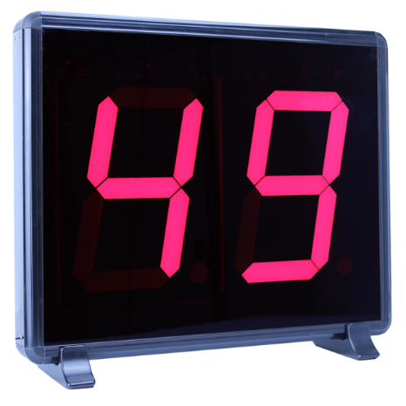 

**Manual to Lab 4: PHY2048C.**

**Florida State University**

**Circuits I**

**About labs in this class**

The labs in this class will have general instructions, and many things need to be figured out by the students. I will be answering any specific questions the students may have without completely giving away the key to the puzzle. **Answer the questions and record your measurements in your lab notebook, and then submit the notebook at the end of the activity.**

**About this lab**

In this lab, you are provided with tools to make a circuit for an LED number panel, and to produce a sound at a particular frequency.

**Activity 1:** Use the voltage power supply provided (the 9V battery or the UI) to draw a 4 on the LED panel display on the board. Draw the circuit that draws a 4 in your notebook.

**Activity 2:** Use the voltage power supply provided (the 9V battery or the UI) to draw a 9 on the LED panel display on the board. Draw the circuit that draws a 9 in your notebook.

**Question 1:** Draw a circuit that would display a 49 if there were two panels like the one on the board.

**Activity 3:** Make the speaker produce the A (La) musical note (which is 440 Hz).

**Activity 4:** Now you will use your phone to double-check that the speaker is sending the right frequency. Follow these steps:

Download the *phyphox* *app* on your phone, <https://phyphox.org>.

Open the app, select and press the “play” icon at the top.

**Question 2:** Does the phone app measure 440 Hz? Can you think of any source of systematic errors in the measurement, or in the speaker, that may cause a discrepancy? List your best guesses as to what may be going on.

**Activity 5:** Open phyphox and the  tool to measure the amplitude of the sound in decibels.

**Question 3:** How does the amplitude and frequency of the sound volume of the sound change with different voltages? Does it make sense to you? Sketch a plot in your notebook of Voltage Vs. Sound Amplitude (In Decibels).