Name_______________________

Class_______________________

Date_______________________

**The H-R Diagram**

Written by Paul McCudden, Colorado Mountain College – [pmccudden@coloradomtn.edu](mailto:pmccudden@coloradomtn.edu)

Modifyid by Daniel Sega, Florida State University – [dsega@fsu.edu](mailto:dsega@fsu.edu)

A star is a delicately balanced ball of gas, fighting between two impulses: **gravity**, which wants to squeeze the gas all down to a single point, and **radiation pressure**, which wants to blast all the gas out to infinity. These two opposite forces balance out in a process called **Hydrostatic** **Equilibrium**, and keep the gas in a stable, fairly constant-sized sphere. The radiation itself is due to the fusion of protons in the star's core – a process that produces huge amounts of energy.

In class we've examined the most important properties of stars: their temperatures, colors and brightnesses. Now let's see if we can find some relationships between these stellar properties. We know that hotter stars are brighter, as described by the **Stefan-Boltzmann Law,** and we know that the hotter stars are also bluer, as described by **Wien's Law**.

The H-R diagram is a way of displaying an important relationship between a star's **Absolute Magnitude** (or **Luminosity**), and its **Spectral Type** (or **temperature**). Remember, Absolute Magnitude is how bright a star would appear to be, *if* it were 10 parsecs away. Luminosity is how much total energy a star gives off every second.

As we studied in a previous exercise, Spectral Type is a system of classifying stars by temperature, from hottest (type O) to coldest (type M). Each letter in the Spectral Type list (O, B, A, F, G, K, and M) is further subdivided into 10 steps, numbered 0 through 9, to make finer distinctions between stars. So a B4 star is slightly hotter than a B6 star, etc.

The two astronomers who figured out that there was a very interesting relationship between **Luminosity** (or absolute magnitude) and **Temperature** (or Spectral Type) when you plotted them on a graph together were Ejnar Hertzsprung and Henry Russell. Their graph or diagram was a profound insight that has helped astronomers organize their thinking about stars since it was created in the 1930's.



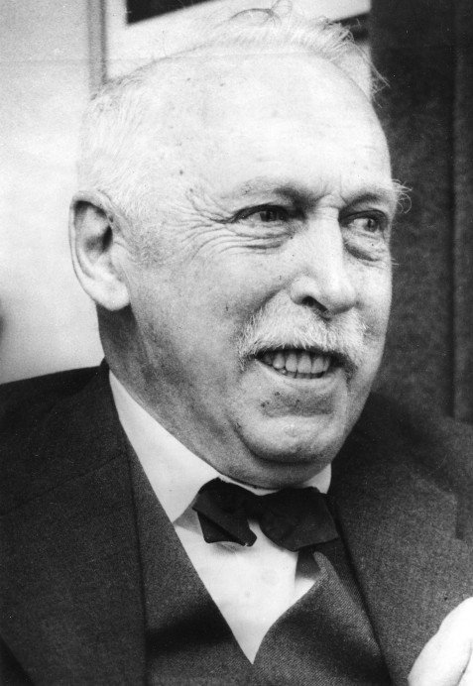

Ejnar Hertzsprung Henry Russell

**PART A**

On the next page, in **Table 1**, is a list of some of the *brightest* stars in the sky, and also some of the *nearest* stars in the sky. Some of these names should be familiar to you, as stars you may have seen in the sky personally. Many of these names, however, will be unfamiliar. The reason for this will become clear. We need to fill in the **Spectral Type** for each star. To do this, we'll need to search for each star in *Stellarium* using its **Hipparcos Catalog Number**. The **Hipparcos Catalog** is a standard reference list of about 100,000 stars in the sky. Every star you can see with the naked eye, and many thousands that you can't see, were all carefully organized in the Hipparcos Catalog in the 1980's and 90's by the Hipparcos spacecraft, which was built by a group of European scientists. *Stellarium* uses the data from the Hipparcos catalog to identify stars in the sky.

Using the given Hipparcos catalog numbers in **Table 1** below, **search** for and select each star in the list below by opening the **search** window (**CTRL-F** or the **F3** button) and typing the letters **HP** and then the Hipparcos catalog number, and then pressing **Enter** to select and center the star and display the **information** on the star. In the information that appears on screen, the star's **Absolute Magnitude** is listed on one of the first few lines of information, and its **Spectral Type** is listed near the bottom of the list. Use this information to fill in the blanks in Table 1 below. Keep only the **first UPPER CASE letter and the subsequent number** in the Spectral Type listing – ignore any Roman Numerals or letters after the numbers (we’ll discuss what those mean in a later assignment).

**Table 1**

| Nearby Stars | | | | | Bright Stars | | | | | |
| --- | --- | --- | --- | --- | --- | --- | --- | --- | --- | --- |
| # | Star name | Hipparcos Catalog Number | Spectral Type | Absolute Magnitude |  | # | Star name | Hipparcos Catalog Number | Spectral Type | Absolute Magnitude |
| 1 | Proxima | 70890 |  |  |  | 26 | Sirius A | 32349 |  |  |
| 2 | Alpha Centauri A | 71683 |  |  |  | 27 | Canopus | 30438 |  |  |
| 3 | Alpha Centauri B | 71681 |  |  |  | 28 | Rigel Kentaurus | 71683 |  |  |
| 4 | Barnard's Star | 87937 |  |  |  | 29 | Arcturus | 69673 |  |  |
| 5 | Kapteyn's Star | 24186 |  |  |  | 30 | Vega | 91262 |  |  |
| 6 | Lalande 21185 | 54035 |  |  |  | 31 | Capella | 24608 |  |  |
| 7 | Sirius A | 32349 |  |  |  | 32 | Rigel | 24436 |  |  |
| 8 | BD+68 946 | 86162 |  |  |  | 33 | Procyon | 37279 |  |  |
| 9 | Wolf 1061 | 80824 |  |  |  | 34 | Achernar | 7588 |  |  |
| 10 | Kruger 60 A | 110893 |  |  |  | 35 | Betelgeuse | 27989 |  |  |
| 11 | Ross 154 | 92403 |  |  |  | 36 | Hadar | 68702 |  |  |
| 12 | Van Maanen 2 | 3829 |  |  |  | 37 | Acrux | 60718 |  |  |
| 13 | Epsilon Eridani | 16537 |  |  |  | 38 | Altair | 97649 |  |  |
| 14 | Ross 128 | 57548 |  |  |  | 39 | Aldebaran | 21421 |  |  |
| 15 | Luyten's Star | 36208 |  |  |  | 40 | Antares | 80763 |  |  |
| 16 | Epsilon Indi | 108870 |  |  |  | 41 | Spica | 65474 |  |  |
| 17 | 61 Cygni A | 104214 |  |  |  | 42 | Pollux | 37826 |  |  |
| 18 | 61 Cygni B | 104217 |  |  |  | 43 | Fomalhaut | 113368 |  |  |
| 19 | Procyon A | 37279 |  |  |  | 44 | Mimosa | 62434 |  |  |
| 20 | Lacaille 8760 | 105090 |  |  |  | 45 | Deneb | 102098 |  |  |
| 21 | Groombridge 34 | 1475 |  |  |  | 46 | Regulus | 49669 |  |  |
| 22 | Lacaille 9352 | 114046 |  |  |  | 47 | Adhara | 33579 |  |  |
| 23 | Tau Ceti | 8102 |  |  |  | 48 | Castor | 36850 |  |  |
| 24 | Ross 614 A | 30920 |  |  |  | 49 | Gacrux | 61084 |  |  |
| 25 | Luyten 725-32 | 5643 |  |  |  | 50 | Shaula | 85927 |  |  |

Do you see why the stars in the left column (the nearby stars) are mostly unknown to you? Compare their absolute magnitudes to the stars in the right column (the bright stars).

* Why are the nearby stars mostly unknown? ________________________________________

**PART B**

Let's make a graph of **Absolute Magnitud**e vs. **Spectral Type** for these stars. This graph is called an **H-R Diagram**. Using the blank graph paper below, plot each star's **Absolute Magnitude** on the y-axis (the vertical axis) and its **Spectral Type** on the x-axis (the horizontal axis). Each star will be a dot somewhere on this graph. Pay careful attention to the SIGN of the Absolute Magnitude – minus signs are important and shouldn’t be ignored!

Notice that one star is already plotted: the Sun! The Sun is a Spectral Type **G2** star, with an Absolute Magnitude of **4.7** (of course its *apparent* magnitude, as discussed in class, is -26!). Following this example, plot the rest of the stars on the graph, **putting the number of each star next to its dot**.

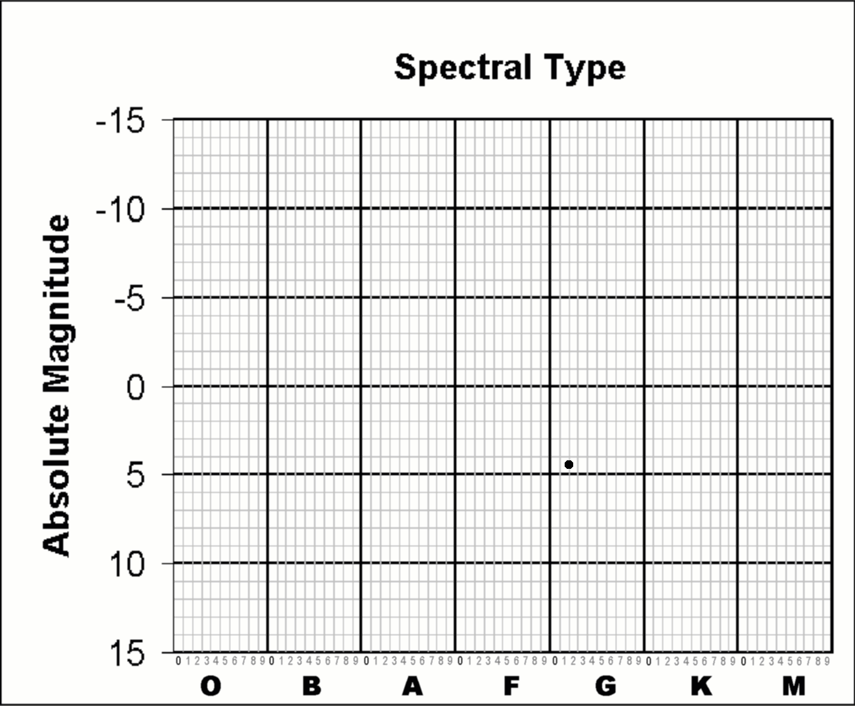

Now let's answer some questions about our completed H-R Diagram...

* In what part of the diagram are most of the nearby stars plotted: choose one: **upper left, lower left, upper right or lower right**? _________________________________________________________
* In what part of the diagram are most of the bright stars plotted? Again, choose one: **upper left, lower left, upper right or lower right**?_________________________
* Where on your diagram are most of the stars you plotted located? __________________________
* Name the hottest star you plotted ___________________________________________________
* Name the coldest star you plotted __________________________________________________
* Name the brightest star you plotted _________________________________________________
* Name the dimmest star you plotted__________________________________________________
* Can you find a star on your diagram that is both bright and cold? What is its name?___________
* What part of the diagram is it located in? ____________________________________
* Can you find a star on your diagram that is both hot and dim? What is its name?______________
* What part of the diagram is it located in? _____________________________________
* Are stars with a larger mass generally **hotter** or **colder**? (Remember, stars are heated by fusion in their core, which is caused by the intense squeezing pressure of gravity) ___________________________
* Compare the star Vega to our Sun. Is it **more** or **less** massive than the Sun? Why? ____________________________________________________________________________________________________________________________________________________________________
* How about Epsilon Eridani? Is it **more** or **less** massive than the Sun? Why? ____________________________________________________________________________________________________________________________________________________________________

The part of the H-R diagram where most of the stars are plotted is called the **Main Sequence**. The Sun, for example is on the Main Sequence. This part of the curve is where stars in the prime of their life are located, as they fuse Hydrogen into Helium in their cores.

Lightly draw a curve through the Main Sequence on your diagram.

* Suppose I told you I found a Main Sequence star that was type A5. Using your diagram, what should its absolute magnitude be? _________________________________
* What about a type K3 star? _________________________________
* What about a type M5? _______________________________________
* Are more stars on the Main Sequence or off it? _____________________________________
* List the stars that are not on the Main Sequence ______________________________________ _____________________________________________________________________________
* In which two parts of the H-R diagram are the non-Main Sequence stars located? _____________________________________________________________________________
* What term do we use to refer to stars in the upper right section of the H-R diagram? __________

These stars are *brighter* than Main Sequence stars of the *same temperature*. In your own words, explain why __________________________________________________________________________ _____________________________________________________________________________________

* What term do we use to refer to stars in the lower left section of the H-R diagram? __________

These stars are *dimmer* than Main Sequence stars of the *same temperature*. In your own words, explain why __________________________________________________________________________ _____________________________________________________________________________________

Suppose a friend pointed at a bright **blue** star in the sky and asked if it was on the Main Sequence. What would you say? Why? ___________________________________________________________________________________________________________________________________________________________________________________________________________________________________________________________________________

Suppose that same friend pointed to a bright **red** star in the sky and asked if it was on the Main Sequence. What would you say? Why? ___________________________________________________________________________________________________________________________________________________________________________________________________________________________________________________________________________

The H-R diagram is an incredibly useful tool and a brilliant insight into stars. A star's position on the diagram tells us a LOT about that star. The H-R diagram is a great example of how scientists use graphs to organize data and provide crucial visual insights into how things are connected to each other – in the case of the H-R Diagram, how a star's Luminosity and Temperature are related.

**Red Giants**

Written by Paul McCudden, Colorado Mountain College – pmccudden@coloradomtn.edu

As we discussed in class, the brightest stars in the sky are not the same as the nearest stars in the sky. Those two groups are not the same! The nearby stars in the sky are mostly dim Type-M stars. The *bright* stars in the sky, on the other hand, tend to be Type O, B or A stars, with a few Type-M stars tossed in for good measure. Today we'll be focusing on those few Type-M stars that are amongst the brightest stars in the sky. Why are these stars so bright? What is going on with them?

These unusually bright red stars are called “Red Giants.” Giant stars, and especially Red Giants, are stars that are near the ends of their lives. They have run out of protons (also known as Hydrogen nuclei) to fuse in their cores, and have therefore begun a complex process of expansion of their outer layers, and compression of their inner layers. As the outer layers of the dying star expand, they cool off (in much the same way as gas expanding out of a tank causes your refrigerator to cool down!). Cooler gases, of course, glow redder, as described by Wien's Law, so the star appears redder. You would also think it would get dimmer, since cooler gases are also *dimmer*, according to the Stefan-Boltzmann Law. But the expanding gases at the same time make the star very *large*, which keeps it bright. Hence the name “Red Giants.”

To give you a sense of how big some Red Giant stars are, here's a picture of the Red Giant star Betelgeuse, with a scale marked on the bottom:

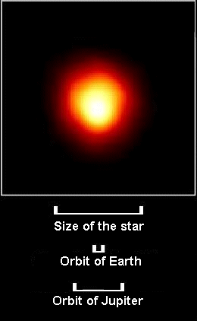

Betelgeuse is larger than the orbit of Jupiter! Clearly Red Giants are no ordinary stars!

Let's use *Stellarium* to take a look at some stars in the sky, and see how many of them are Giants of one sort or another are, and see if that can help us understand these bizarre, aging stars.

**PART A**

First let’s see how many Red Giant stars there are among the bright stars in our average night sky. Start *Stellarium*. Turn off the **Atmosphere** and **Ground** if they are on. **Table 1** is a familiar list of the 25 brightest stars in the sky (including the Sun). For each star, find the star's **Absolute Magnitude** and **Spectral Type** from *Stellarium*. Enter the values in Table 1 for each star. The Sun's Spectral Type is entered for you. After you've filled in the table, plot the stars on the blank H-R Diagram on page 3.

**Table 1**

|  |  |  |  |  |  |  |  |  |  |  |  |  |  |  |  |  |  |  |  |  |  |  |  |  |  |  |  |  |  |  |  |  |  |  |  |  |  |  |  |  |  |  |  |  |  |  |  |  |  |  |  |  |  |  |  |  |  |  |  |  |  |  |  |  |  |  |  |  |  |  |  |  |  |  |  |  |  |  |  |  |  |  |  |  |  |  |  |  |  |  |  |  |  |  |  |  |  |  |  |  |  |  |  |  |  |  |  |  |  |  |  |  |  |  |  |  |  |  |  |  |  |  |  |  |  |  |  |  |  |  |  |  |  |  |  |
| --- | --- | --- | --- | --- | --- | --- | --- | --- | --- | --- | --- | --- | --- | --- | --- | --- | --- | --- | --- | --- | --- | --- | --- | --- | --- | --- | --- | --- | --- | --- | --- | --- | --- | --- | --- | --- | --- | --- | --- | --- | --- | --- | --- | --- | --- | --- | --- | --- | --- | --- | --- | --- | --- | --- | --- | --- | --- | --- | --- | --- | --- | --- | --- | --- | --- | --- | --- | --- | --- | --- | --- | --- | --- | --- | --- | --- | --- | --- | --- | --- | --- | --- | --- | --- | --- | --- | --- | --- | --- | --- | --- | --- | --- | --- | --- | --- | --- | --- | --- | --- | --- | --- | --- | --- | --- | --- | --- | --- | --- | --- | --- | --- | --- | --- | --- | --- | --- | --- | --- | --- | --- | --- | --- | --- | --- | --- | --- | --- | --- | --- | --- | --- | --- | --- | --- |
| |  |  |  |  |  | | --- | --- | --- | --- | --- | | # | Star | Absolute Magnitude | Spectral Type | Luminosity Class | | **1** | The Sun | 4.7 | G2 | V | | **2** | Sirius |  |  | V | | **3** | Canopus |  |  |  | | **4** | Rigil Kent |  |  |  | | **5** | Arcturus |  |  | III | | **6** | Vega |  |  | V | | **7** | Capella |  |  | III | | **8** | Rigel |  |  |  | | **9** | Procyon |  |  | IV | | **10** | Achernar |  |  | V | | **11** | Betelgeuse |  |  |  | | **12** | Hadar |  |  |  | | **13** | Acrux |  |  |  | | **14** | Altair |  |  | IV | | **15** | Aldebaran |  |  |  | | **16** | Antares |  |  | Ia | | **17** | Spica |  |  | V | | **18** | Pollux |  |  | III | | **19** | Fomalhaut |  |  |  | | **20** | Beta Crucis (Mimosa) |  |  |  | | **21** | Deneb |  |  |  | | **22** | Regulus |  |  |  | | **23** | Adhara |  |  |  | | **24** | Castor |  |  | V | | **25** | Gacrux |  |  |  | | **26** | Shaula |  |  | IV | |

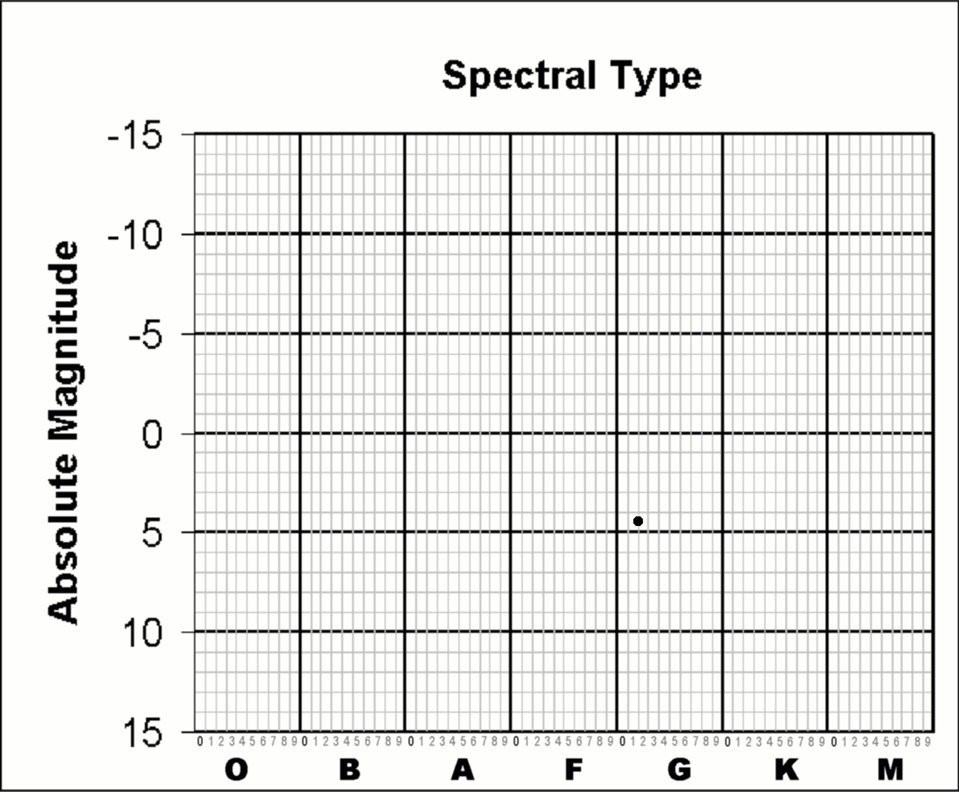

Some of these stars are Main Sequence stars, and some are not. It's not easy to tell which are which. Most blue stars are Main Sequence stars. But whereas some red stars in the list are simply tiny, cool Main Sequence stars, other red stars of the *exact same color* are huge Red Giants! Telling the difference between the Main Sequence red stars and the Red Giant stars involves some complex measurements of the properties of the absorption lines in a star's spectrum. Thankfully, many astronomers have already done these careful measurements for us, and have developed a classification system to distinguish between Main Sequence stars and Giants. This system is called the **Luminosity Class** system. Every star is assigned to a particular Luminosity Class – either **I**, **II**, **III**, **IV** or **V**, with subdivisions within several of the classes (e.g., Ia or Ib, or IIIa or IIIb).

Stars of Luminosity Classes I, II, III, and IV are different kinds of Giants, while Luminosity Class V stars are Main Sequence stars. Stars of Luminosity Class I are the **Super Giants,** Luminosity Class II are the **Bright Giants,** Luminosity Class III are the **Giants**, and Luminosity Class IV are the **Sub-Giants**.

Go back and look at Table 1 above. See the column that says **Luminosity Class**? For each star in Table I that does not have its Luminosity Class listed, search for that star in *Stellarium* and find its Luminosity Class, which is the Roman Numeral listed just AFTER the star's Spectral Class. Fill in the blanks in the Table 1.

* Draw a circle around the Main Sequence on your H-R Diagram (remember, all stars with **Luminosity Class V** are Main Sequence stars).
* How many of the 26 stars in the table are ***off*** the Main Sequence? ____________________
* List them _________________________________________________________________ _________________________________________________________________________ _________________________________________________________________________
* If we assume that all the non-Main Sequence stars are Giants, what fraction of the total stars in the table are Giants? ________________________________________________________
* Which stars in the Table are **Luminosity Class I** or “**Super Giants”**? __________________ __________________________________________________________________________
* On your H-R Diagram, circle and label the area that is occupied by these **Class I** **Super Giant** stars.
* How many stars in the table are **Luminosity Class II “Bright Giants”**? _______________
* Name the stars in the table that are **Luminosity Class III “Red Giants”**? ______________ _________________________________________________________________________
* On your H-R Diagram, circle and label the area that is occupied by the **Class III** **Giant** stars.

**PART B**

Now let's try to understand how stars evolve from one part of the H-R diagram to another as they get older. First, let's assume that the larger and bluer a star is to begin with, the larger a Red Giant it will eventually become. These largest of Giants are the **Type I Super Giants**. Notice that not all of these Giant stars are *red* – some are so hot to begin with that even when they enlarge and cool down, they're still blue!

* If that's the case, which stars in our table were once bright, hot, blue Main Sequence stars? ____________________________________________________________________________________________________________________________________________________
* Which stars in our table will someday *become* Type I Super Giants? _______________ _______________________________________________________________________

Let's also assume that the bigger the Red Giant is, the faster it will die (just as the bigger a Main Sequence star is, the faster it will consume its fuel and *become* a Red Giant).

* If this is the case, which star in our table is closest to its death? ________________________

So large, Type-O or Type-B stars become Type I Blue Giants, and Type A and F stars might become Type II Red Super Giants or Type III Red Giants. Now let's think about our Sun. It's a Type-G star. Where do you think *it* might end up when it runs out of nuclear fuel?

* Which star in our table do you think the Sun will be most like when it gets older? _________
* What property of a star is the only important factor that determines what its fate will be – whether it becomes a Type I Super Giant, a Type II Bright Giant, or a Type III Red Giant? ___________
* In a Red Giant star the core is *hotter* than it was when the star was on the Main Sequence, while its surface is *cooler*! How can this be?
* ____________________________________________________________________________________________________________________________________________________
* In your own words, explain how and why a star becomes a Giant.

________________________________________________________________________________________________________________________________________________________________________________________________________________________________________________

Write a brief conclusion describing what you learned in this exercise

________________________________________________________________________________________________________________________________________________________________________________________________________________________________________________

________________________________________________________________________________________________________________________________________________________________________________________________________________________________________________________________________________________________________________________________