Software Design Description  
*AstroloZ*

Apply UML

Each component and connector in diagram must have name/description

Each diagram must have an ID

Ensure no spelling mistake!

# Summary

This document describes architectural design for AstroloZ via 4+1 View approach

The intended audiences are software development team and deployment team.

## Reference

# Architecture Style Selection

| Selected Architecture Style | Justification of Selection | Affected FRs | Affected NFRs |
| --- | --- | --- | --- |
| Master - Slave | This application is developed to serve some customers in the first moments. However,This app will be upgraded for more customers to have access in the near future . so Master-slave will be applied to this database for future serve. | FR_02, FR_01 | NFR_01 |
| Repository | Use multi database | FR_01, FR_17 | NFR_01 |
| Message Broker | This application will have a lot of customers.So the more customers use this application , the more request the application system receives.That’s why we tend to use this style for decoupling the system into microservices.That helps this system carry a bunch of users’ requests and avoid making system dead because of lots of request. | UC7 | NFR_01, NFR_02 |

# Architectural Design

## Scenario View

| UC ID | Use case | Actors | Pre-condition | Post-condition | Logical Processing |
| --- | --- | --- | --- | --- | --- |
| UC1 | Share information card | Registered User | User must login into the system and have available profile | Success: User will have a card with information to share.  Fail: Show message.   |  | | --- | |  | | 1. Users create an information card. 2. Users share information cards. 3. Other users take information in cards and view. |
| UC2 | Book a meeting with Astrologer | Registered User | User must login in the system | Success:Registered User booked a meeting successfully  Fail:Show error message | 1.Users must login in the application  2.Users click on Astrologer screen  3.Users choose an Astrologer  4.Users click on ‘Book’ button in Astrologer Detail Screen  5.Users fill in their information in booking form  6.Users click on ‘Confirm’ button to book a meeting |
| UC3 | Update work schedule | Astrologer | User must login into the system with role Astrologer. | Success: Astrologer change successfully change schedule.  Fail: Show error when have message error. | 1. Astrologer clicks on “View” button. 2. Astrologer clicks on “Booked Calendar” cell. 3. Astrologer drag and drop Booked Calendar cell to empty Cell. |
| UC14 | Chat | Registered User, Astrologer | User must login into the system | Success: A message will be sent to another user.  Fail: Show error when message not be sent. | 1. Registered User or Astrologer click on another user avatar in the contact list. 2. Registered User or Astrologer type message and click the “Send” button. |
| UC5 | Write blog | Astrologer | User must login into the system with role Astrologer. | Success: Astrologer create successfully blog.  Fail: Show error when have message error. | 1. Astrologer click on “Write blog” button. 2. Astrologer input new blog data and click button “Create” |
| UC6 | Accept customer booking | Astrologer | The Astrologer must login to the system with an account that has the authorized user | Success:Show successfully message  Fail: Show error message. | 1. Astrologer click on “accept” button in the notification panel include:  * Name customer * Work time * Accept button * Cancel button |
| UC7 | Generate NatalChart | Registered User | User must enter user birth place, birth time | Success: Registered User get an natal chart.  Fail: Show an message Error. | 1. User enter user’s birth place and birth time. 2. User click button view Natal Chart. |

## Logical View - Tùng

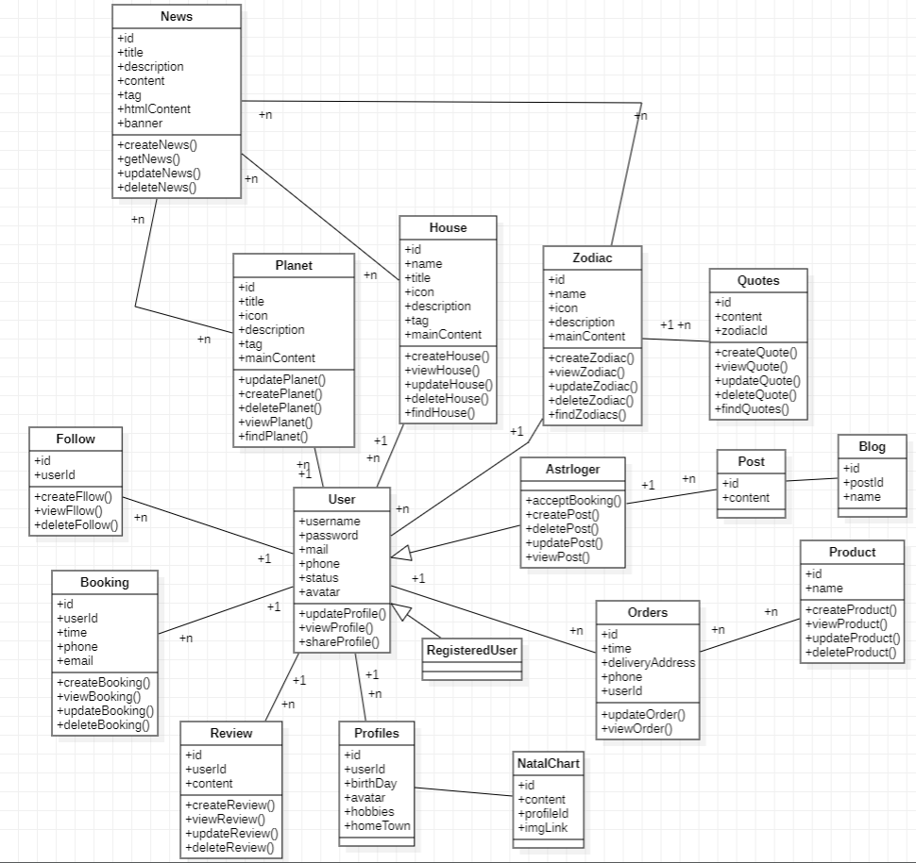

## Process View - Lộc/Vũ

*Generate NatalChart (Master slave, message broker)*

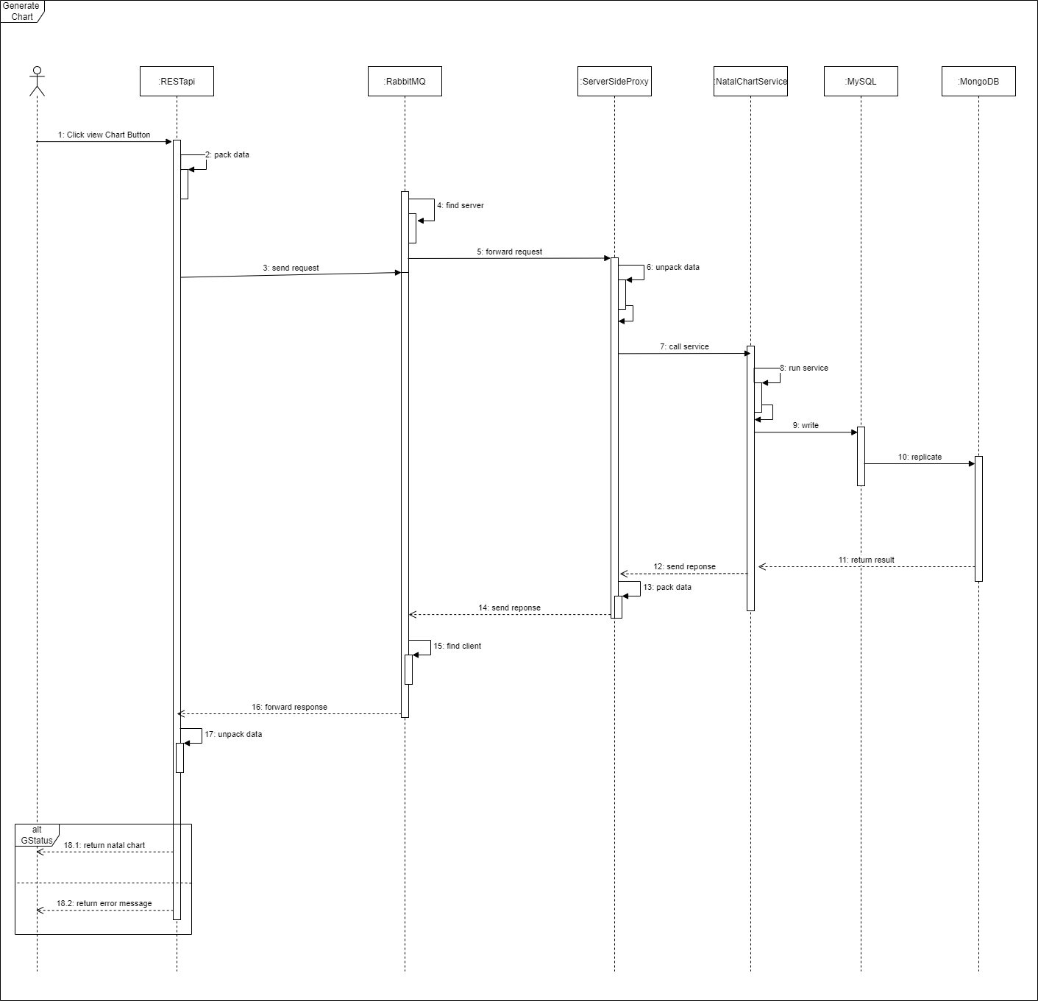

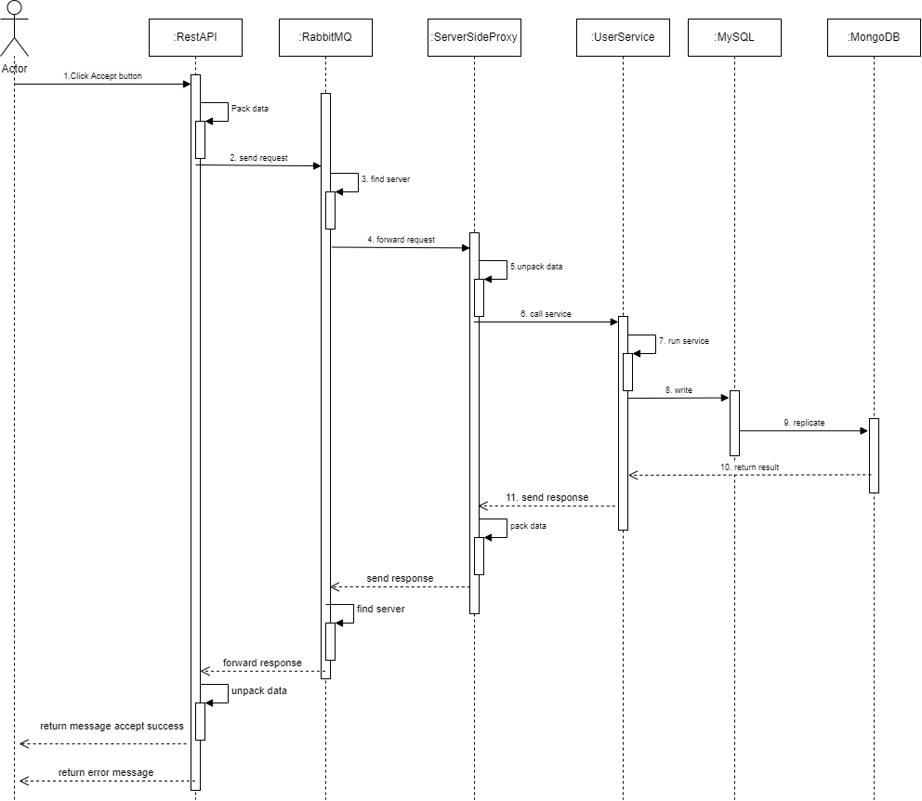

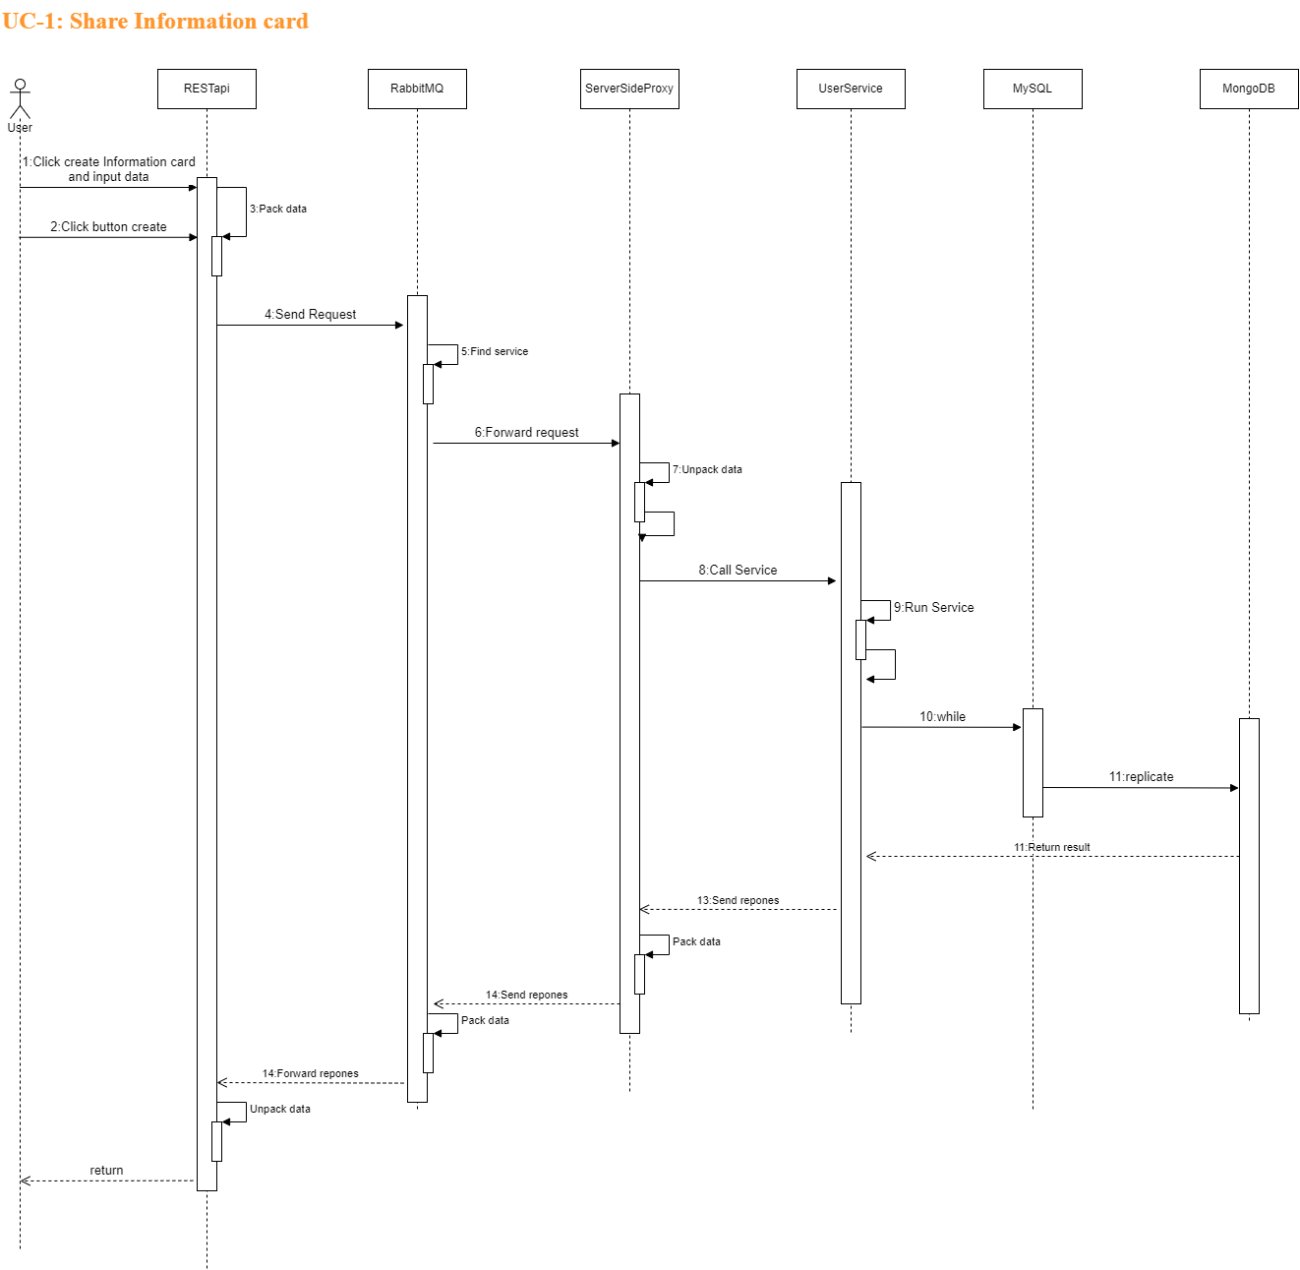

## Development View (optional)

*Component diagrams*

## Physical View - Quy

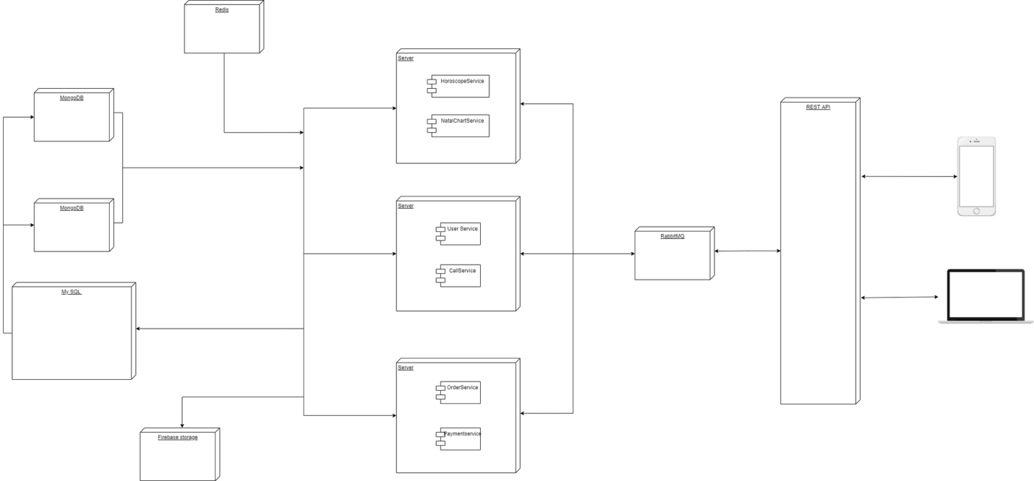

# Design Traceability

| Use case ID | Logical View | Process View | Development View | Physical View |
| --- | --- | --- | --- | --- |
| UC1 | LV2 | PV2 |  |  |
| Uc2 | LV3, 4 | PV1 |  |  |
| UC3 | LV1 | PV3 |  |  |
|  |  |  |  |  |
|  |  |  |  |  |
|  |  |  |  |  |