**I: Introduction**

Over the course of our experiment, fundamental particles are generated as protons collide with one another. We are most interested in measuring the Z0-boson, as it is the neutral carrier of the weak force. However, the Z0 boson is unstable and decays into a pair of charged leptons. Since energy cannot be created or destroyed, these leptons must always have opposite charge. Furthermore, since matter and energy cannot be created or destroyed, we can determine the mass of the Z0 by measuring the total energy stored in the pair of leptons.

The pair of leptons have a few measurable quantities. The transverse momentum *pT,* the total energy *E,* the angle with respect to the beamline η, and the azimuthal angle ϕ. These define the four momentum of the particle:

$$\begin{aligned}p=\left(E, p_{x},p_{y},p_{z}\right)\#1\end{aligned}$$

where px, py, pz are defined as:

$$\begin{aligned}{p_{x}=p}_{T}\cos\left(ϕ\right), p_{y}=p_{T}\sin\left(ϕ\right), p_{z}=p_{T}\sinh\left(η\right)\#2\end{aligned}$$

Since we are looking at a pair of leptons, we must add the four momentum of both particles component-wise. From these, we can define the particles invariant mass as:

$$\begin{aligned}M= \sqrt{E^{2}-\left(p_{x}^{2}+p_{y}^{2}+p_{z}^{2}\right)} \#3\end{aligned}$$

Because of the properties of leptons, measuring the total energy of all double-lepton events result with a peak at the mass of the Z0.

**II: The Invariant Mass Distribution**

For the ATLAS experiment, we took all four measurements as defined above. Then, using equation 2, we transformed those measurements into the four momentum. Using equation three gave us the particle’s invariant mass. From that data, we created a histogram of the invariant masses of all the double-lepton events (Figure 1). We calculated the error on the number of events in each bin as the square root of the number of events in the bin. The range was over 80 to 100 GeV.

The distribution of decays at a reconstructed mass m follows the Breit-Wigner fit, modeled by the following equation, where mo is the mass of the Z0 and Γ is the “width” parameter.

$$\begin{aligned}D=\frac{1}{π}\frac{\frac{Γ}{2}}{{\left(m-m_{0}\right)}^{2}+{\left(Γ/2\right)}^{2}} \#4\end{aligned}$$

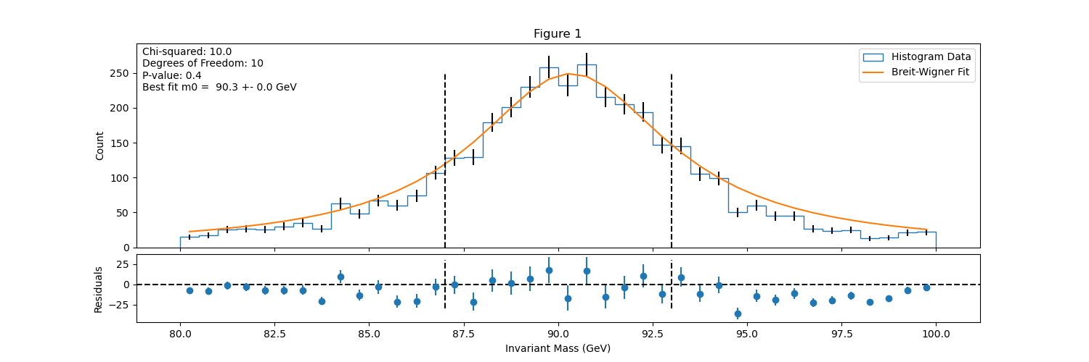 Since we did not have the best-fit width parameter or mass of the Z0, we used a function in python, curve_fit, that completes an least-squares analysis of the data to find the best fit for both free variables. We chose to limit the fitting area from 87 to 91 GeV (shown within the dashed lines). We plotted the model against the data in figure 1, as well as adding the residuals on the bottom panel of the graph.

Curve_fit returned a best-fit value for m0 of 90.34 ± 0.009. Using this, we found a $χ^{2}$ value of 9.985. We determined that there are 10 degrees of freedom in our experiment, as we have twelve bins within the fitting range (twelve comparisons between model and data), and two fitting parameters. Using those values, we found a p-value of 0.441. This p-value indicates good agreement between the model and the data. A p-value of less than 0.05 would indicate the data and model disagree significantly, while a value of over 0.95 would indicate suspiciously good agreement. However, as our value is between the two cutoffs, it indicates that the data and model have good agreement.

**III: The 2D Parameter Scan**

While curve_fit is a useful tool, occasionally it will result in the wrong best fit value. Depending on how the $χ^{2}$ changes in relation to the free variables, the curve_fit can get “stuck” in a local minimum of $χ^{2}$, and stop analyzing, returning the wrong best-fit values. Therefore, it is important to visualize the joint-probability space. To generate the plot, we must evaluate the $χ^{2}$ value at each value of Γ and m0 respectively.

We chose a range of 89 to 91 GeV for m0 and a range of 5 to 8 for Γ. After determining the chi-squared value for all combinations, we subtracted the minimum $χ^{2}$ value in order to find the $Δχ^{2}$. As we don’t need to consider very high ${Δχ}^{2}$ values, we set any values above 35 to 35, as to make the data easier to read. We added two contour lines at $1σ$ and $3σ$ as well.

To evaluate whether the best-fit value curve_fit returned was accurate, we plotted the point of best fit to the contour map. Through this, we see that the curve_fit result was mostly accurate, as it lands within the lowest area of the graph. Therefore, we can conclude the curve_fit did not have any errors and returned the correct best-fit value.

**IV: Discussion and Future Work**

The Particle Data Group published a list of accepted masses for the boson particles. In particular, they found the mass of Z0 to be 91.1880 ± 0.0020 GeV/c2, compared to our experimental value of 90.34 ± 0.009. While this value is in the range of the accepted value, it is not within the range of error.

To improve the accuracy of our value, we must improve the complexity of our calculations. During our calculations, we did not take into account any systematic uncertainties, or the energy resolution of the ATLAS detector. These assumptions could account for the error in our final value. To make our calculations more realistic, we can measure the precision of the ATLAS detector to find a better estimate for the error rate of each measurement. Then, we can use propagation of errors to determine a better uncertainty for the invariant mass. Farther in the future, we can improve the energy resolution of the ATLAS detector, so we can obtain more accurate values.

Milo Rickert