Table of Contents
Paper 1: Time-series Generative Adversarial Network 4
Background 4
Weaknesses of existing models: 4
Strength of proposed TimeGAN: 5
TimeGAN uses: 5
Notation: 5
Problem formulation: 5
• Goals: 5
• Global objective: 5
• Local objective: 5
TimeGAN Model Architecture: 5
• Embedding Function: 6
• Recovery Function: 6
• Sequence Generator: 6
• Sequence Discriminator: 7
TimeGAN Loss Functions: 7
• Reconstruction loss 7
• Unsupervised loss 7
• Supervised loss 7
• Optimization 8
Paper 2: Anomaly Detection in Time Series – Comprehensive Evaluation 9
Background 9
Anomaly detection definitions: 9
Anomaly detection techniques 10
1. Forecasting Methods 11
2. Reconstruction Methods 11
3. Encoding methods 12
4. Distance Methods 12
5. Distribution Methods 12
6. Isolation Tree Methods 12
Discussion 12
Paper 3: Using GANs for Sharing Networked Time Series Data 13
Background 13
Challenges of Existing GAN Implementation 13
Novel Contributions 13
Use Cases & Scope 14
Data Abstraction Notation 14
Problem Formulation 15
SOTA GAN Review 15
DopperlGANger Design 16
Capturing long-term effects 16
Tackling mode collapse 16
Capturing attribute relationships 16
Putting it all together 17
Paper 4: GAN-based Synthetic Radar Micro-Doppler Augmentations for Improved Human Activity Recognition 18
Background 18
ACGAN Design 18
Evaluation Metrics 19
Recent Metrics 19
Wasserstein Distance 19
Kolmogorov-Smirnov (KS) Test 19
Time Series Similarity Metrics 19
Conventional Metrics 19
Frechet Inception Distance (FID) 19
Inception Score (IS) 19
Maximum Mean Discrepancy (MMD) 19
Autoencoder Reconstruction Error 19
Root Mean Square Error (RMSE) 20
Mean Absolute Percentage Error (MAPE) 20
Predictive Model Performance 20
Visual Inspection 20
Paper 5: Generating Real-valued Failure Data for Prognostics Under the Conditions of Limited Data Availability 21
Background 21
t-SNE Evaluation Metrics 22

Paper 1: Time-series Generative Adversarial Network
Paper Link:
- https://proceedings.neurips.cc/paper_files/paper/2019/file/c9efe5f26cd17ba6216bbe2a7d26d490-Paper.pdf
Code Link:
- https://github.com/jsyoon0823/TimeGAN/blob/master/tutorial_timegan.ipynb

Background
Good generative model needs to capture temporal structure of the time-series data. Difficulty in generative model time series is that the model does not only need to capture the distributions of features within each time point, they also need to capture complex dynamics of said variables across time.
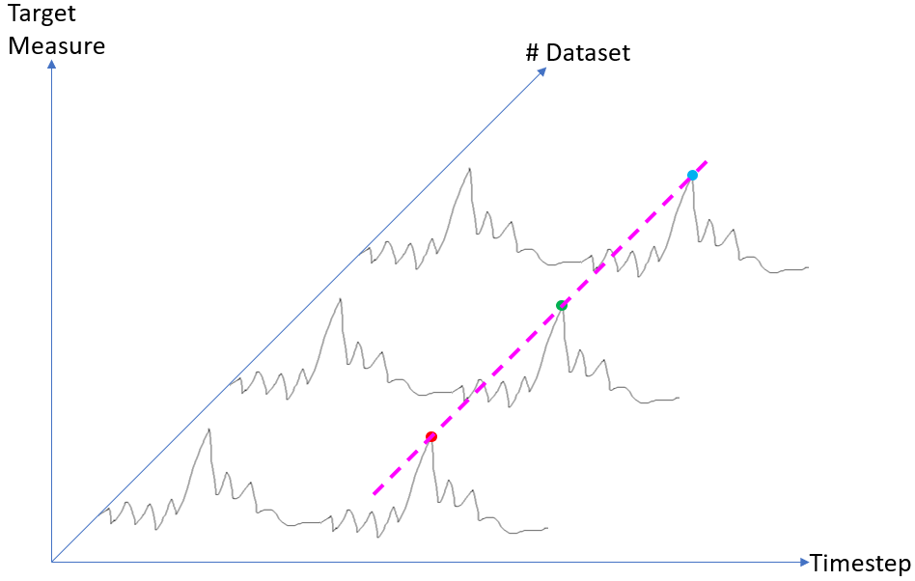

Weaknesses of existing models:
- GAN: Temporal structure is not preserved
- Supervised: Network dynamics are inherently deterministic as they do not accommodate explicitly sampling from a learned distribution, but only focusing on stepwise transition dynamics
Existing supervised model is called autoregressive model that that factor distribution of sequences into a product of conditional data probability at next timestep t given historical data of timestep 1 until timestep t-1. This is useful for forecasting data for next timesteps, but it’s fundamentally deterministic. The generative model we desire is the ability to sample new sequences randomly without external conditioning. This model also suffers large prediction errors when performing multi-step sampling due to discrepancy between closed-loop training (conditioned on ground truth) and open-loop inference (conditioned on previous guesses).
Existing GAN framework employs LSTM networks for generator and discriminator where data is generated recurrently by taking inputs such as noise vector & data generated from previous timestep. Some other works add additional conditioning on previously generated data. However, all these existing GAN frameworks rely only on the binary adversarial feedback for learning (i.e. fake or ground-truth data) which may not be sufficient to capture temporal dynamics in the training data.

Strength of proposed TimeGAN:
- Combines flexibility from unsupervised paradigm & control from supervised training
- Outperforms SOTA benchmark with respect to similarity & predictive ability
- Two-fold novelties: supervised loss to better capture temporal dynamic + embedding network to provide lower-dimensional adversarial learning space.

TimeGAN uses:
- Unsupervised adversarial loss from GAN framework for sequence generation based on both real and synthetic sequences
- Supervised stepwise loss using original data as supervision to encourage the model to capture stepwise conditional distribution in the data. We can also learn the transition dynamics. This basically introduces control as that provided in autoregressive models for sequence prediction.
- Embedding network that maps between features and latent time-series learning representations to reduce high-dimension of adversarial learning space.
- Joint training between embedding network and generator network so that latent space promotes parameter efficiency & learns temporal relationships.

Notation:
- S: vector space of static features; S: random vector element S, s: Specific static feature value of S
- X: vector space of temporal features, X: random vector element X, x: Specific temporal feature value
- T: Sequence length is a random variable
- Data tuple $\left(S, X_{1:T}\right)$ with some joint distribution p.
- N: Dataset size
- Dataset D = ${\left\{\left(s_{n},x_{n,1:T_{n}}\right)\right\}}_{n=1}^{N}$

Problem formulation:

Goals:
  - Initial goal: Use training dataset D to learn density $\hat{p}\left(S, X_{1:T}\right)$ that best approximates $p\left(S, X_{1:T}\right)$
  - Simplification using autoregressive decomposition: $p\left(S, X_{1:T}\right)=p(S)\prod_{t}{p\left(X_{t}|S, X_{1:t-1}\right)}$
  - Updated goal: Use training dataset D to learn density $\hat{p}\left(X_{t}|S, X_{1:t-1}\right)$ that best approximates $p\left(X_{t}|S, X_{1:t-1}\right)$

Global objective:
  - $\min_{\hat{p}}{JSD\left(p\left(S, X_{1:T}\right)||\hat{p}\left(S, X_{1:T}\right)\right)}$
  - This minimization relies on perfect adversary (not always present)

Local objective:
  - $\min_{\hat{p}}{KLD\left(p\left(X_{t}|S, X_{1:t-1}\right)||\hat{p}\left(X_{t}|S, X_{1:t-1}\right)\right)}$
  - This minimization only relies on ground-truth sequences (always present)

TimeGAN Model Architecture:
- Main components: embedding function, recovery function, sequence generator, sequence discriminator.

Embedding Function:
  - Maps static (s) and temporal ($x_{1:T}$) features to latent static ($h_{\underline{S}}$) and latent temporal ($h_{\underline{X}}$) codes using temporal convolution
  - $e:\underline{S} × \prod_{t}{\underline{X}}→{\underline{H}}_{\underline{S}}×\prod_{t}{{\underline{H}}_{\underline{X}}}$ Transformation of static and temporal spaces to latent static and temporal spaces.
  - $h_{\underline{S}},h_{1:T}=e\left(s,x_{1:T}\right)$
  - $\left[embedding network\right] h_{\underline{S}}=e_{\underline{S}}\left(s\right)$
  - ${\left[recurrent embedding network\right] h}_{t}=e_{\underline{X}}\left(h_{\underline{S}},h_{t-1},x_{t}\right)$
  - $e_{\underline{S}}:\underline{S}→{\underline{H}}_{\underline{S}} ;e_{\underline{X}}:{\underline{H}}_{\underline{S}}×{\underline{H}}_{\underline{X}}×\underline{X}$

Recovery Function:
  - Maps latent static and latent temporal codes to static and temporal features using attention-based transformer
  - $r:\underline{{\underline{H}}_{\underline{S}}×\prod_{t}{{\underline{H}}_{\underline{X}}}→\underline{S}} × \prod_{t}{\underline{X}}$ Transformation of latent static and temporal spaces to static and temporal spaces.
  - $\tilde{s},{\tilde{x}}_{1:T}=r\left(h_{\underline{S}},h_{1:T}\right)$
  - $\left[recovery network for static embedding\right] \tilde{s}=r_{\underline{S}}\left(h_{\underline{S}}\right)$
  - ${\left[recovery network for temporal embedding\right] \tilde{x}}_{t}=r_{\underline{X}}\left(h_{t}\right)$
  - $r_{\underline{S}}:{\underline{H}}_{\underline{S}}→\underline{S} ;r_{\underline{X}}:→\underline{X}$

Sequence Generator:
  - Generator generates output into embedding space, not directly into feature space. This is the difference with vanilla GAN. The generator function g is implemented using RNN.
  - Generator operates in embedding space
    - 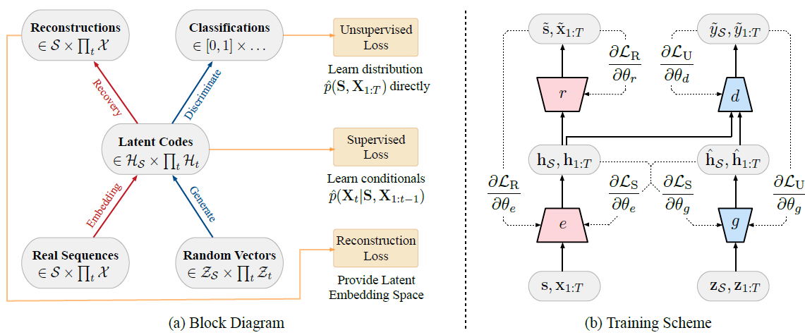
  - 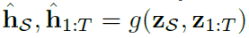
  - 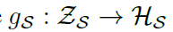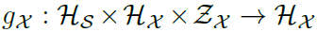

Sequence Discriminator:
  - Discriminator receives static and temporal codes from synthetic and real sequence and returns binary classification (0/1). The discriminator function d is implemented using bidirectional RNN with a feedforward output layer.
  - 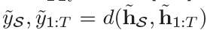
  - 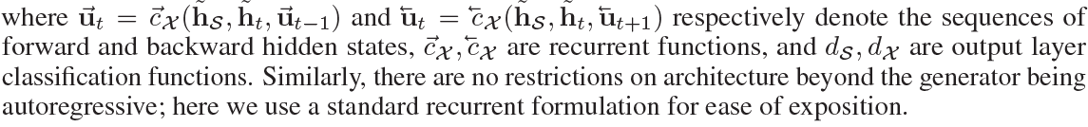

TimeGAN Loss Functions:
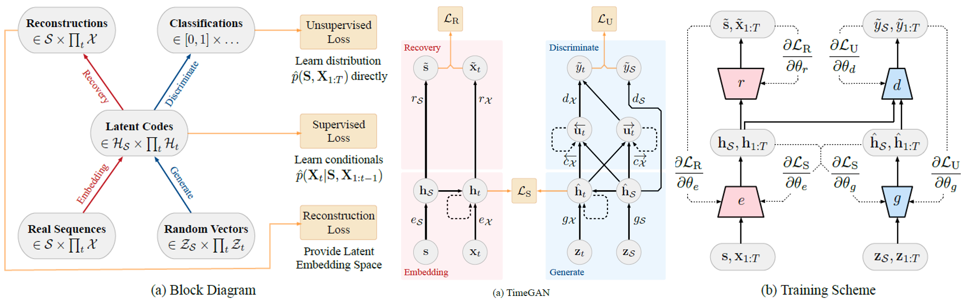

Reconstruction loss
  - Reconstruction loss ensure accurate reversible mapping between feature & latent spaces

Unsupervised loss
  - Generator g receives 2 types of inputs which are static & temporal random vectors $z_{\underline{S}},z_{1:T}$ from Gaussian distribution, and previous synthetic embeddings ${\hat{h}}_{\underline{S}},{\hat{h}}_{1:t-1}$ from autoregressive open loop to generate next synthetic embeddings ${\hat{h}}_{\underline{S}},{\hat{h}}_{1:t}$.
  - Maximize discriminator, minimize generator
  - Unsupervised loss forces the generator g to create realistic sequences

Supervised loss
  - Unsupervised adversarial loss alone is insufficient to train generator g to capture stepwise conditional distribution in the data.
  - In alternating training fashion against open-loop autoregressive in unsupervised loss, generator is trained in close-loop fashion where it receives ground-truth latent static and temporal codes and random temporal vector $h_{\underline{S}},h_{t-1},z_{t}$ to generate next synthetic latent temporal code ${\hat{h}}_{t}$. Discrepancy between $h_{t}$ and ${\hat{h}}_{t}$ is the supervised loss.
  - Supervised loss forces further ensures generator g to produce similar stepwise transitions.

Optimization
  - Hyperparameters for embedding & recovery functions are trained on both reconstruction loss & supervised loss
    - 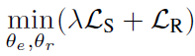
  - Hyperparameters for generator & discriminator networks are trained adversarially
    - 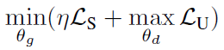

Paper 2: Anomaly Detection in Time Series – Comprehensive Evaluation
Paper Link:
- http://vldb.org/pvldb/vol15/p1779-wenig.pdf
Code Link:
- https://hpi-information-systems.github.io/timeeval-evaluation-paper/

Background
Time-series data is an ordered sequence of data points whose order is based on time. Regardless of the ordering measure, the recording of the data points usually follows discrete, equally-spaced intervals. The data points of a time-series record are 1 or multiple real-valued variables. Each variable models 1 channel of the time-series. If the data points consist of only 1 variable, the time series is called univariate (e.g. ECG); otherwise, it is multivariate (e.g. multivariate time-series with random mode-jumps).
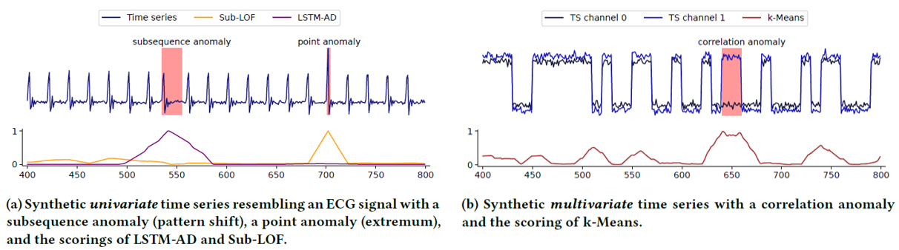
Anomaly in time-series can be a point (i.e. outlier) or point sequence (i.e. irregularity) that deviates from regular patterns. In multivariate time-series, the anomaly can occur in any single channel or also in the correlation of channels. Such anomalous subsequences can describe hearth failures in cardiology, structural defects in jet turbine, etc.
This paper gathers 158 publications about anomaly detection algorithms for time-series datasets ranging from simple outlier detection over statistical analysis, signal processing, and data mining to deep learning approaches. This paper aims to provide comprehensive evaluation on most SOTA anomaly detection algorithms (71 algorithms & 976 uni- and multivariate time-series datasets).

Anomaly detection definitions:
- Time-series anomaly is a sequence of data points (i.e. subsequence) that deviates from model, characteristic embedding, and/or similarity measure from frequent patterns. Related analytics tasks to anomaly detection is time-series forecasting & classification.
  - Forecasting: To predict future progression of a time-series.
  - Classification: To assign entire time-series to certain classes which is often used as a post-processing step to classify detected anomalies into domain-specific classes.
- Since this paper aims to evaluate various algorithms’ accuracy, the result needs to be transformed into a uniform output format which in this case is called point-wise scoring. An anomaly score is assign to each time-series data point in time domain. The higher the value, the more anomalous the time-series data point is. There are 3 threshold-agnostic AUC measure used to evaluate the scoring:
  - AUC-ROC: Area under Curve Receiver Operating Characteristics
    - This uses the false-positive-rate (FPR) instead of precision
    - This rewards sensitive algorithm
  - AUC-PR: Area under Curve Precision-Recall
    - This contrasts the precision to the recall score
    - This rewards precise algorithm
  - AUC-PTRT: Area under Curve range-based Precision, range-based Recall
    - This simply calculates are under the curve for these 2 metrics
    - This softens the very strict preciseness requirements
  - Some common AUC metrics:
    - Precision = TP / (TP+FP)
    - Sensitivity/TPR/Recall = TP/(TP+FN) = TP / ActualPositive
    - FNR = FN/(TP+FN) = FN / ActualPositive
    - Specificity /TNR = TN/(TN+FP) = TN / ActualNegative
    - FPR = FP/(TN+FP) = FP / ActualNegative
    - 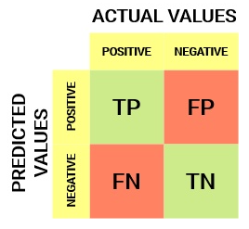
Anomaly detection techniques:
From 158 publications, this paper categorizes the anomaly detection algorithms to several method families, namely, Deep Learning, Stochastic Learning, Classic Machine Learning, Outlier Detection, Statistics (Regression & Forecasting), Data Mining, and Signal Analysis. 71 representative algorithms were chosen as shown below.
In the table below, input dimensionality describes whether the algorithm can use inter-variable dependencies and correlations (i.e. multivariate) or not (i.e. univariate). For learning type, we have unsupervised, supervised, and semi-supervised.
- Unsupervised learning requires no prior knowledge (i.e. prior training) as the algorithm can separate normal and anomalous subsequences based on less frequency, different shape, different distribution.
- Supervised learning can model the normal and anomalous subsequences on unseen time-series data based on prior explicit training step. Each time-series training data point is marked 0 or 1 for anomaly indication. This learning type is restricted to detect unseen anomalies, therefore they are rarely used.
- Semi-supervised learning is trained with normal time-series subsequences. When applied to unseen time-series dataset, all subsequences that do not conform to normal behavior are marked as anomalous.
In addition to input dimensionality & learning type, anomaly detection algorithms are also categorized under different method families, namely, forecasting, reconstruction, encoding, distance, distribution, and isolation tree methods.
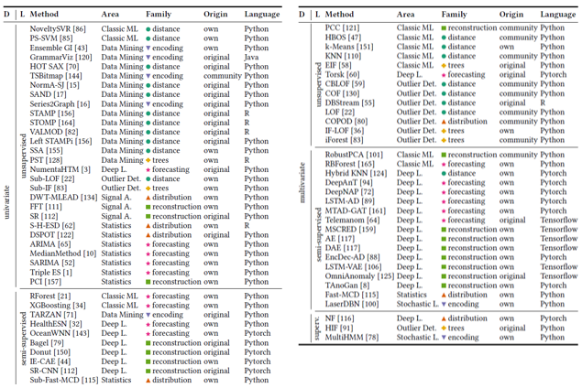

Forecasting Methods
  - This method continuously uses a learned model to forecast a number of time steps based on a current context window. The forecasted points are then compared to the observed values in the original time-series dataset to determine how anomalous the observed values are.
  - This method is trained in a semi-supervised way where time-series datasets without anomalies is used to learn the normal model of the data.
  - Example: AD-LTI, ARIMA, DeepAnT, DeepNAP, HealthESN, LSTM-AD, MedianMethod, MTAD-GAT, NumentaHTM, NoveltySVR, OceanWNN, RBForest, RForest, SARIMA, Telemanom, Torsk, TripleES, XGBoosting.

Reconstruction Methods
  - This method builds a model by encoding normal subsequences into latent space. To detect anomalies in test time-series subsequences, these observed subsequences are reconstructed from latent space. Since the earlier model is trained with normal subsequences alone, the latent space of test subsequences will lose information of the anomalies. Hence, anomalies can be detected by calculating the difference between reconstructed test subsequences and actual test subsequences.
  - Example: AE, Bagel, DAI, Donut, EncDec-AD, FFT, IE-CAE, LSTM-VAE, MSCRED, OmniAnomaly, PCI, PCC, RobustPCA, SR, SR-CNN, TAnoGAN

Encoding methods
  - This method is similar to reconstruction method where normal subsequences are encoded to latent space. However, to detect anomalies in test subsequences, it directly computes the anomaly score from latent space representation.
  - Example: EnsembleGI, GrammarViz, LaserDBN, MultiHMM, PST, Series2Graph, TARZAN, TSBitmap.

Distance Methods
  - This method predominantly belongs to unsupervised learning type where there is no training involved but distance calculation to compare points or subsequences. Anomalous subsequences will have larger distance from normal subsequences.
  - Distance calculation may take all other subsequences, only some nearest neighbors, or certain cluster centroids as distance reference points.
  - Cluster-based distance methods cluster similar subsequences together and compute the distances to dense area.
  - Example: CBLOF, COF, DBStream, HOT SAX, HybridKNN, k-Means, KNN, LOF, NormA-SJ, PS-SVM, SAND, SSA, STAMP, STOMP, Sub-LOF, VALMOD, LeftSTAMPi.

Distribution Methods
  - This method predominantly belongs to unsupervised learning type where distribution of the data is calculated over data points or subsequences. Anomaly scores are measures using probabilities, likelihoods, or distances of the points or subsequences from prior calculated distributions.
  - For supervised learning type, this method estimates the distribution of training time-series that contains only normal behavior. Then, the points or subsequences of test time-series are checked against previously learned distribution.
  - Example: COPOD, DWT-MLEAD, Fast-MCD, HBOS, NF, S-H-ESD, DSPOT, Sub-Fast-MCD.

Isolation Tree Methods
  - This method build an ensemble of random trees that partition the samples (points or subsequences) of the test time series. During tree construction, random feature with random values are chosen as tree nodes to eventually isolate the samples in tree leaves.
  - To detect anomaly, the method will focus on random trees with shorter depth since anomalous samples are easier to separate than normal samples, therefore making them closer to the tree roots.
  - Example: EIF, HIF, IF-LOF, iForest, Sub-IF

Discussion
Despite higher processing effort on training data, deep learning approaches are not yet competitive. There is no single algorithm that clearly performs best.
- Flexibility: No algorithm clearly dominates & solves all anomaly detection setups.
- Reliability: Only very few algorithms can process all time series without errors & within common time & memory limits
- Simplicity: Most anomaly detection algorithms are very sensitive to parameter settings (>7). This issue is exacerbated by the absence of training data for algorithm configurations.

Paper 3: Using GANs for Sharing Networked Time Series Data
Paper Link: https://arxiv.org/abs/1909.13403
Code Link: https://github.com/fjxmlzn/DoppelGANger

Background
There is limited data access which becomes barrier in networking & system R&D. Reason being is because collaborating stakeholders are likely to be reluctant to share datasets to protect business secret and user privacy.
It would be good if data holders can utilize some models to create and share synthetic dataset modeled from real traces, thus promoting data access/sharing.
Aim: To create a high-fidelity generative model that requires little-to-no human expertise
Why GANs?
- It offers ability to learn high-fidelity representation of high-dimensionality relationships in dataset.
- It allows users to flexibly tune the generation process of synthetic datasets.

Challenges of Existing GAN Implementation
- Fidelity
  - Complex correlation between measurements & the associated metadata due to high data dimensionality.
  - Mode collapse that reduces distribution modes of data samples.
  - Long-term dependency to day-to-day variation of time-series dataset.
- Privacy
  - There is no clear study to understand to what degree can GANs “memorize” real data
  - With varying degree of severity, this can dangerously reveal proprietary information or reveal user identity.

Novel Contributions
- Workflow called DoppelGANger (DG) that generates domain-specific insights & solves fidelity challenges
  - To solve correlation between measurements & metadata, metadata is decoupled from time-series => metadata are fed to time-series generator for each t => auxiliary discriminator to assist in metadata generation
  - To solve mode collapse, generator generates randomized max-min limits & normalized time-series that can be rescaled back to realistic range.
  - To solve long-term dependency, DG generates batched samples instead of singletons.
- Exploration of privacy trade-offs remains an open challenge.
  - Membership inference attacks are mitigated with training on larger datasets
  - Decoupling of generator network enables data holders to hide certain metadata
- 43% test accuracy improvement against SOTA GANs upon benchmarking with diverse

Use Cases & Scope
Data sharing scenarios in this paper:
- Collaboration across stakeholders:
  - A scenario where enterprises impose restriction between internal employee and external vendors due to privacy concerns
- Reproducible open research:
  - A scenario where it’s hard to replicate test result due to lack of data sharing transparency to research community.
Use cases considered in this paper:
- Structural characterization:
  - Generated data should preserve temporal & geographic trend & distribution so as to help system designers to reveal structural insights.
- Predictive modeling:
  - Generated data should have high fidelity in such a way that predictor trained on generated data can make meaningful prediction on real data.
- Algorithm evaluation:
  - Generated data should hold the same property as original data in such a way that algorithm A performs better than algorithm B on real data, then the same thing must happen on generated data.
Scope of this paper:
- Dataset of interest is multi-dimensional time-series datasets in networking & system fields.
- Example:
  - Prediction & recommendation:
    - Web traffic traces of webpage views with metadata such as URLs.
  - Network management:
    - Network measurement of packet loss rate, bandwidth, delay with metadata such as location & device type.
  - Resource allocation & scheduling:
    - Cluster usage measurements of CPU/memory usage with metadata such as server & job type.

Data Abstraction Notation
Dataset D, client sample O, metadata A, time-series of record R, timestamp t, measurement f.
$$D=\left\{O^{i}\right\}=\left\{O^{1}, O^{2},…, O^{n}\right\}$$
$O^{i}=\left(A^{i}, R^{i}\right)$ where $A^{i}=\left\{A_{j}^{i}\right\}=\{A_{1}^{i}, A_{2}^{i}, …, A_{m}^{i}\}$, and $R^{i}=\left\{R_{j}^{i}\right\}=\{R_{1}^{i}, R_{2}^{i}, …, R_{T^{i}}^{i}\}$
$R_{j}^{i}=(t_{j}^{i},f_{j}^{i})$ where $f_{j}^{i}=\left\{f_{j,k}^{i}\right\}=\left\{f_{j,1}^{i}, f_{j,2}^{i}, …, f_{j,K}^{i}\right\}$
# of clients n, # of metadata m, # of timestamps for i-th client $T^{i}$, # of measurements per timestamp K.
k={1, 2, …, K} here represents ping loss rate & traffic byte counter at this timestamp.

Problem Formulation
To generate a new dataset D’ as output that should exhibit fidelity & general enough methodology to handle dataset in aforesaid abstraction.

SOTA GAN Review
GAN aims to use dataset $O_{1}, O_{2}, …, O_{n} (O_{i}∈R^{p})$ to learn a model that can draw samples in i.i.d. manner from distribution $P_{O}$. Generator maps a noise vector $z∈R^{d}$ (which is drawn from Gaussian or Uniform distribution $P_{z}$) to a sample $O∈R^{p}$ where p>>d. Adversarial loss function is:
$$\min_{G}{\max_{D}{E_{o\sim p_{o}}\left[log⁡D(o)\right]+E_{z\sim p_{z}}\left[log⁡(1-D(G(z)))\right]}}$$
Benefit of GAN model:
- GAN can be general across datasets as D can universally judge the fidelity of generated samples based on GT samples.
- GAN can generate measurements f and metadata m. This can be used for cross-correlation between measurements and metadata.
- GAN has is used in multi-domain research for generating realistic high-fidelity datasets for complex tasks (e.g. music, images, text).
In order to generate time-series data, GAN will take prior measurements (real or generated) & noise as input and generate 1 measurement at a time. This changes GAN architecture and/or training.
- RCGAN:
  - RNN is used to generate time series conditioned by metadata
  - (-) Cannot generate metadata itself.
- TimeGAN:
  - RNN is used to generate & discriminate. Additional NN (i.e. embedding network) is trained to map time series to vector embeddings. Generator generates embeddings instead of samples.
  - (-) TimeGAN use small partition of time-series data during generation that does not work with long time scales in network & system design field
  - (-) Even with smaller time-series data partition, the temporal correlation is still poor as tested with Wikipedia web traffic open-source dataset.
Challenges from SOTA GAN models:
  - (-) Poor fidelity on generated samples in network & system design field.
  - (-) Mode collapse detected due to high variability nature of measurements in network & system design dataset.
  - (-) Cannot capture complex relationship between metadata and measurement in network & system design (e.g. ISP & packet loss rate)
  - (-) Do not take into account privacy notions like differential privacy (i.e. how much does any single data point contribute to a model), & membership inference attack.

DopperlGANger Design

Capturing long-term effects
An RNN variant called LSTM is used to model time-series. Instead of generating all the sequences at once, RNN generate 1 record $R_{j}^{i}$ for $T^{i}$ passes to generate the entire time series. RNN can learn correlation across dimensions and output multi-dimensional outputs as RNN implicitly encodes all past states of the signals $R_{1}^{i}, …, R_{j-1}^{i}$ to generate $R_{j}^{i}$. However, given the fact that characteristics of network & system design time series are to be learnt over long time scales, this makes RNN generators struggle to capture temporal correlations due to too many passes in long time series, thus making RNN tends to forget the temporal correlation.
The proposed idea is to use batch generation where S consecutive records are generated at a time instead of only 1 record. This reduces the number of passes by factor of S. However, since this method ignores the timestamps from generation, we can only use this method if raw timestamps are not important (i.e. each point is equally spaced). The alternative way is to make inter-arrival times (w.r.t timestamp of 1st measurement) as an additional measurement f.

Tackling mode collapse
Mode collapse is indicated by homogenous generated samples despite being trained on a diverse dataset. Generated samples which are mode-collapsed exhibit similar amplitudes, offsets, and shapes. Unlike images or medical data, network & system design data have higher range of variability which makes them harder to be learnt by the model. So, mode collapse is more prominent in such high-variability data.
Typical normalization is to normalize each measurement signal $f^{i}$ based on entire dataset, but this is just shifting and scaling the signals by a constant. Mode collapse still occurs.
The proposed idea is to develop a custom auto-normalization heuristic where each measurement $f^{i}$ is normalized individually. Further, the max/min range of $f^{i}$ are stored as a “fake” metadata. This way, GAN learns to generate fake measurement signals which can then be rescaled back based on stored max/min.

Capturing attribute relationships
It is clear that metadata influence the characteristics of measurements (e.g. optical fiber provides lower network latency as compared to copper wire). However, naively generating concatenated metadata $A^{i}$ and measurements $R^{i}$ does not learn the correlations between them well. The hypothesis is that jointly generating metadata & measurements using a single generator is too difficult.
The 1st proposed idea is problem decoupling into 2 sub tasks, namely, generating metadata & generating measurements conditioned on metadata: $P\left(A^{i},R^{i}\right)=P\left(A^{i}\right)P(R^{i}|A^{i})$.
- Generation of metadata:
  - Metadata generation uses MLP-based generator
  - First, generate “real” metadata using the MLP generator.
  - Second, generate “fake” (max/min) metadata using another MLP with generated metadata as input.
- Generation of measurements:
  - Measurement generator uses RNN-based generator, conditioned on generated metadata
  - Third, generate measurements using generated “real” and “fake” metadata as inputs
The 2nd proposed idea is to introduce auxiliary discriminator that discriminates only on metadata. The motivation is that generator decoupling is not enough to give good fidelity score. The reason is because discriminator’s input is fed into generator training but discriminator cannot effectively judge sample (measurement + metadata) with large dimension.
- Auxiliary discriminator helps generator to generate high-fidelity metadata
- Original discriminator helps generator to generate measurement
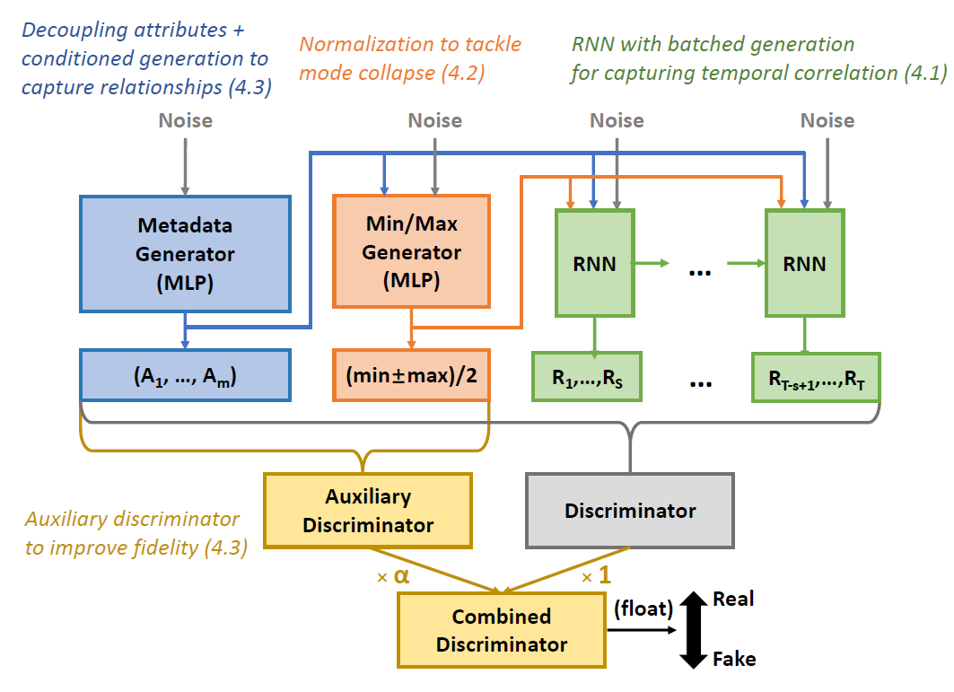

Putting it all together
To capture temporal correlation & generate long time-series:
- Use batched generation via RNN-based generator
To address mode collapse:
- Add “fake” metadata that captures the min/max values of each generated samples.
To capture correlations between metadata & measurement:
- Decouple generation of metadata & measurement, & conditioning the measurement based on generated metadata.

Paper 4: GAN-based Synthetic Radar Micro-Doppler Augmentations for Improved Human Activity Recognition
Paper Link:
- https://ieeexplore.ieee.org/stamp/stamp.jsp?tp=&arnumber=8835589

Background
This paper aims to improve research work using DCNN for radar-based human activity recognition application by solving dataset availability limitation through utilization of GAN to generate synthetic radar time-frequency domain signatures on different operational environment.
Authors proposed ACGAN (Auxiliary Classifier GAN) model that is conditioned by external class labels to generate large amount of realistic human time-frequency signatures that include environmental effects (e.g. clutter due to through-the-wall scattering)

ACGAN Design
The generator network in ACGAN is conditioned on external information (e.g. class labels). This is good as we don’t need to train N separate models which have high potential of overfitting due to small available training data, & high computational power. The descriptor network is modified to contain auxiliary decoder network that outputs the class labels for the training data.
The loss function contains of 2 parts, namely, log likelihood of correct source Ls and log likelihood of correct class Ly. Generated images are denoted by s. Discriminator is trained to maximize Ls+Ly, while generator is trained to minimized Ly-Ls
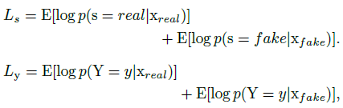
Generator:
- Input = 100x1 random numbers are drawn from uniform distribution + class labels
- Output = 64x64x1 image
- MLP with 4x4x128 layer with each layer containing 4 3x3x128 convolution filters + BN layer + 2x2 up-sampling.
- Dropout rate = 0.15 for each hidden layer
- Hidden layers use ReLU activation function, while output layer uses tanh activation function.
Discriminator:
- Base design is VGG16
- Dropout rate = 0.15 for every even hidden layer
- Hidden layers use LeakyReLU activation function, wihle output layer uses sigmoid activation function

Evaluation Metrics
Time Series Generative Adversarial Network (GAN) models are often used to generate synthetic time series data that resembles real-world time series. Evaluating the performance of these models is crucial to ensure the quality of the generated data. Here is a list of performance metrics commonly used to evaluate Time Series GAN models:

Recent Metrics

Wasserstein Distance
- Measures the minimum “cost” required to transform 1 distribution into another to quantify the dissimilarity between 2 probability distributions.

Kolmogorov-Smirnov (KS) Test
- The KS test compares the cumulative distribution functions of real and generated time series. It quantifies the maximum vertical distance between the two distributions, providing an idea of how well the generator captures the distribution of the real data.

Time Series Similarity Metrics
- Dynamic Time Warping (DTW) distance, Pearson correlation coefficient (i.e. autocorrelation), and cosine similarity are examples of metrics that quantify the similarity between the shapes and patterns of real and generated time series.

Conventional Metrics

Frechet Inception Distance (FID)
- Originally designed for image data, FID measures the similarity between the statistics of real and generated time series data. It utilizes an Inception-v3 network to extract features and then computes the Fréchet distance between the feature distributions of real and generated data.

Inception Score (IS)
- Similar to FID, the Inception Score also employs the Inception-v3 network to evaluate the quality and diversity of generated time series. It measures the balance between the generated samples' quality and their diversity.

Maximum Mean Discrepancy (MMD)
- MMD measures the difference between the distributions of real and generated data in a reproducing kernel Hilbert space. It's commonly used to evaluate the discrepancy between two sets of samples.

Autoencoder Reconstruction Error
- If you have access to a well-trained autoencoder model that can reconstruct the original time series, you can measure the error between the real data and the data reconstructed from the generated samples.

Root Mean Square Error (RMSE)
- This metric calculates the root mean square difference between the values of real and generated time series. It provides a measure of how well the generator replicates the patterns and magnitudes of the real data.

Mean Absolute Percentage Error (MAPE)
- MAPE computes the percentage difference between the real and generated time series values, providing insight into the accuracy of the generated data.

Predictive Model Performance
- Train predictive models (e.g., ARIMA, LSTM) on real data and evaluate their performance on generated data. If the generated data is of high quality, the predictive model's performance should be similar for both real and generated data.

Visual Inspection
- While not a quantitative metric, visually inspecting the generated time series compared to real data can provide valuable insights into the model's performance, especially in capturing important features and trends.

Paper 5: Generating Real-valued Failure Data for Prognostics Under the Conditions of Limited Data Availability
Paper Link:
- https://ieeexplore.ieee.org/document/8819392

Background
Xxx

t-SNE Evaluation Metrics
In order to better visualize high-dimensional input space, the idea is to build a map that reflects the distances of similar data in high-dimensional manifold to low-dimensional manifold. We need to minimize some objective function that measures the discrepancy between similarities in the data & similarities in the map.
PCA is common dimension reduction technique, but it has a setback in visualizing high-dimensional data. Example would be swiss roll data manifold. Since PCA minimizes the Euclidean distance between original points and projected points on the significant eigenvectors, local structure is not preserved.
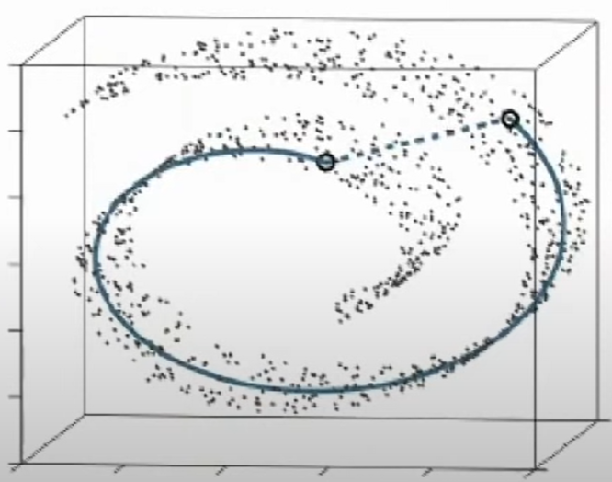
In order to preserve local structure, t-SNE (t-distributed stochastic neighbor embedding) measures pairwise similarities between high-dimensional objects (pij) and pairwise similarities between low-dimensional objects (qij).
- High score: High probability for a pair of points are located in similar proximity within the manifold
- Low score: Low probability for a pair of points are located in similar proximity within the manifold
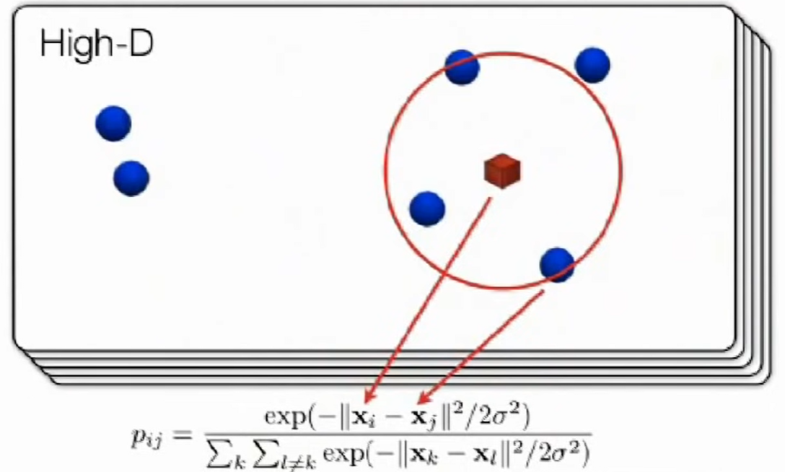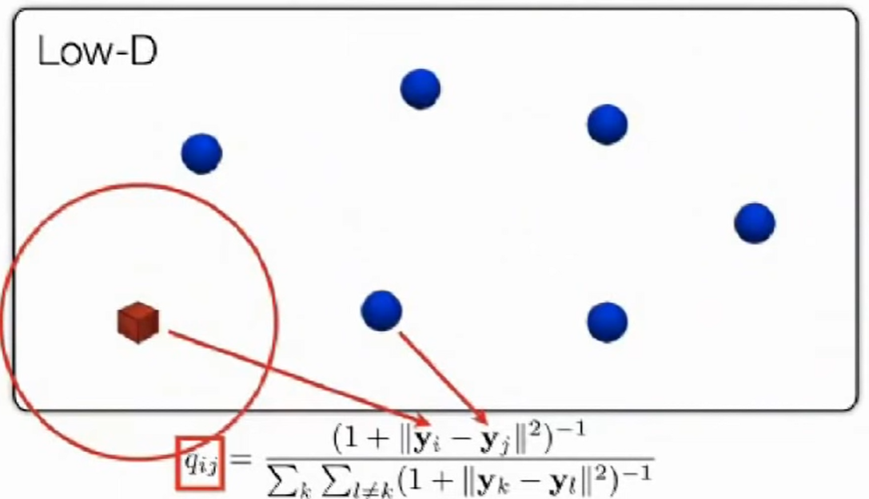
In practice, we first compute conditional distribution of input similarity. After that, we compute the join distribution by average of conditional distribution symmetry. The same method applies on qij.
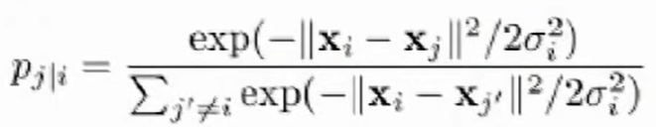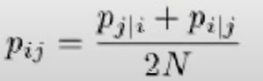
With gradient descent, we try to minimize the KL divergence value.
- If pij is large, the algo will train dataset to model large qij correspondingly, hence preserving local similarity structure of data.
- If pij is small, there will be small penalty of regardless of large qij.

Low-dimensional similarity score (qij) is calculated using student-t distribution so as to allow dissimilar points to be modeled as too far apart in the low-dimensional map.
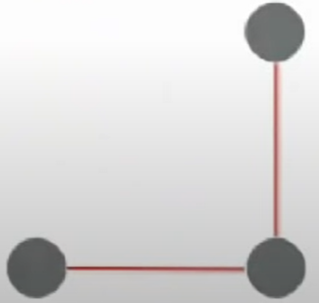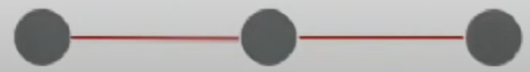
Recall that formulas to calculate pij and qij involve every pairwise interactions which will take time for large datasets. Therefore, Barnes-Hut approximation is used where a group of points that are far away from the point of interest will be represented by:
# of faraway points * interaction between center of mass and point of interest.
This way, lots of pairwise calculations can be skipped, thus reducing processing time.
