**ACD_BDD_Session_16_Assignment_1_Main**

**Problem Statement**

Link: https://acadgild.com/blog/transactions-in-hive/

Refer the above given link for transactions in Hive and implement the operations given in the blog using your own sample data set and send us the screenshot.

**Solution**

Transactions are provided at the row level in Hive 0.14. Row level transactions available in Hive are as follows-

1. Insert

2. Update

3. Delete

**Creating a table that supports Hive transaction:**



**Inserting data into a Hive table:**

INSERT INTO TABLE classes values (212,'astha','gopichand',’badminton’),(213,'archana','sania',’tennis’),(214,'anindita','sat prakash',’basketball’),(215,'soni','kamlesh',’tt’);

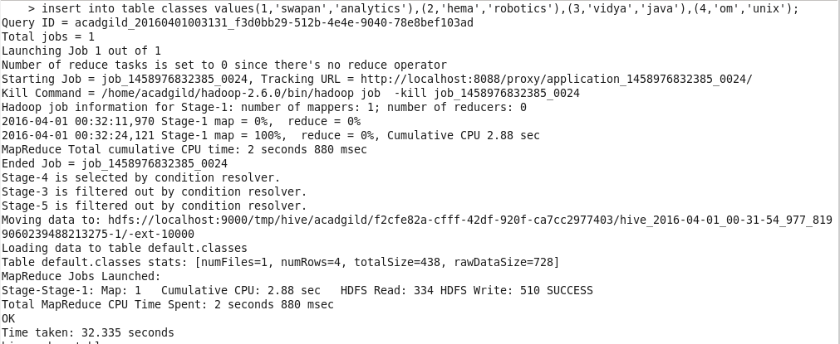

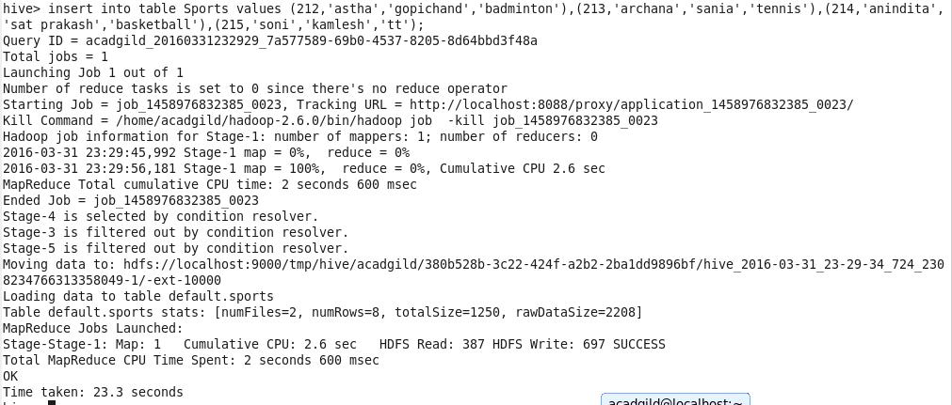

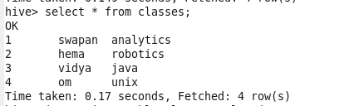

**Re-inserting the same data:**

If we try to re-insert the same data in the table, the data gets appended.

(212,'astha','gopichand',’badminton’),(213,'archana','sania',’tennis’),(214,'anindita','sat prakash',’basketball’),(215,'soni','kamlesh',’tt’);

select * from classes;

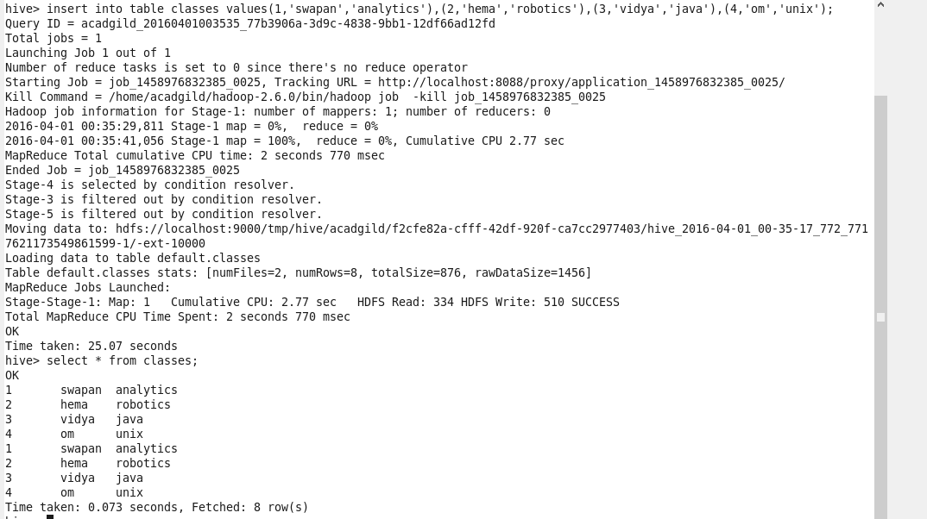

**Updating the data into a Hive table:**

UPDATE classes set cls_id=7 where cls_id = 2;

Since, update command is not supported on the bucketed columns. So we get the above error.

Failed: SementicException[Error 10302]: Updating values of bucketing columns is not supported. Column cls_id

Now, we will perform the update operation on Non bucketed column:

UPDATE Classes set subj = 'Linux' where cls_id = 2;

Select * from classes;

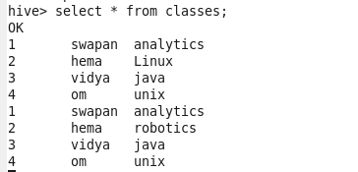

**Deleting the data from a Hive table:**

DELETE from classes where cls_id = 2;

Select * from classes;

