**ACD_BDD_Session_16_Assignment_2_Main**

**Problem Statement**

Link: https://acadgild.com/blog/indexing-in-hive/

Follow the blog link given above and implement the concepts of Indexing.

Perform the operations given in the above blog using your own sample dataset and send us the code snippets and output screenshot.

**Solution**

There are 2 types of Indexes in Hive:

1. Compact Indexing

2. Bitmap Indexing

The following are the different operations that can be performed on Hive indexes:

1. Creating index

2. Showing index

3. Alter index

4. Dropping index

**Creating Index in Hive**

Syntax for creating a compact index in Hive is as follows:

CREATE INDEX index_name

ON TABLE table_name (columns,....)

AS 'org.apache.hadoop.hive.ql.index.compact.CompactIndexHandler'

WITH DEFERRED REBUILD;

**Table Creation**

CREATE TABLE olympic_index(

Athlete STRING,

Age INT,

Country STRING,

Year INT,

Closing_Date STRING,

Sport STRING,

Gold_Medal INT,

Silver_Medal INT,

Bronze_Medal INT,

Total_Medal INT)

ROW FORMAT DELIMITED

FIELDS TERMINATED BY '\t'

STORED AS TEXTFILE;

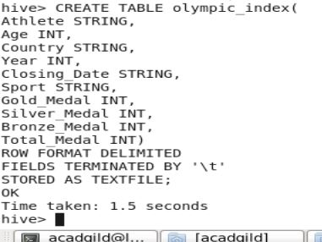

load data local inpath '/home/acadgild/Documents/olympix_data.csv' into table myhive.olympic_index;

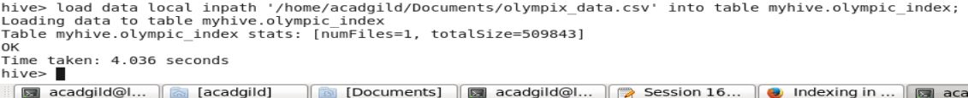

SELECT AVG(age) from olympic_index;

26.405433646812956

Time taken: 61.253 seconds, Fetched: 1 row(s)

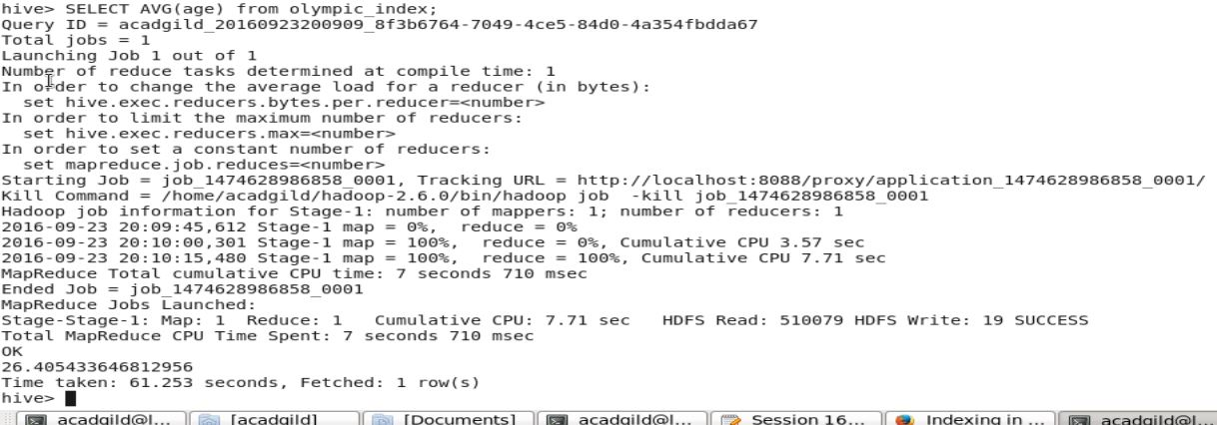

**Creating index for the table olympic_index:**

CREATE INDEX olympic_index_compact

ON TABLE olympic_index (age)

AS 'org.apache.hadoop.hive.ql.index.compact.CompactIndexHandler'

WITH DEFERRED REBUILD;

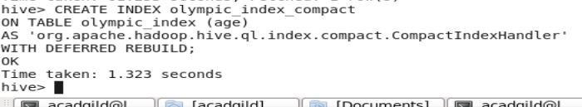

ALTER INDEX olympic_index_compact on olympic_index REBUILD;

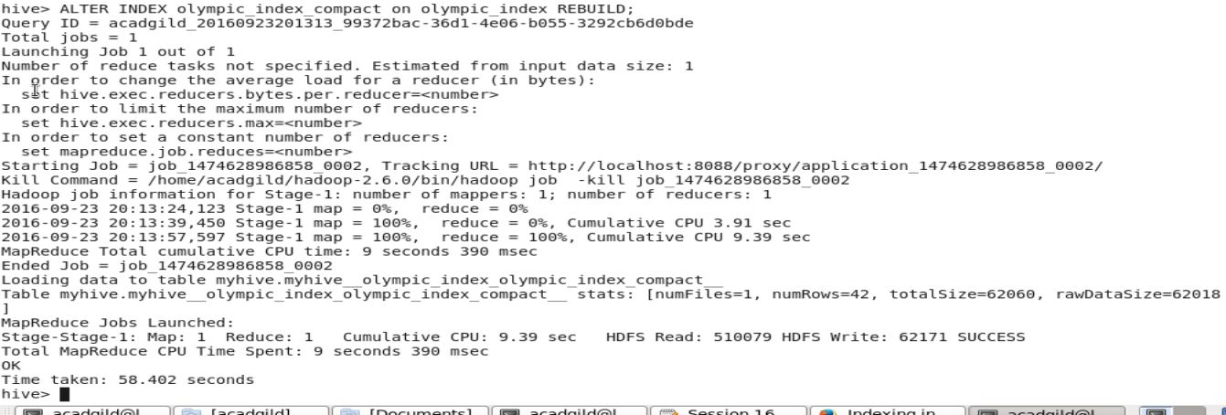

show formatted index on olympic_index;

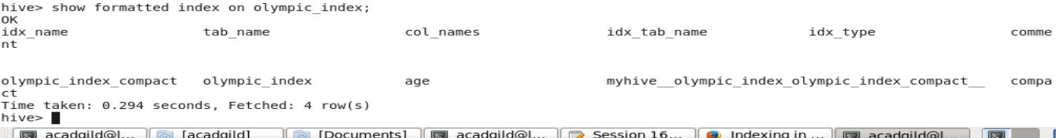

SELECT AVG(age) from olympic_index;

26.405433646812956

Time taken: 51.073 seconds, Fetched: 1 row(s)

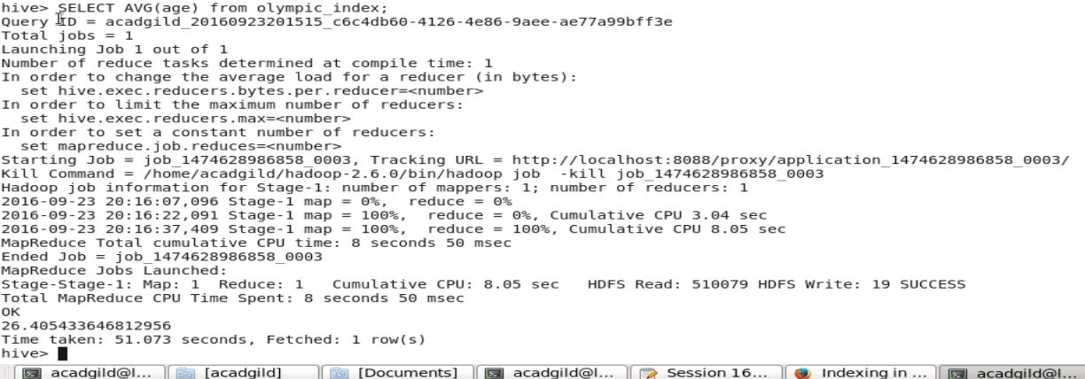

**Creating a Bitmap index for the same table:**

CREATE INDEX olympic_index_bitmap

ON TABLE olympic_index (age)

AS 'BITMAP'

WITH DEFERRED REBUILD;

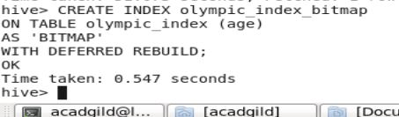

ALTER INDEX olympic_index_bitmap on olympic_index REBUILD;

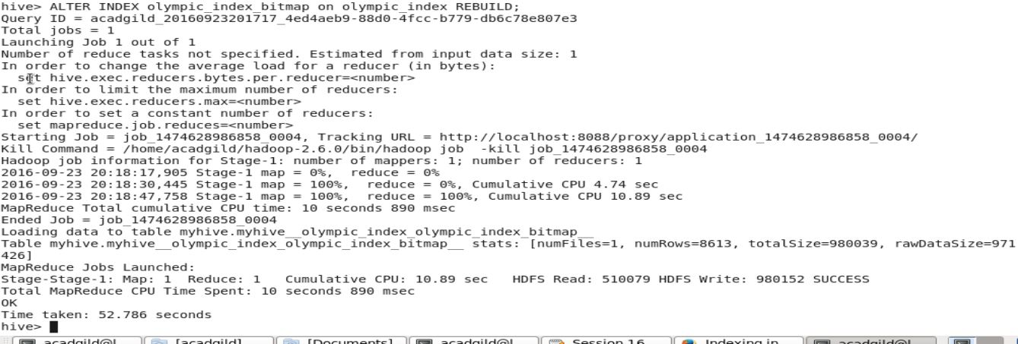

show formatted index on olympic_index;

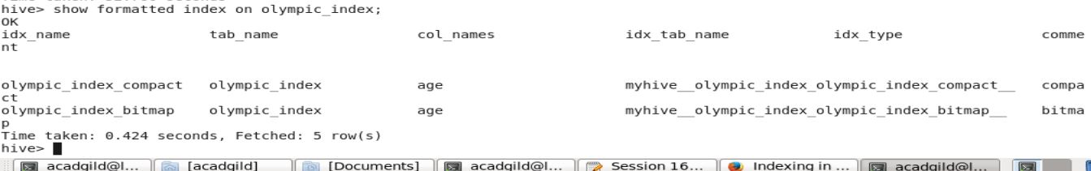

Now, performing select operation having 2 indexes:

SELECT AVG(age) from olympic_index;

26.405433646812956

Time taken: 47.648 seconds, Fetched: 1 row(s)

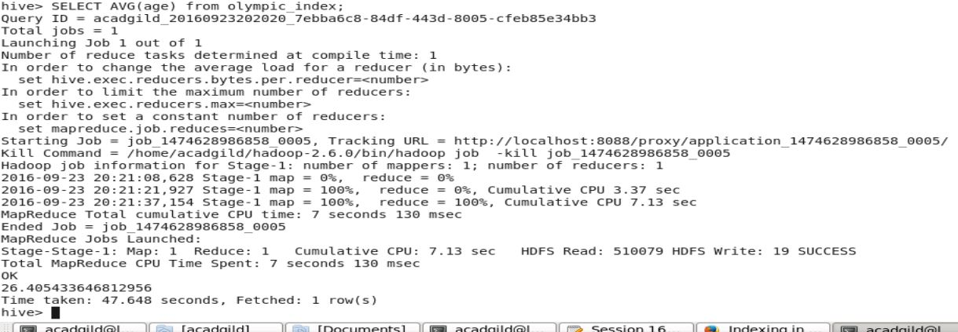

**Note:** With different types (compact,bitmap) of indexes on the same columns, for the same table, the index which is created first is taken as the index for that table on the specified columns.

Now let's delete one index using the following command:

DROP INDEX IF EXISTS olympic_index_compact ON olympic_index;

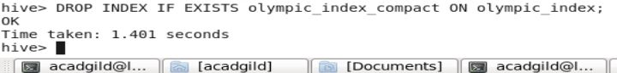

Average Operation with Bitmap Index:

SELECT AVG(age) from olympic_index;

26.405433646812956

Time taken: 48.216 seconds, Fetched: 1 row(s)

