LocalFinder: detecting local correlation and enrichment between epigenomic tracks
Pengfei Yin^{1,3,#}, Puxuan Sun^{1,#}, Yongwen Ding¹, Yanqiang Fu¹ and Jiankang Wang^{1,2,*}
¹School of Biomedical Sciences, Hunan University, Changsha, China
²Shenzhen Research Institute, Hunan University, Shenzhen 518000, China
³Institute of Pathology, University Medical Center Göttingen, 37075 Göttingen, Germany
#These authors contributed equally.
Corresponding author:
Jiankang Wang, Email: wangjk321@hnu.edu.cn
Adress: School of Biomedical Sciences, Hunan University, Changsha, 410082, Hunan Province, China

Abstract
Local relationships between genomic tracks often encode key regulatory information, yet most existing methods focus on either local enrichment or local correlation, leaving their joint signal underused. Here we present LocalFinder, a tool that computes local enrichment significance (ES) and harmonic-mean–weighted local correlation (HMC) profiles from a pair of genomic tracks. ES quantifies local enrichment robustly in low-coverage regions via zero-inflated negative binomial (ZINB) model and floor correction, whereas HMC quantifies local concordance by harmonic-mean–weighted the local correlation. Benchmarking on synthetic and real datasets for classifying unchanged, partially depleted, and totally depleted regions shows that (1) combining local enrichment and local correlation consistently outperforms single-feature approaches (MACS2 ppois, enrichment-only; StereoGene LC, correlation-only); (2) LocalFinder’s individual features (ES and HMC) each outperform their respective single-feature baselines (MACS2 ppois and StereoGene LC); and (3) Integration of ES and HMC achieves the best overall performance, surpassing the three cross-tool pairings. LocalFinder supports ES-only, HMC-only, or joint ES+HMC analyses across diverse genomic assays and scales to large datasets, enabling systematic discovery of local regulatory changes and biological insights.
Keywords: Local relationship; Local correlation; Local enrichment; Genomic track analysis; Epigenomics;
Introduction
Genome-wide scale relationships between epigenomic features and transcription are informative—for example, H3K4me3 is broadly enriched at promoters of actively transcribed genes, linking a chromatin mark to gene activity¹.However, such global relationships can provide limited insight into regulatory mechanisms at specific loci, because a high overall correlation can mask sharp, functionally meaningful local differences. For instance, Maurano et al. reported a very high overall similarity between DNase-seq profiles in fetal heart and fetal kidney (R = 0.99), yet individual local regions exhibit markedly different accessibility, consistent with tissue-specific regulatory element usage². Importantly, shifting from global to local relationships reveals distinct patterns—such as partially versus totally depleted loci or pre-programmed versus reprogrammed sites—that often reflect different regulatory mechanisms. Here, “totally depleted” is used for convenience throughout the paper to denote loci whose signal is reduced to near-background levels (i.e., below the detection threshold), rather than an absolute absence of signal. In glucocorticoid signaling, John et al. showed that GR binding occurs either at pre-existing accessible chromatin (pre-programmed) or at sites with newly induced accessibility (reprogrammed), consistent with stimulus-dependent remodeling and tissue-specific responses³. Likewise, acute CTCF depletion shows dose-dependent effects, with stronger insulation loss at loci approaching complete depletion (totally depleted) than at partially depleted loci⁴.
Various tools have been developed to quantify relationships between genomic tracks, but they typically emphasize either correlation or enrichment. For global correlation, deepTools^{5, 6} computes genome-wide correlations between signal tracks, StereoGene⁷ rapidly estimates genome-wide correlation using kernel-based correlation, and BEDTools⁸ summarizes genome-wide co-occurrence using interval overlap metrics. For local correlation, StereoGene reports a position-resolved local correlation (LC) track by evaluating kernel correlation as a function of genomic position⁷, and deepTools can quantify correlation within genomic bins or sliding windows to obtain locus-level correlation profiles^{5, 6}. For local enrichment, numerous peak callers have been developed⁹; for example, MACS2¹⁰, HOMER¹¹, and DROMPAplus¹² call enriched regions by testing whether local read/coverage accumulation exceeds an expected background, optionally using control/input to account for background biases.
When calculating local enrichment and local correlation between genomic tracks, a key challenge is that bins with low values in both tracks can produce large relative fluctuations, making locus-level scores unreliable. For example, DROMPAplus reports enrichment using track-to-track ratios (e.g., IP relative to control), but ratios of two small numbers can vary dramatically¹². More broadly, peak callers such as MACS2 and DROMPAplus rely on Poisson or negative binomial distribution to test whether local accumulation exceeds an expected background; however, the prevalence of zeros across the genome can violate these assumptions and reduce reliability in low-coverage regions, motivating the application of ZINB distribution¹³. In practice, MACS2 mitigates this by prioritizing high-confidence candidate enriched regions, but this can de-emphasize low-coverage loci that may still carry regulatory information^{14, 15}. Furthermore, MACS2 tests whether a region is enriched over background, but it does not explicitly distinguish de novo peaks from strengthened peaks across conditions—patterns that can carry distinct biological significance³. Additionally, methods like TOBIAS¹⁶ use a floor value to filter out low-coverage regions, ensuring that unreliable data does not influence the results. For local correlation, StereoGene's LC approach addresses fluctuations in low-coverage regions by using coverage as a weight in the correlation calculation, reducing the impact of unreliable data and ensuring more accurate correlations in higher-coverage regions⁷.
Here, we introduce LocalFinder, which computes both local enrichment significance (ES) and harmonic-mean–weighted local correlation (HMC) profiles, whether they originate from distinct assays or from bulk and single-cell datasets. Unlike methods that focus solely on high-coverage regions, LocalFinder produces robust estimates in low-coverage regions by incorporating a zero-inflated negative binomial (ZINB) model and floor correction for the ES track and by applying harmonic-mean weight to local correlation to generate the HMC track. Users can use LocalFinder outputs in three ways: (i) jointly utilize ES+HMC for a given track pair, (ii) compare ES profiles between two track pairs/conditions, and (iii) compare HMC profiles between two track pairs/conditions. LocalFinder, along with tutorials and examples, is freely available at https://github.com/astudentfromsustech/localfinder.
Results
Overview of LocalFinder
LocalFinder is a unified framework for quantifying local relationships by computing two complementary profiles from a pair of genomic tracks: ES and HMC. LocalFinder bin accepts common track formats (bigWig/bedGraph/BAM) and converts them into fixed-width binned signals (default 200 bp), enabling consistent analysis across diverse assays (e.g., ChIP–seq, ATAC–seq, CUT&Tag/CUT&RUN, RNA-seq, and Hi-C–derived 1D tracks) from bulk samples or cell-type–specific pseudo-bulk tracks aggregated from single-cell data. LocalFinder calc then applies a sliding-window strategy to compute ES and HMC at each bin. To suppress spurious extremes in low-signal regions where both tracks are near zero, ES first performs floor correction¹⁶ to suppress extreme ratios from near-zero coverage and then quantifies signed local enrichment significance using ${ES}_{i}=sgn(log⁡{FC}_{i})(-{log⁡}_{10}p_{i})$, where $p_{i}$is obtained from a Wald test¹⁷ under ZINB model. In parallel, HMC computes ${HMC}_{i}={\overset{ˉ}{r}}_{i}w_{i}$, combining windowed local Pearson correlation with a harmonic-mean coverage weight $w_{i}$ to down-weight low-signal bins and make local correlation estimates more robust (Fig. 1a; Methods).
ES and HMC profiles produced by LocalFinder support three analysis modes covering common and biologically meaningful use cases (Fig. 1b). First, for a single pair of genomic tracks, joint ES+HMC interpretation uses ES to call significantly differential regions (SDRs; ES^{high}) and hen stratifies these SDRs by HMC into biologically meaningful subclasses, such as partially depleted versus totally depleted regions (or pre-programmed versus re-programmed regions when the track order is reversed). ES and HMC jointly define four typical classes: totally depleted (ES^{high} and HMC^{low,} blue box), partially depleted (ES^{high} and HMC^{high}, red box), unchanged-high (ES^{low} and HMC^{high}, black box), and unchanged-low (ES^{low} and HMC^{low}, grey box) (Fig. 1b, left). Second, HMC-only analysis compares HMC profiles between track pairs to assess locus-level concordance. In the example, the factor1–factor3 pair shows consistently higher HMC than the factor1–factor2 pair across this region, indicating stronger local concordance (Fig. 1b, middle). Third, ES-only analysis focuses on treatment-associated changes by comparing ES profiles (control vs treated) across factors (Fig. 1b, right); concordant ES patterns indicate similar local regulatory responses, suggesting potentially coordinated regulation.

Two-feature integration outperforms single-feature methods across datasets, with ES–HMC as the top-performing combination
One key innovation of LocalFinder is that it recognizes and demonstrates local enrichment and local correlation as complementary local features, and jointly leverages them (ES and HMC) to characterize paired genomic tracks; to our knowledge, most existing methods quantify either local enrichment (peak/enrichment callers) or local correlation, leaving their combined signal underused^{18, 19, 20}.
There are four biologically meaningful local patterns that commonly arise when comparing two genomic tracks: unchanged-high, unchanged-low, partially depleted / pre-programmed, and totally depleted / re-programmed (Fig. 2a). Notably, the partially depleted versus pre-programmed patterns (and likewise totally depleted versus re-programmed) are direction-dependent and become equivalent after swapping the order of the two tracks. For benchmarking, we therefore emphasize depletion magnitude and report performance using three collapsed classes—partially depleted, totally depleted, and unchanged (merging unchanged-high/unchanged-low)—unless otherwise specified.
To test whether combining local enrichment and local correlation improves detection of local regulatory changes, we benchmarked four two-feature combinations (ES+HMC, ES+ StereoGene LC, MACS2 ppois+HMC, MACS2 ppois+ StereoGene LC) against single-feature strategies (MACS2 ppois, ES, HMC, StereoGene LC) on both simulated and real datasets (Fig. 2; Fig. S2). Here, MACS2 represents a widely used enrichment-based tool; MACS2 ppois denotes the −log₁₀p signal track produced by macs2 bdgcmp -m ppois. StereoGene provides a representative correlation-based signal via its position-resolved LC track. In the simulated benchmark, we generated regions with ground-truth labels representing partially depleted, totally depleted, and unchanged patterns (Methods), and an example locus illustrates that enrichment-based scores (ES and MACS2 ppois) capture local differences between tracks, whereas correlation-based scores (HMC and StereoGene LC) capture local concordance (Fig. 2a). In the real-data benchmark, we analyzed CTCF perturbation tracks (untreated vs auxin-treated; KO-like) and used region labels adapted from the corresponding published peak annotations (Methods; Fig. S2a).
Across both datasets, two-feature combinations consistently outperform single-feature strategies, as reflected by higher class-specific AUPRC values (Fig. 2d,e; Fig. 2f–m; Fig. S2d–i). This advantage is also apparent in feature space: joint two-dimensional scoring yields clearer separation of partially depleted, totally depleted, and unchanged regions than considering either feature alone, highlighting the complementarity between enrichment and concordance signals (Fig. 2f–m; Fig. S2d–i). For instance, the ES–HMC joint feature space (Fig. 2f) separates classes more distinctly than its one-dimensional marginals—projection onto the HMC axis corresponds to using HMC alone, and projection onto the ES axis corresponds to using ES alone—both of which show increased class overlap relative to the two-feature representation (Fig. 2f,k,l). Among all the eight tested strategies, ES+HMC achieves the best overall performance on both simulated and real data (Fig. 2d,e; Fig. 2f–m; Fig. S2d–k), exceeding the other three cross-tool combinations (ES+ StereoGene LC, MACS2 ppois +HMC, MACS2 ppois+ StereoGene LC) and all single-feature alternatives.
We notice that the overall performance of the eight strategies is lower on the real dataset than in simulation (Fig. 2e vs Fig. 2d), likely reflecting label noise of real dataset in the absence of true ground-truth annotations: simulated regions are generated with known labels, whereas real-data labels were derived from published peak annotations⁴ (Methods). Consistent with this, the dashed red box in Fig. S2a marks a region annotated as totally depleted but displaying a partially depleted pattern by visual inspection. LocalFinder classifies this region as partially depleted, showing simultaneously high ES and high HMC—an ES–HMC signature characteristic of partial depletion (Fig. S2a).

LocalFinder’s ES and HMC each outperform the corresponding single-feature baselines.
In addition to improving performance through two-feature integration, LocalFinder also strengthens each component feature on its own. Across both simulated and real benchmarks, ES and HMC each achieve higher class-specific AUPRC than their single-feature counterparts (ES vs MACS2 ppois; HMC vs StereoGene LC) (Fig. 2d,e; Fig. 2f–m; Fig. S2d–k). Mechanistically, ES separates differential from unchanged regions because its Wald test is driven by the local log fold-change, which captures the magnitude of local enrichment between tracks (Methods). As a result, depleted regions concentrate at higher |ES|, whereas unchanged regions cluster near |ES| ≈ 0, consistent with the class-wise |ES| distributions and ES-based feature spaces (Fig. 2c,f,k; Fig. S2c–e). In contrast, MACS2 ppois primarily test whether a locus is significantly enriched relative to background, rather than quantifying the magnitude of enrichment change between two conditions; therefore, MACS2 ppois alone has limited power to separate partially versus totally depleted regions (Fig. 2j vs Fig. 2k; Fig. S2h vs Fig. S2i). ES improves over this baseline by explicitly modeling low-coverage behavior (floor correction + ZINB) and by using a signed, effect-size–aware significance score, which stabilizes estimates in sparse regions and yields cleaner separation between depleted and unchanged classes (Methods).
HMC provides complementary gains on the concordance side. Although both HMC and StereoGene LC quantify local track concordance, HMC more effectively separates partially versus totally depleted regions: partially depleted regions tend to retain coordinated signal between tracks and therefore show higher HMC, whereas totally depleted regions show lower HMC (Fig. 2b,l,m; Fig. S2b,j,k). Mechanistically, this improvement arises from how HMC stabilizes correlation estimates in low-signal windows: LocalFinder computes a windowed Pearson correlation ${\overset{ˉ}{r}}_{i}$ and then scales it by a harmonic-mean coverage weight $w_{i}$ (${HMC}_{i}={\overset{ˉ}{r}}_{i}w_{i}$), explicitly down-weighting windows where either (or both) tracks have low coverage (Methods). In contrast, StereoGene LC is derived from a kernel-weighted local cross-correlation (via convolution/Fourier-domain filtering with kernel $q$) and normalized by global standard deviations ($2σ_{f}σ_{g}$), without an explicit joint-coverage down-weighting term. As a result, StereoGene LC is more prone to attenuation toward near-zero values in low-signal regions and to kernel-induced smoothing that can blur sharp local transitions, reducing effective resolution for distinguishing depletion magnitude⁷. Together, coupling correlation with joint coverage makes HMC less sensitive to spurious correlations in near-zero regions and better resolves biologically meaningful differences (e.g., partially vs totally depleted; and, depending on track order, pre-programmed vs re-programmed regions).

LocalFinder distinguishes differential CTCF perturbation effects between knockout and knockdown.
1. ES-only comparison across conditions (ES profiles computed for each factor between control and treated conditions can be compared across factors; concordant ES patterns suggest similar treatment-associated regulatory changes)
2. HMC-only application (HMC-only comparison across track pairs—HMC profiles from two track pairs are compared to assess locus-level concordance patterns; in this example, factor 1 shows higher concordance with factor 3 than with factor 2.), HMC can more precisely capture the correlation than StereoGene LC (Sun’s application)
3. ES-HMC application (LocalFinder distinguishes differential CTCF perturbation effects between knockout and knockdown.)

Discussion
LocalFinder formalizes local enrichment and local correlation as complementary descriptors of paired genomic tracks, demonstrating that their joint consideration provides a more comprehensive view of regulatory change than either feature alone (Fig. 2d,e; Fig. 2f–m; Fig. S2d–i). While most existing tools focus on either local enrichment (e.g., peak/enrichment callers) or local correlation, the combined signal is often underutilized. In LocalFinder, the ES profile first identifies SDRs, and then HMC stratifies these SDRs into biologically meaningful subclasses, such as partially depleted versus “totally depleted” regions (or, when track order is reversed, pre-programmed versus re-programmed regions) (Fig. 2a).
Beyond integration, each component is robust on its own: ES combines floor correction with a ZINB-based Wald test to produce a signed, effect-size–aware significance profile in sparse regions, whereas HMC uses a harmonic-mean joint-coverage weight to down-weight low-signal windows and reduce spurious correlations near background. These design choices likely explain why ES outperforms enrichment-only baselines (e.g., MACS2 ppois) and HMC outperforms correlation-only baselines (e.g., StereoGene LC). Mechanistically, ES is driven by the local log fold-change between tracks, directly capturing the magnitude of change, while MACS2 ppois primarily tests whether there is enrichment relative to background, making it less sensitive to distinguishing partially depleted from totally depleted regions. HMC computes a windowed Pearson correlation ${\overset{ˉ}{r}}_{i}$and scales it by joint coverage (${HMC}_{i}={\overset{ˉ}{r}}_{i}w_{i}$), explicitly suppressing windows where either track has low coverage; in contrast, StereoGene LC relies on kernel-weighted cross-correlation and global normalization without an explicit joint-coverage term, making it more prone to signal attenuation in low-signal regions. Additionally, the kernel smoothing applied by StereoGene LC can blur sharp local transitions, reducing its ability to distinguish localized changes effectively. Notably, the signed ES feature in LocalFinder enables the detection of both enriched (positive) and depleted (negative) regions, whereas MACS2 ppois can only detect enriched regions relative to the first track. For tracks with both enriched and depleted regions, MACS2 requires two separate operations: one to identify enriched regions and another with the track order swapped to detect depleted regions.
LocalFinder is broadly applicable for three reasons. First, it captures a general and biologically plausible continuum of change: regions typically transition from unchanged to intermediate (partial) change, and ultimately to near-complete gain/loss, reflecting distinct regulatory mechanisms. For example, in time-series tracks (1, 2, 3), early time points show chromatin accessibility transitioning from closed to open (pre-programmed pattern between time points 1 and 2), followed by further opening at later time points (pre-programmed pattern between time points 2 and 3). Second, LocalFinder provides a unified framework for quantifying local relationships from paired tracks by computing two complementary profiles (ES and HMC) from standardized, fixed-width binned signals. LocalFinder bin accepts common inputs (bigWig/bedGraph/BAM) and converts them to a consistent binning resolution (default 200 bp), enabling comparable analyses across diverse assays and track types, including ChIP–seq, ATAC–seq, CUT&Tag/CUT&RUN, RNA-seq, and Hi-C–derived 1D profiles, as well as pseudo-bulk tracks aggregated from single-cell datasets. Third, the chromosome-wise, multi-threaded implementation minimizes memory overhead and enables scalable analysis across multiple track pairs, making LocalFinder suitable for large-scale analyses involving diverse factors, conditions, and time points.
[Discussion for other applications]
Several limitations suggest clear directions for future work. First, our enrichment-only baseline focused solely on MACS2, but there are other peak-calling tools available¹⁸. Broader comparisons to alternative enrichment frameworks and additional statistical formulations could help contextualize performance across various assays and coverage regimes. Second, the simulated benchmark currently uses a limited set of perturbation magnitudes (specifically, FC=0.2 and FC=3) and types (broad peaks). Expanding simulations to include a broader range of fold changes, spatial patterns (e.g., broadened/narrowed peaks), and noise models would improve generalizability. Third, real-data benchmarking depends on proxy labels derived from peak sets and replicate consensus. Incorporating orthogonal ground truth (e.g., perturbation-validated loci, spike-ins, or multi-omic readouts) would refine how ES/HMC regimes correspond to specific regulatory mechanisms. Fourth, ES relies on local distributional assumptions (ZINB with empirical dispersion) and percentile-based floor correction; while these stabilize sparse regions, parameter choices (e.g., bin size, window size, percentile) could affect sensitivity–specificity trade-offs, motivating data-driven guidance and multi-scale extensions. Finally, HMC currently emphasizes non-negative concordance and may under-represent biologically relevant anti-correlated relationships (Bioinformatics 2017, PMID: 29028265). Extending the framework to capture anti-correlation and handle local positional shifts (e.g., near-matching but displaced signals) would expand its applicability.

Methods
Overview of LocalFinder. LocalFinder computes ES and HMC profiles from a pair of genomic tracks. LocalFinder can additionally call SDRs by thresholding ES, and then use HMC to further classify SDRs into biologically meaningful categories, including partially versus totally depleted regions (or pre-programmed versus re-programmed patterns when the track order is swapped)

Input formats and binning. LocalFinder bin accepts common genomic track formats, including BigWig, BedGraph, and BAM. For BAM inputs, reads are converted to coverage tracks; all inputs are represented as a BedGraph-like signal and then discretized into fixed-width genomic bins (default 200 bp), enabling consistent analysis across diverse assays (e.g., ChIP–seq, ATAC–seq, CUT&Tag/CUT&RUN, RNA-seq, and Hi-C–derived 1D tracks) from bulk samples or cell-type–specific pseudo-bulk tracks aggregated from single-cell data. For each bin $i$, LocalFinder records a pair of coverage values $(x_{1,i},x_{2,i})$ for track 1 and track 2, respectively, across $N$ total bins per chromosome.
Normalization. For each genomic bin i, LocalFinder records the raw read-coverage values $x_{k,i}$ for the two tracks ($k∈ ADDIN EN.CITE <EndNote><Cite><Author>Bailey</Author><Year>2013</Year><RecNum>3</RecNum><DisplayText><style face="superscript">2</style></DisplayText><record><rec-number>3</rec-number><foreign-keys><key app="EN" db-id="w5f2wav2qdxe0metvfy50ztpeewswtdev2r9" timestamp="1767737500">3</key></foreign-keys><ref-type name="Journal Article">17</ref-type><contributors><authors><author>Bailey, T.</author><author>Krajewski, P.</author><author>Ladunga, I.</author><author>Lefebvre, C.</author><author>Li, Q.</author><author>Liu, T.</author><author>Madrigal, P.</author><author>Taslim, C.</author><author>Zhang, J.</author></authors></contributors><auth-address>Institute for Molecular Bioscience, The University of Queensland, Brisbane, Australia.</auth-address><titles><title>Practical guidelines for the comprehensive analysis of ChIP-seq data</title><secondary-title>PLoS Comput Biol</secondary-title></titles><periodical><full-title>PLoS Comput Biol</full-title></periodical><pages>e1003326</pages><volume>9</volume><number>11</number><edition>20131114</edition><keywords><keyword>*Chromatin Immunoprecipitation</keyword><keyword>Computational Biology/*methods</keyword><keyword>High-Throughput Nucleotide Sequencing</keyword><keyword>Humans</keyword><keyword>Reproducibility of Results</keyword><keyword>Sequence Analysis, DNA/*methods</keyword></keywords><dates><year>2013</year></dates><isbn>1553-7358 (Electronic)\&\#xD;1553-734X (Print)\&\#xD;1553-734X (Linking)</isbn><accession-num>24244136</accession-num><urls><related-urls><url>https://www.ncbi.nlm.nih.gov/pubmed/24244136</url></related-urls></urls><custom1>The authors have declared that no competing interests exist.</custom1><custom2>PMC3828144</custom2><electronic-resource-num>10.1371/journal.pcbi.1003326</electronic-resource-num><remote-database-name>Medline</remote-database-name><remote-database-provider>NLM</remote-database-provider></record></Cite></EndNote>Error! Bookmark not defined.$; $i=1,…,N$), and defines the total coverage of track k as $T_{k}=\sum_{j=1}^{N}{x_{k,j}}$, where N is the total number of bins. LocalFinder then applies one of three per-track normalization options:
(i) RPKM (reads per kilobase per million): ${\tilde{x}}_{k,i}={10}^{6} x_{k,i}/(T_{k}⋅L/1000)$, where L is the bin length (bp).
(ii) CPM (counts per million): ${\tilde{x}}_{k,i}={10}^{6} x_{k,i}/T_{k}$.
(iii) SCALE (downscale to the smaller library): ${\tilde{x}}_{k,i}=x_{k,i}⋅min⁡(T_{1},T_{2})/T_{k}$.
For simplicity, the normalized values ${\tilde{x}}_{k,i}$are denoted as $x_{k,i}$in all subsequent steps.

Sliding-window ES calculation. ES captures signed local enrichment (or depletion) of track 2 relative to track 1 at each genomic bin, while suppressing spurious extremes arising from near-zero coverage. LocalFinder calc includes four main steps:

(i) Floor correction. Low-coverage bins can yield inflated ratios and unstable fold-change estimates. To stabilize local statistics, LocalFinder applies a percentile-based floor independently to each track: values below the p-th percentile (default p = 90%) are replaced by that percentile, i.e., $x_{k,i}^{'}=max⁡(x_{k,i},τ_{k})$, where $τ_{k}$is the per-track percentile threshold computed across bins. Subsequent ES calculations use the floored signals $x_{k,i}^{'}$.
(ii) Window statistics. ES uses two window scales: a peak window of size $P=2h_{p}+1$ to compute peak-window means for fold-change estimation, and a sliding window of size $W=2h+1$ to estimate local sampling variability. The peak-window mean is computed as ${\tilde{μ}}_{k,i}=\frac{1}{P}\sum_{j=i-h_{p}}^{i+h_{p}}{x_{k,j}^{'}}$, and the sliding-window mean is $μ_{k,i}=\frac{1}{W}\sum_{j=i-h}^{i+h}{x_{k,j}^{'}}$. Within each sliding window, LocalFinder computes local means $μ_{k,i}$and empirical variances $σ_{k,i}^{2}$, and estimates a non-negative overdispersion parameter $ϕ_{k,i}$ using a method-of-moments estimator consistent with a ZINB mean–variance relationship.
$$ϕ_{k,i}=max\left(\frac{σ_{k,i}^{2}-μ_{k,i}}{μ_{k,i}^{2}} , 0\right)$$(iii) Wald test. For each bin $i$, LocalFinder computes a local log fold-change relative to a fold-change threshold ${FC}_{\text{thresh}}$(default 1.5) using the peak-window means, i.e., $log⁡{FC}_{i}=ln⁡({\tilde{μ}}_{2,i}/{\tilde{μ}}_{1,i})/ln⁡({FC}_{\text{thresh}})$. The standard error is obtained under the locally estimated ZINB variance model and written as:
$${SE}_{i}=\sqrt{\frac{1}{μ_{1,i}}+\frac{1}{μ_{2,i}}+ϕ_{1,i}+ϕ_{2,i}}$$A Wald statistic is computed as $Z_{i}={logFC}_{i}/{SE}_{i}$ and converted to a two-sided p-value $p_{i}=2(1-Φ(∣Z_{i}∣))$, where $Φ(⋅)$is the standard normal CDF. By default (FDR = True), LocalFinder then applies Benjamini–Hochberg multiple-testing correction across all tested bins to convert $p_{i}$to an FDR-adjusted value ${FDR}_{i}$(i.e., q value), which can be used in place of $p_{i}$ in downstream scoring.
(iv) Signed ES. ES is defined as a signed significance score:
$${ ES}_{i}=sgn⁡(log⁡{FC}_{i}) (-{log⁡}_{10}{FDR}_{i})$$Positive ${ES}_{i}$ indicates enrichment of track 2 over track 1, whereas negative ${ES}_{i}$indicates depletion.
Sliding-window HMC calculation. HMC quantifies local concordance between two tracks while explicitly accounting for local signal strength. For each bin $i$(with half-window $h$, window size $W=2h+1$), HMC is computed in three steps:
(i) Local Pearson. First, we compute the windowed Pearson correlation between the normalized binned coverages of the two tracks within the window $\left[i-h, i+h\right]$:
$$r_{i}=\frac{\sum_{j=i-h}^{i+h}{(}x_{1,j}-μ_{1,i})(x_{2,j}-μ_{2,i})}{\sqrt{\sum_{j=i-h}^{i+h}{(}x_{1,j}-μ_{1,i})^{2}} \sqrt{\sum_{j=i-h}^{i+h}{(}x_{2,j}-μ_{2,i})^{2}}}$$
where $μ_{1,i}$and $μ_{2,i}$are the window means for track 1 and track 2, respectively. To reduce random fluctuations, correlations are smoothed by averaging across neighboring bins:
$${\overset{ˉ}{r}}_{i}=\frac{1}{W}\sum_{t=i-h}^{i+h}{{max\{r}_{t},0\}}.$$
(ii) Harmonic-mean weight. Because correlation is noisy in low-signal windows, LocalFinder down-weights weak regions using a harmonic-mean coverage weight:
$$w_{i}=\frac{μ_{1,i}μ_{2,i}}{μ_{1,i}+μ_{2,i}+ε},ε={10}^{-9}.$$
(iii) HMC. The per-bin HMC score is then
$${HMC}_{i}={\overset{ˉ}{r}}_{i} w_{i},$$
so concordance is amplified only when both tracks have appreciable local signal (via $w_{i}$) and ${HMC}_{i}≥0$.
SDRs identification. Optionally, users can run LocalFinder findreg to call SDRs from the ES profile using a user-defined significance threshold applied to p-values (or, when enabled, the corresponding FDR); the default threshold is p_thresh = 0.05. Bins exceeding the threshold are first stratified by the sign of $ES_{i}$(enrichment versus depletion). Adjacent significant bins with the same sign are then merged into contiguous SDRs using a gap-tolerant procedure analogous to peak merging in MACS2. By default, an SDR must contain at least $binNum_thresh=2$consecutive significant bins and allows no gaps ($max_gap_bins=0$); both parameters are user-configurable.
For each SDR, LocalFinder summarizes the concordance signal by computing HMC using only the bins within the SDR. SDRs are then ranked by their mean HMC: regions with lower mean HMC correspond to near-complete loss of coordinated signal (e.g., totally depleted / re-programmed patterns), whereas regions with higher mean HMC indicate residual concordance despite enrichment changes (e.g., partially depleted / pre-programmed patterns, depending on track order).
Speed and memory optimization. To efficiently compute HMC and ES on large genomic datasets, LocalFinder adopts a chromosome-by-chromosome, multi-threaded strategy that minimizes memory footprint and reduces redundant computation. The core optimizations include:
(i) Chromosome-wise parallelism: Each chromosome is processed independently in separate threads, avoiding the need to load the entire genome into memory at once and enabling parallel execution.
(ii) Vectorized operations with prefix sums: Bin counts are converted to NumPy arrays, and prefix-sum arrays are precomputed for values, squares, and cross-products. This allows O(1) retrieval of sliding-window means and variances, avoiding repeated summations in loops.
These optimizations collectively reduce both runtime and memory usage, enabling LocalFinder to process high-resolution genomic tracks efficiently on multi-core systems.

Benchmarking on simulated dataset. We benchmarked LocalFinder against MACS2 and StereoGene on the simulated dataset with labeled regions as ground truth. For each method, we computed LocalFinder ES and HMC, MACS2 ppois, and StereoGene LC within labeled regions and evaluated performance using per-class AUPRC. All analyses in this section used the hg19 reference genome.
Construction of simulated dataset with labeled regions. We constructed a simulated benchmarking dataset from the Roadmap (Nature 2015, PMID: 25693563) E071 H3K4me1 tagAlign file (30 million tags) (Supplementary Table 1). Reads were independently downsampled to 50% twice using different random seeds (seed 7 for Track 1 and seed 42 as the baseline for Track 2) to introduce stochastic sampling noise while maintaining overall similarity. We sampled genomic windows and binned each window into 11 bins of 200 bp (2.2 kb per region), then applied region-specific fold-change (FC) scaling only to the seed-42 signal to generate Track 2 by multiplying binned signals within selected windows by preset FC values, while Track 1 was left unchanged. In total, we generated 24,000 labeled regions as ground truth (Fig. 2a): 8,000 pre-programmed regions (FC = 3), 8,000 “totally depleted” regions (FC = 0.2; Track 2 is reduced to near-background levels rather than exactly zero), and 8,000 unchanged controls (FC = 1), including 4,000 unchanged-high and 4,000 unchanged-low regions. For BedGraph generation, downsampled tagAlign files were deduplicated, strand-specifically extended by 200 bp, and converted to BedGraph coverage using ¹⁰ genomecov -bg (¹⁰ v2.31.1) for BAM generation, tagAlign entries were converted to BED6 intervals and then to BAM using ⁹ bedtobam, followed by sorting and indexing with samtools sort and samtools index (samtools v1.13).
Scores calculation over labeled region for each method. BedGraph files from Track 1 and Track 2 were used as inputs for LocalFinder and StereoGene (v2.31), and BAM files from Track 1 and Track 2 were used as inputs for MACS2 (v2.2.6). For LocalFinder, input tracks were binned to 200 bp using LocalFinder bin and processed with LocalFinder calc (binNum_peak = 5, percentile = 90, --norm_method rpkm, other parameters default) to generate ES and HMC tracks, and ES/HMC values were averaged across bins within each labeled region. For StereoGene LC, 200-bp binned BedGraph tracks were used to compute the LC track with default parameters, and LC values were averaged across bins within each labeled region. For MACS2, we ran macs2 callpeak -B to generate treatment pileup and control lambda BedGraphs and computed genome-wide −log₁₀p tracks with macs2 bdgcmp -m ppois; because ppois is directional and Track 2 contains both enriched and depleted regions relative to Track 1, we repeated the procedure with the two BAMs swapped, took the per-position maximum of the two −log₁₀p tracks, and averaged the resulting signal across bins within each labeled region.
Per-class AUPRC calculation. We evaluated four two-feature strategies and four single-feature baselines using a Random Forest classifier (n_estimators = 100) with a stratified 80/20 train–test split (random_state = 42). For two-feature strategies, each labeled region was represented by the mean feature values across the 11-bin window (|ES|+HMC, |ES|+StereoGene LC, MACS2 ppois +HMC, and MACS2 ppois+StereoGene LC); for single-feature baselines (StereoGene LC, |ES|, HMC, or MACS2 ppois), each region was represented by the corresponding window-averaged scalar feature. Per-class precision–recall curves (Plos One2015, PMID: 25738806) were computed in a one-vs-rest manner from predicted class probabilities on the test set, and AUPRC was reported as the average precision for each class.

Benchmarking on real dataset. We benchmarked LocalFinder against MACS2 and StereoGene on the real dataset with labeled regions as ground truth. For each method, we computed LocalFinder ES and HMC, MACS2 ppois, and StereoGene LC within labeled regions and evaluated performance using per-class AUPRC. All analyses in this section used the mm9 reference genome.
Construction of real dataset with labeled regions. We used CTCF ChIP–seq peak files, bigWig signal tracks, and FASTQ files from a published CTCF-AID study (Cell, 2017; PMID: 28525758), including CTCF-AID_untreated and CTCF-AID_auxin2days, each with two biological replicates (Supplementary Table 1). Within each condition, peaks from the two replicates were intersected and recentered to fixed 200-bp windows. We then defined the labeled regions as the union of the recentered peak sets from untreated and auxin conditions, and quantified signal in each region as the base-pair–weighted mean from the corresponding 200-bp binned BedGraph track (derived from bigWig). Regions with peaks present in untreated but absent in auxin were labeled totally depleted, whereas regions present in both conditions were labeled by the untreated/auxin fold change (FC) as partially depleted (FC ≥ 1.5) or unchanged (1/1.5 < FC < 1.5).
Scores calculation over labeled region for each method. LocalFinder, StereoGene, and MACS2 ppois were computed and averaged within labeled regions using the same workflow as for the simulated dataset. The only differences were that LocalFinder used binNum_peak = 3 and percentile = 99, and MACS2 inputs were generated from FASTQ using Churros (v1.2.2).
Per-class AUPRC calculation. Per-class AUPRC was computed as described for the simulated dataset.

Visualization. All tracks were visualized by pyGenomeTracks v3.9 (Bioinformatics 2021, PMID: 32745185)

Acknowledgements
Conflict of interest: The authors have declared that no competing interests exist.

Funding
This work was supported by

Data availability
All datasets used in this study are publicly available and are summarized in Supplementary Data 1, including accession codes and/or URLs.
Code availability
LocalFinder is available on GitHub: https://github.com/astudentfromsustech/localfinder.
Custom analysis scripts are available from the authors upon reasonable request and will be deposited at https://github.com/astudentfromsustech/localfinder_analysis.

Author contribution
Pengfei Yin developed LocalFinder (including the concept of using two complementary features and the algorithmic design and implementation), performed the benchmarking and part of the application analyses, and contributed to writing the manuscript.

References
1. Barski A, et al. High-resolution profiling of histone methylations in the human genome. Cell 129, 823-837 (2007).

2. Maurano MT, et al. Systematic localization of common disease-associated variation in regulatory DNA. Science 337, 1190-1195 (2012).

3. John S, et al. Chromatin accessibility pre-determines glucocorticoid receptor binding patterns. Nat Genet 43, 264-268 (2011).

4. Nora EP, et al. Targeted Degradation of CTCF Decouples Local Insulation of Chromosome Domains from Genomic Compartmentalization. Cell 169, 930-944.e922 (2017).

5. Ramírez F, Dündar F, Diehl S, Grüning BA, Manke T. deepTools: a flexible platform for exploring deep-sequencing data. Nucleic Acids Res 42, W187-191 (2014).

6. Ramírez F, et al. deepTools2: a next generation web server for deep-sequencing data analysis. Nucleic Acids Res 44, W160-165 (2016).

7. Stavrovskaya ED, Niranjan T, Fertig EJ, Wheelan SJ, Favorov AV, Mironov AA. StereoGene: rapid estimation of genome-wide correlation of continuous or interval feature data. Bioinformatics 33, 3158-3165 (2017).

8. Quinlan AR, Hall IM. BEDTools: a flexible suite of utilities for comparing genomic features. Bioinformatics 26, 841-842 (2010).

9. Szalkowski AM, Schmid CD. Rapid innovation in ChIP-seq peak-calling algorithms is outdistancing benchmarking efforts. Brief Bioinform 12, 626-633 (2011).

10. Feng J, Liu T, Qin B, Zhang Y, Liu XS. Identifying ChIP-seq enrichment using MACS. Nat Protoc 7, 1728-1740 (2012).

11. Heinz S, et al. Simple combinations of lineage-determining transcription factors prime cis-regulatory elements required for macrophage and B cell identities. Mol Cell 38, 576-589 (2010).

12. Nakato R, Sakata T. Methods for ChIP-seq analysis: A practical workflow and advanced applications. Methods 187, 44-53 (2021).

13. Rashid NU, Giresi PG, Ibrahim JG, Sun W, Lieb JD. ZINBA integrates local covariates with DNA-seq data to identify broad and narrow regions of enrichment, even within amplified genomic regions. Genome Biol 12, R67 (2011).

14. Chen X, Neuwald AF, Hilakivi-Clarke L, Clarke R, Xuan J. ChIP-GSM: Inferring active transcription factor modules to predict functional regulatory elements. PLoS Comput Biol 17, e1009203 (2021).

15. Nordin A, Pagella P, Zambanini G, Cantù C. Exhaustive identification of genome-wide binding events of transcriptional regulators. Nucleic Acids Res 52, e40 (2024).

16. Bentsen M, et al. ATAC-seq footprinting unravels kinetics of transcription factor binding during zygotic genome activation. Nat Commun 11, 4267 (2020).

17. Love MI, Huber W, Anders S. Moderated estimation of fold change and dispersion for RNA-seq data with DESeq2. Genome Biol 15, 550 (2014).

18. Bailey T, et al. Practical guidelines for the comprehensive analysis of ChIP-seq data. PLoS Comput Biol 9, e1003326 (2013).

19. Roadmap Epigenomics C, et al. Integrative analysis of 111 reference human epigenomes. Nature 518, 317-330 (2015).

20. Tsompana M, Buck MJ. Chromatin accessibility: a window into the genome. Epigenetics Chromatin 7, 33 (2014).

Figure legends
Fig.1 | Overview of LocalFinder.
a, LocalFinder workflow. Two input genomic tracks (bigWig/bedGraph/BAM) are first converted into fixed-width binned signal tracks by LocalFinder bin (default bin size = 200 bp). LocalFinder calc then applies a sliding-window strategy to compute two per-bin profiles: ES, a signed local enrichment significance score derived from a Wald test with low-coverage handling, and HMC, a harmonic-mean–weighted local Pearson correlation that down-weights low-signal bins to reduce spurious fluctuations. LocalFinder findreg identifies SDRs using an ES threshold; SDRs can then be prioritized by the window-averaged HMC, where lower average HMC indicates weaker local concordance and is more consistent with totally depleted or re-programmed SDRs. b, Three ways to use LocalFinder outputs. Left: Joint ES+HMC interpretation—ES and HMC jointly define four typical classes: totally depleted (ES^{high} and HMC^{low}, blue box), partially depleted (ES^{high} and HMC^{high}, red box), unchanged-high (ES^{low} and HMC^{high}, black box), and unchanged-low (ES^{low} and HMC^{low}, grey box); SDRs correspond to the ES^{high} regions. Middle: HMC-only comparison across track pairs—HMC profiles from two track pairs are compared to assess locus-level concordance patterns; in this example, factor 1 shows higher concordance with factor 3 than with factor 2. Right: ES-only comparison across conditions—ES profiles computed for each factor between control and treated conditions can be compared across factors; concordant ES patterns suggest similar treatment-associated regulatory changes (and potentially coordinated regulation).

Fig.2 | Two-feature integration outperforms single-feature methods across datasets, with ES–HMC as the top-performing combination across datasets.
a, Example locus illustrating the four region classes in the simulated dataset. Two simulated input tracks (Track 1 and Track 2) are shown together with the ground-truth region-type annotation. Colored bars denote regions with known labels: unchanged-high (black), unchanged-low (grey), re-programmed / patially depleted (red), and totally depleted / pre-programmed (blue). Colored boxes highlight representative instances of each class in the displayed locus (black, grey, red, and blue boxes, respectively). Below, MACS2 ppois, LocalFinder ES and HMC profiles, and StereoGene LC are shown for the same interval, illustrating that enrichment-based scores (ES and MACS2 ppois) capture differential enrichment, whereas correlation-based scores (HMC and StereoGene LC) reflect local concordance. b,c, Distributions of HMC (b) and |ES| (c) across annotated (ground-truth labeled) regions in the simulated dataset. d,e, AUPRC comparison on simulated (d) and real (e) datasets. Bars show class-specific AUPRC for partially depleted, totally depleted and unchanged regions for two-feature combinations (ES+HMC, ES+ StereoGene LC, MACS2 ppois+HMC and MACS2 ppois+ StereoGene LC) and single-feature scores (MACS2 ppois, ES, HMC and StereoGene LC). Panel d summarizes the simulated-data evaluations shown in panels f–i, whereas panel e summarizes the real-data evaluations in Supplementary Fig. 2 panels d-i. f–i, Performance of two-feature combinations on the simulated dataset.Annotated regions from the simulated dataset are shown in pairwise feature space (left) together with the corresponding one-vs-rest precision–recall (PR) curves (right) for classifying partially depleted, totally depleted, and unchanged regions. f, |ES| versus HMC. g, |ES| versus StereoGene LC. h, MACS2 ppois versus HMC. i, MACS2 ppois versus StereoGene LC. Points are colored by ground-truth class; AUPRC values are reported in the PR-curve legends. j–m, Performance of single features on the simulated dataset. Per-class score distributions for annotated regions (left) and the corresponding one-vs-rest PR curves (right) are shown for individual features. j, MACS2 ppois k, |ES|. l, HMC. m, StereoGene LC. AUPRC values are reported in the PR-curve legends.

Fig.3 | Two-feature integration outperforms single-feature methods across datasets, with ES–HMC as the top-performing combination on real dataset.
a, Example locus illustrating annotated region classes in the real dataset. Two experimental input tracks (e.g., untreated and auxin-treated) are shown together with the region-type annotation (unchanged, black; partially depleted, red; totally depleted, blue). The dashed red box marks a region labeled as totally depleted in the original annotation but exhibiting a partially depleted pattern by visual inspection. Below, MACS2 ppois, LocalFinder ES and HMC profiles, and StereoGene LC are shown across the same interval. b,c, Distributions of HMC (b) and ES (c) across annotated regions in the real dataset. d–g, Performance of two-feature combinations on real dataset. Annotated regions are shown in pairwise feature space (left) with the corresponding one-vs-rest PR curves (right) for classifying partially depleted, totally depleted and unchanged regions. d, ES versus HMC. e, ES versus StereoGene LC. f, MACS2 ppois versus HMC. g, MACS2 ppois versus StereoGene LC. AUPRC values are reported in the PR-curve legends. h–k, Performance of single features on real dataset. Per-class score distributions (left) and the corresponding one-vs-rest PR curves (right) are shown for individual features. h, MACS2 ppois. i, ES. j, HMC. k, StereoGene LC. AUPRC values are reported in the PR-curve legends.

Fig. 4 | LocalFinder distinguishes differential CTCF perturbation effects between knockout and knockdown.
a, Representative locus comparing CTCF perturbations in KO-like (CTCF-AID: untreated vs auxin) and KD (CTCF shCtrl vs shCTCF). For each track pair, the input signal tracks are shown together with LocalFinder outputs: the ES, HMC, and SDRs called by thresholding ES. b, Joint ES–HMC landscape distinguishes KO-like and KD perturbations. Scatter plot of ES versus log₁₀(1+HMC) across binned genomic positions for the KO (CTCF-AID comparison) and KD (shRNA comparison), with marginal density plots summarizing the distributions along each axis.

Fig.1
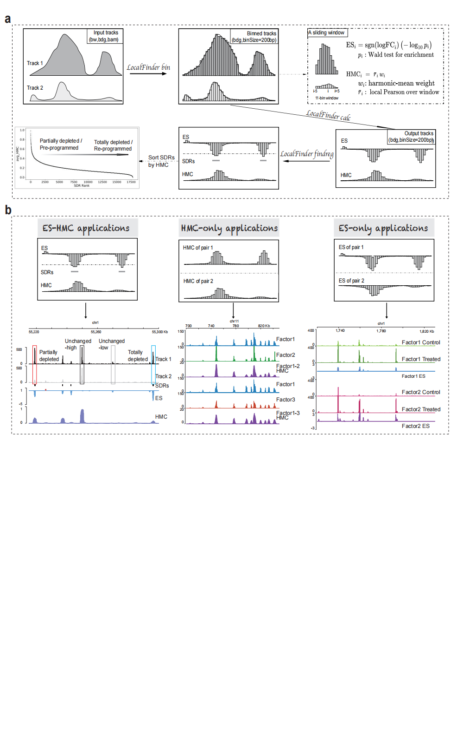
Fig. 2
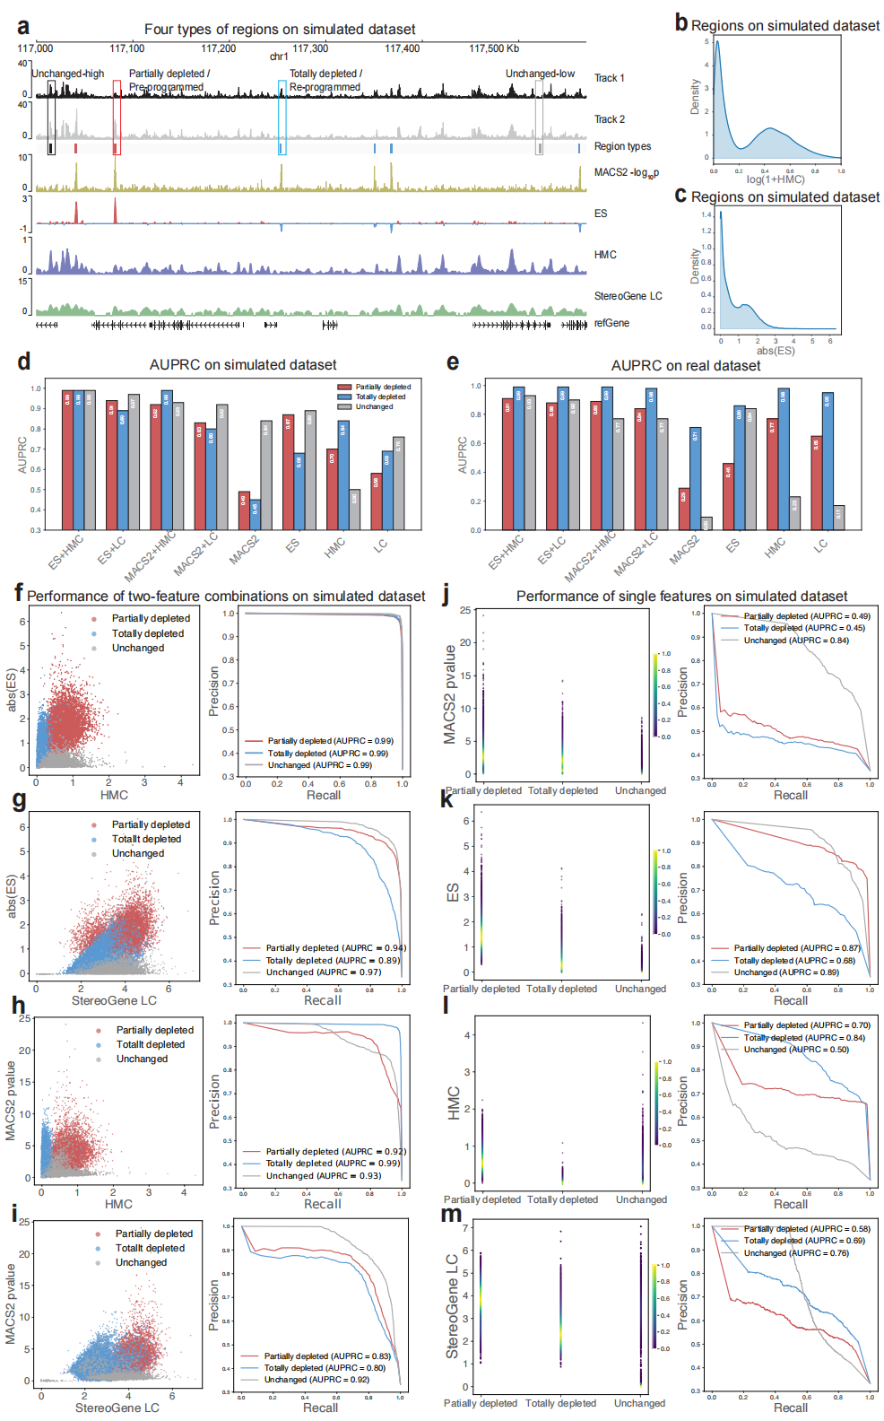
Fig. 3 (or Supplementary Fig. 2)
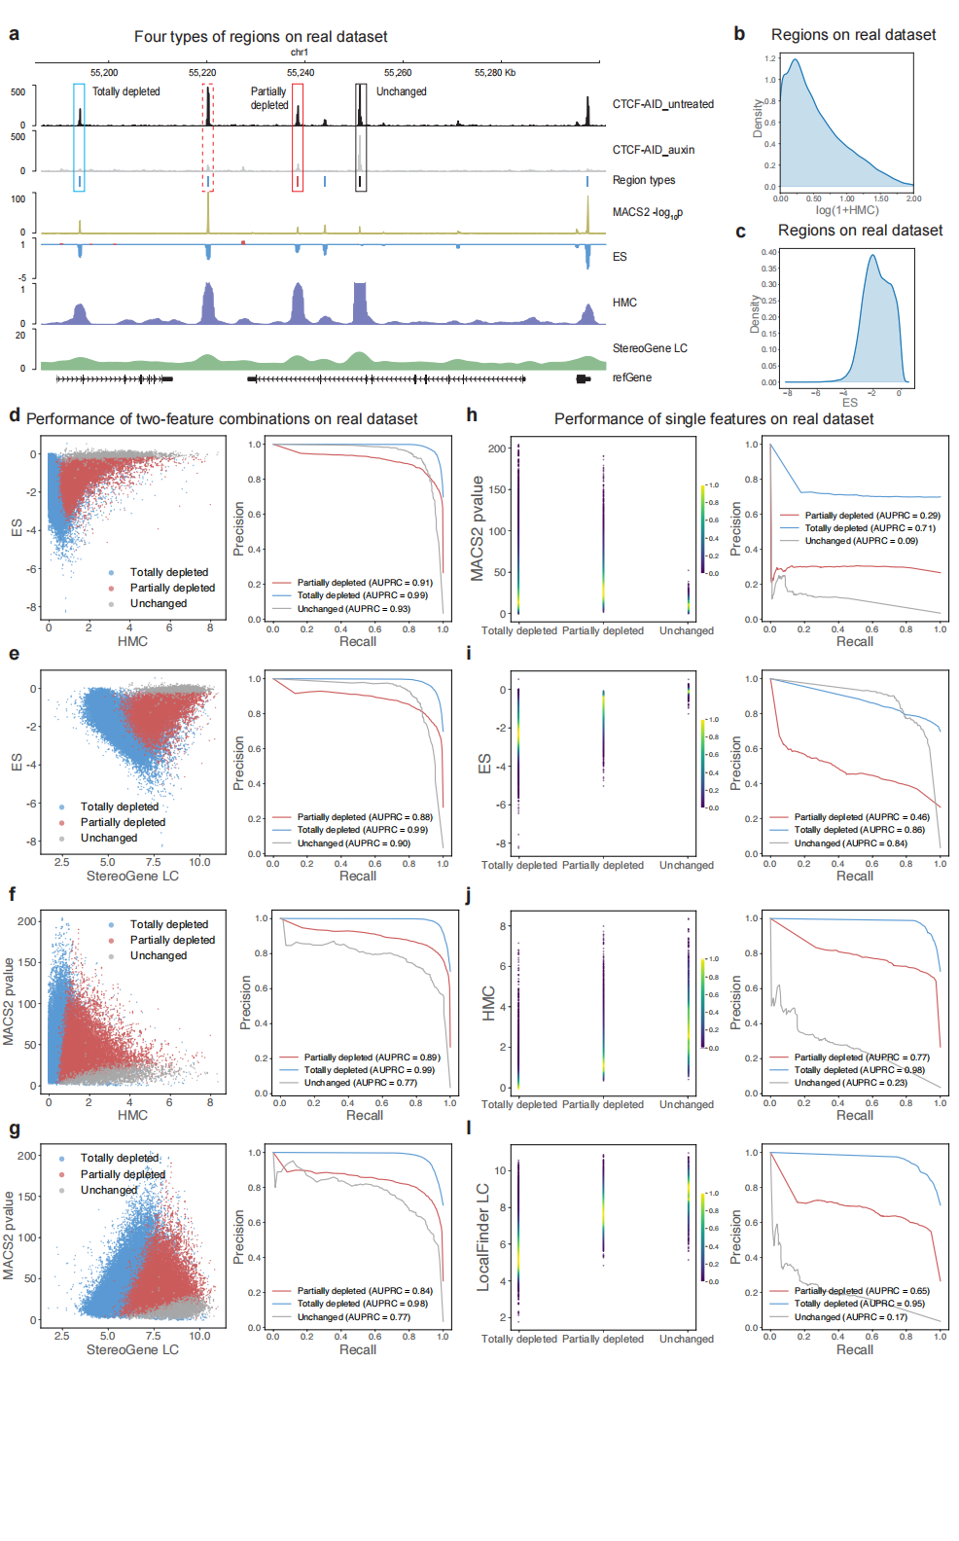
Fig. 4 (or Fig. 3)
