

Dear all,

Today at 19:00, we want to have pizza together! If you want to join, just put your name in the list below. After diner, you can be in <10 mins at Delft centraal!

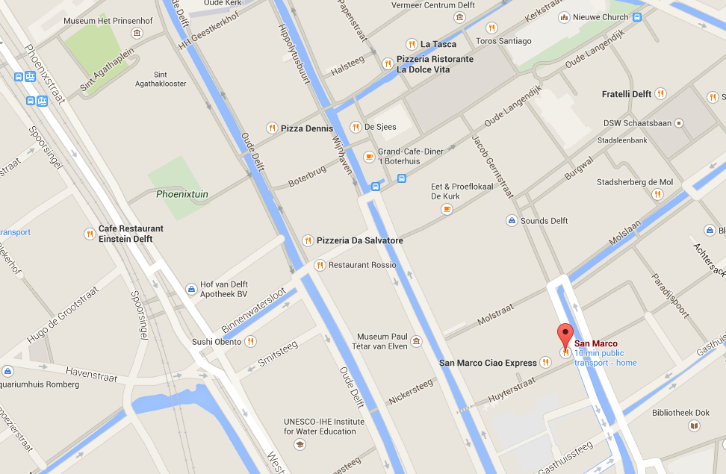

Pizzeria San Marco

Brabantse Turfmarkt 23,
2611 CL Delft

19:00 – 21:00

