Student Krylov Day 2015

#KD15

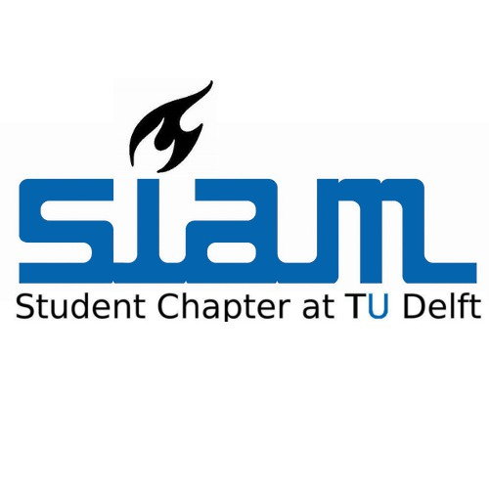
Snijderszaal LB 01.010
February 2, 2015
10:00 – 17:30

