SIAM Student Krylov Day 2015

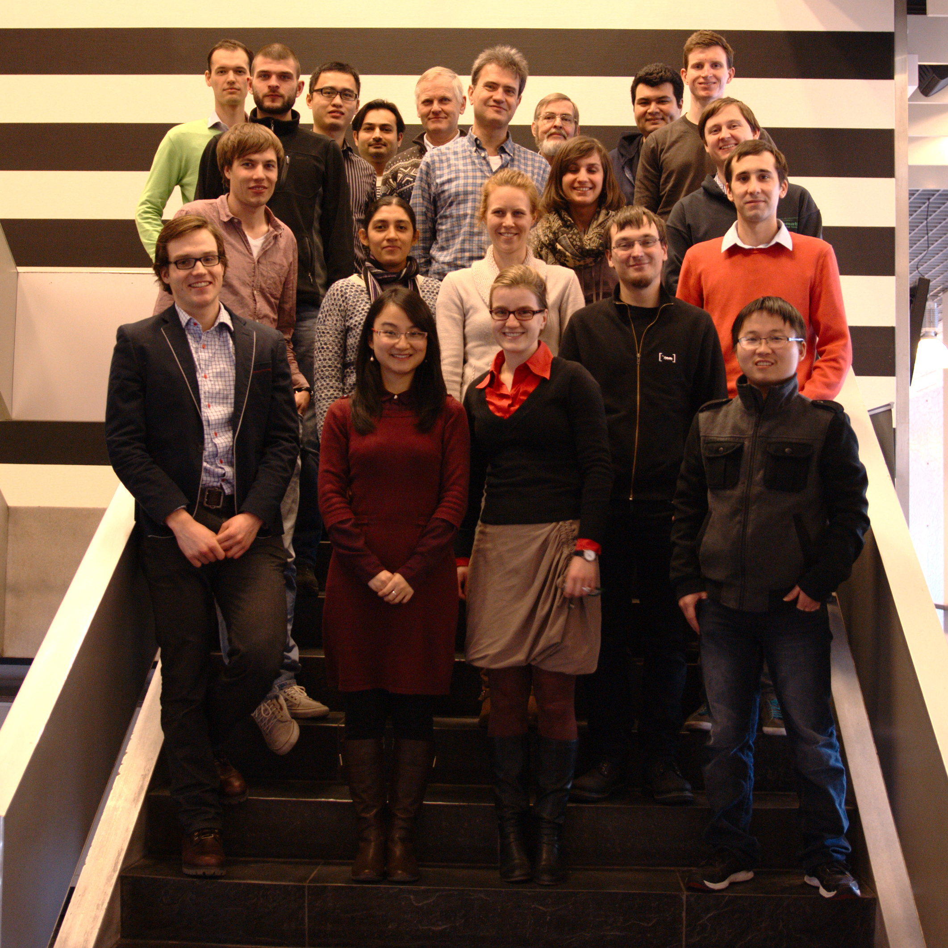
The SIAM Student Chapter at TU Delft organized a one-day workshop on Krylov subspace methods.

