Additional Features:

* Video Call Integration: Enable users to initiate video calls with seamsters to discuss project details, showcase designs, and provide real-time feedback.
* Appointment Booking: Allow users to schedule appointments with seamsters directly through the app, specifying date, time, and location preferences.
* In-App Chat: Implement a messaging feature that enables seamless communication between users and seamsters within the app, facilitating quick queries and

updates.

* Collaboration Boards: Create collaborative boards where users and seamsters can share design inspirations, sketches, and reference images to align on project visions.
* Measurement Guides: Offer detailed measurement guides within the app to assist users in accurately measuring themselves for custom-fit garments.
* Community Forum: Establish a community forum where users can share tips, experiences, and insights related to custom clothing projects, fostering a sense of belonging and collaboration.
* Progress Tracking: Enable users to track the progress of their clothing orders in real-time, providing transparency and peace of mind throughout the production process.
* Multi-language Support: Ensure the app supports multiple languages to cater to a diverse user base worldwide.
* Loyalty Program: Implement a loyalty program where users can earn points for each completed project or referral, redeemable for discounts or exclusive perks on future orders.
* Customisation Options: Offer a wide range of customization options for users to personalize their clothing designs, including fabric choices, color variations, and embellishments.
* Seamless Returns and Refunds: Simplify the process for users to initiate returns or request refunds for unsatisfactory orders, enhancing customer satisfaction and trust in the platform.

Tailor Discovery: Incorporate a Tinder-like feature where users can quickly browse through profiles of seamsters by swiping left or right based on their preferences, allowing for efficient and engaging exploration of potential collaborators.

* Separate screen for user and tailor login
* User login signup normal
* Tailor login normal, sign up will have 3 sections-

1. Personal info
2. Shop info
3. Tailor skills/About/Info

* Dashboard for tailors
* **Tailor screen**

1. Sliding sections

* My orders
* My work/Recent works
* Reviews

1. Profile and settings visible to user

* **User Screen**
* Explore section-Random cloth photos (pinterest like) takes directly to tailor profile when clicked
* Search and tailor section-

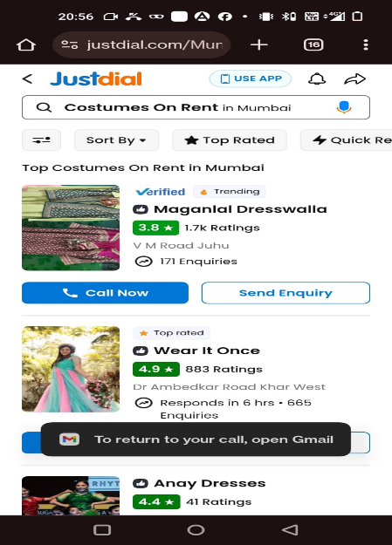

* Notifications for order status
* My orders
* profile

**After Search and tailor section once user clicks on any tailor box**

* Tailor profile opens with normal details and call and chat option

**After Search and tailor section once user clicks on send enquiry**:

* Direct chat box between tailor and user

**After Search and tailor section once user clicks on call now:**

* Direct call to tailor