

***Website Audit-***

[**https://gladdenhub.com/**](https://gladdenhub.com/)



**Parameters** **Page Number**

|  |  |
| --- | --- |
| Domain Statistics of Website | 3 |
| Crawl Statistics of Website | 4 |
| Website Loading Time | 5 |
| XML Sitemaps | 6 |
| Robots.txt | 7 |
| HTTP Status Code | 8 |
| Content Overview | 9 |
| URL Structure | 10 |
| Meta Title Tags | 11 |
| Meta Description Tags | 12 |
| Header Tags | 13 |
| ALT Tags | 14 |
| URL & IP Canonicalization | 15 |
| Internal Linking | 16 |
| Google+ Publisher Markup | 17 |
| Structured Data Markup | 18 |
| Mobile Responsiveness | 19 |
| Accelerated Mobile Pages | 20 |
| Mobile Optimization | 21 |
| HTTPS vs. HTTP | 22 |
| Social Media Visibility | 24 |
| Ghost Referral Traffic | 25 |
| W3C Validation | 26 |
| Conclusion | 27 |

## **Domain Statistics of Website**

**NA**

**9,530,945**

**NA**

|  |  |
| --- | --- |
|  | **2 Months, 5 Days** |
|  |  |

## **Crawl Statistics of Website**

**17** Pages Indexed

**17** Pages Indexed

**81**Pages Indexed

## **Website Loading Speed**

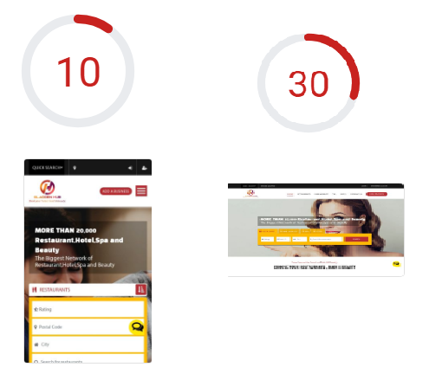

This audit is done through a Google Developer tool. This is an overview of how Google currently view your site when it comes to both Mobile and Desktop site speed.

A score below 75 usually point towards poor site speed. Each audit breaks down the issues that need to be addressed by priority level.

1. If you finalize that your requirement has fullfilled then we will start website optimization like website speed of the website.

## **Xml Sitemap**

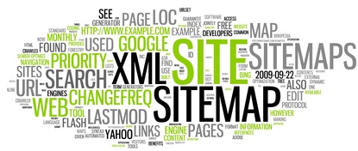

A sitemap is a file where you can list the web pages of your website to tell Google and other search engines about the organization of your site’s content.

By implementing Sitemaps on the website you can set priority for the URLs according to their importance.

1. We have already set site.xml in your website, so you can check through **https://gladdenhub.com/sitemap.xml**

This URL.

## **Robots.txt**

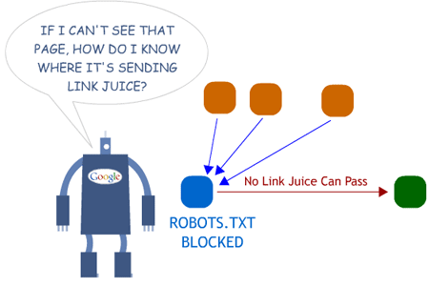

Robots.txt file on a website is used to instruct crawlers about the exclusion of WebPages. In other words, this file is used by websites to communicate with Search engine crawlers.

## **HTTP Status Code**

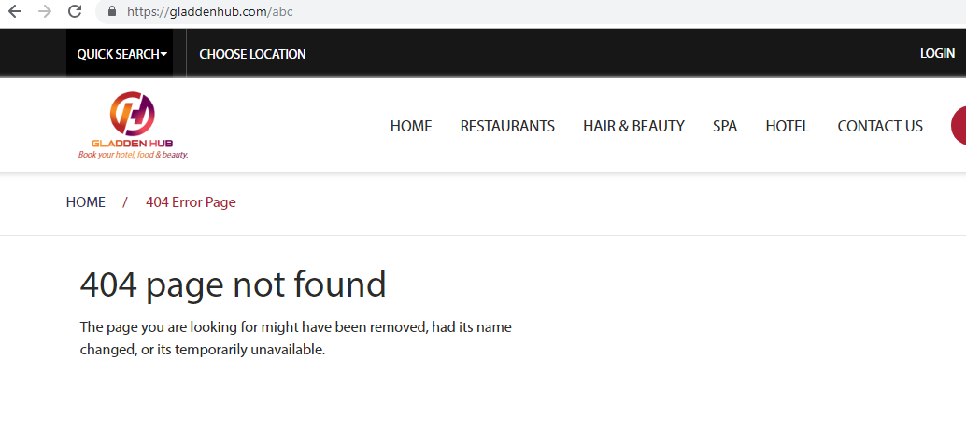

HTTP status code tells whether requested web pages are Error, Forward and redirection. The responses are in the human-readable diagnostic information.

**Response codes** – A 404 indicating a page was not found. A **301** tells a client that the resource they asked for has permanently moved to a new location. A 403 status code indicates that the client cannot access the requested resource.

1. Already exists  **404 Not Found Page** on website**.**

## **Content Overview**

One of the most important aspects of a website is web content and it is one of the reasons that people visit your website. Not only for people but web content is also very important for search engines as well.

A good content is which provides exact information, a user is looking for. Important keywords can be added to target and for better indexing of the site.

**Review Content Overview:**

1. **Which section of home page you want to add fresh content ?**

## **URL Structure**

A site’s URL structure is extremely important to both users and search engines. Poor URL structure can hurt rankings, prevent pages from being indexed and lower your click-through-rate (CTR).

It is very important for URLs to be readable, user friendly, and that they contain the keyword of the page. Always separate keywords with dashes, not underscores in URLs.

URLs should also be relatively short, with 100 characters in length being the current SEO best practice. While longer URLs aren't necessarily bad but shorter URLs are less likely to be truncate in search results and they have a positive impact on SERPs click-through-rates.

## **Meta Title Tag**

After the URL, the second most important place on a page to have the keyword is Title tag. Title tag is the first description of a page that search engine users will read. This will not only help to improve rankings, but can significantly improve your click-through-rate as well.

A proper Title tag will:

• Be 15-65 characters in length (50-65 is ideal).

• Be unique to that page don’t use same title tag on multiple pages.

• Use keyword of that page twice if space permits "once at the start, followed by separator such as a colon, hyphen and then once again in a call to action!. If characters limit prevent the usage of the keyword twice then use it once in a good call to action in the beginning of the Title tag.

• If relevant, include a geo-qualifier "such as Washington or Seattle, WA).

1. We will done from our end.

## **Meta Description Tag**

Meta descriptions shows in the Search engine as snippets (brief) of the particular webpage.

Meta descriptions should adhere to the following guidelines:

• Be unique and relevant to that page.

• Be written as descriptive ad text, with a call to action.

• No more than 165 characters in length including spaces and punctuation (50-165) is ideal! but no less than 51 characters (Google considers 50 characters or less to be too short!

• Contain 1-2 complete sentences with correct punctuation, and no more than 5 commas.

• Use the keyword once per sentence, as close to the start of each sentence as possible.

• Include a geo-qualifier, such as “Seattle, WA”, if relevant.

1. We will done from our end.

## **Header Tags**

H1 and H2 Tags are the Main heading of website after site’s Title.

These headings are HTML tags that can help emphasize important topics and keywords of web pages.

1. We will do.

## **Alt Tag**

For the benefit of search engines, code compliance, and visually impaired users, every image MUST have an ALT tag. ALT tag should accurately describe the image, and should contain a keyword but only if the keyword is relevant to that particular image.

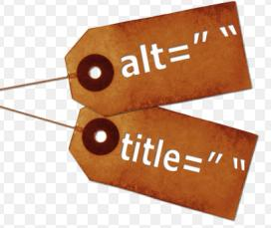

1. --------------------------

## **URL Canonicalization**

**URL Canonicalization:** It occurs when Homepage of the website is accessible with multiple URLs.

Canonicalization leads to duplicate content issue.

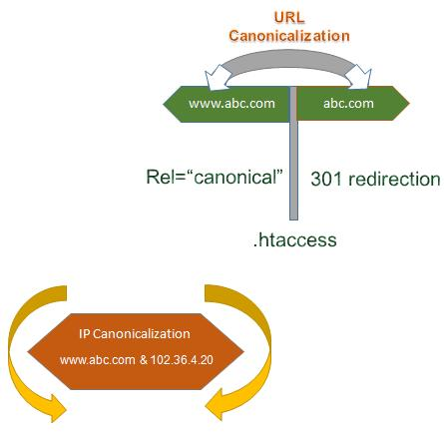

1. ------------------------------------

## **Internal Linking**

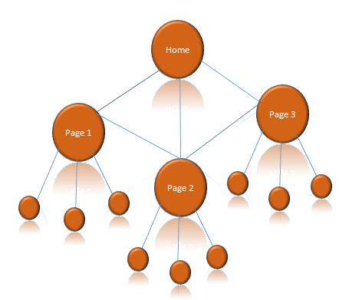

Internal linking is used for better navigation of the website. These links goes from one webpage to another in the same domain.

Benefits of internal linking are:

* Makes Navigation easy for Users
* Establish Hierarchy for the website
* Provides link juice within the website

1. -----------------

## **Structured Data Markup**

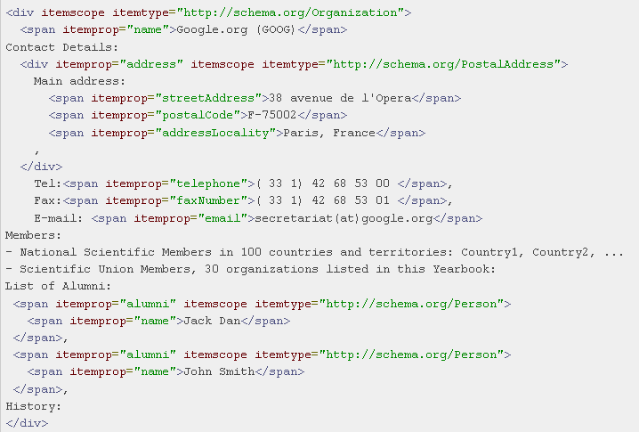

There are two types of structured data markups available online.

1. Schema Markup
2. Open Graph Markup

They are very helpful as they provide brief of site to the major Search engines like: Google, yahoo, Bing and Yandex. In other words, “Structured data markup" is a standard way to annotate your content so that machines can understand it. When your web pages include structured data markup, Major Search Engines can use that data to index your content better, present it more prominently in search results.

1. We will done from our end.

## **Mobile Responsive**

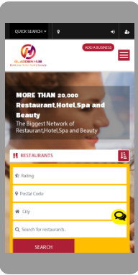

There is NO doubt that Responsive Web Design is very important according to today’s web design point of view. Smartphone and tablet adoption rapidly increasing, so does the importance of mobile-friendly websites. Smartphone’s and tablets have changed the approach toward design and user experience. With the explosion of mobile device usage in recent years, it is imperative that businesses develop a mobile strategy that is in line with business priorities. If your website has not been optimized for an audience on-the-go with a smaller screen i.e. Smartphone, Android and tablets, you are missing out on a huge opportunity to drive physical traffic to your business.

1. Already Responsive.

## **Accelerated Mobile Pages**

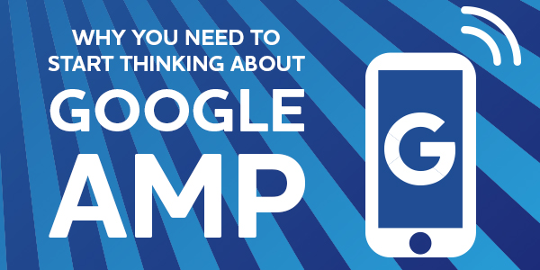

The AMP is an open-source initiative aiming to make the web better for all. AMP enables the creation of websites and ads that are consistently fast and high-performing across devices and distribution platforms.

Key benefits include:

* Faster loading of Mobile Pages
* Improves Click through rate
* Higher Performance and Engagement

## **HTTPS vs. HTTP**

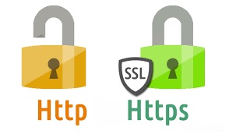

Hyper Text Transfer Protocol Secure abbreviated as HTTPS is a secure version of transferring data between browser and website.

HTTPS adds authentication and encryption.

1. Already secured your website with HTTPS.

## **Google Analytics& Webmaster Tools**

Webmaster code on your site will ensure that you are running a healthy website with the utmost efficiency.

Basic Benefits:

* Access to search statistics on Google.
* Latest data regarding incoming links and internal links.
* Sends notification if your site has any crawl errors (misdirecting) and/or malware (spam, viruses, etc)
* Shows you keywords you are targeting and how effective they are.
* Insights into crawling and indexing activity on the site.

Google Analytics is a valuable tool for monitoring, tracking the efficiency of your online campaigns.

## **Social Media Visibility**

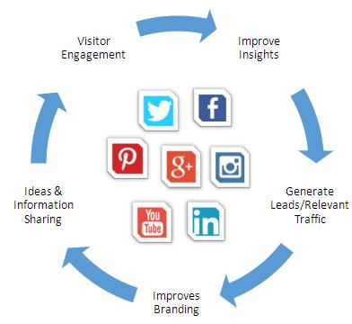

Today, Social Media plays an important role in marketing.

You can get connected with people and can make your brand popular by reaching more and more relevant audience or users.

These channels should be updated with fresh and informative content.

Using Hash (#) tag in the posts (on the correct words) plays very important role to increase the insights.

|  |  |  |
| --- | --- | --- |
|  | Facebook | Connected |
| instagram.jpg | Instagram | Connected |
|  | Twitter | Connected |

1. Social media link already there.

## **W3C Validation**

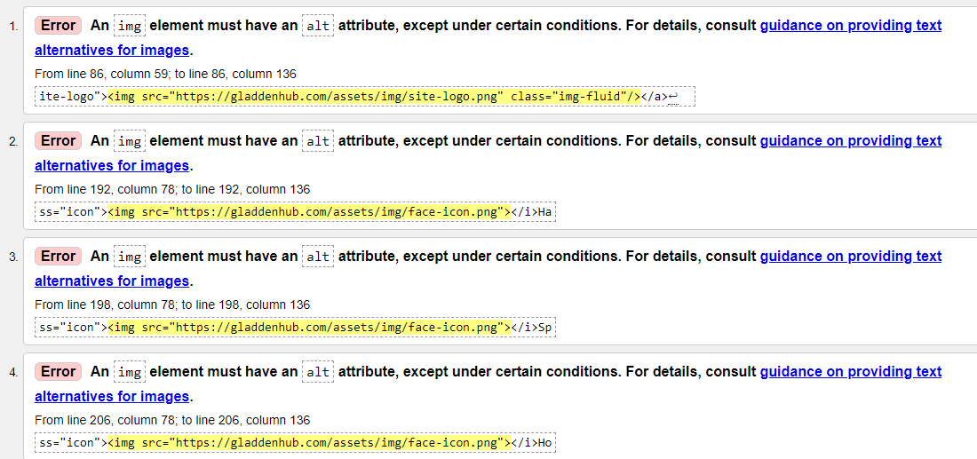

The Markup Validation Service is a validation by the World Wide Web Consortium (W3C) that allows Internet users to check HTML and XHTML documents for well-formed markup.

Markup validation is an important step towards ensuring the technical quality of web pages.

W3C validation is the process of checking a websites code to determine if it follows the formatting standards. If you fail to validate the pages of your website based on W3C standards, your website will most likely suffer from errors or poor traffic owing to poor formatting and readability.

1. We will check and try to fix it from our level best.

***Conclusion***

Overall, we found that the SEO situation on [**https://gladdenhub.com/**](https://gladdenhub.com/)is average; it needs to work on the major ON-Page factors. By working to fix the issues identified in this audit, we’ll be surely be able to achieve more accurate or desired ranking results for our website.