Blueprint Summary for Reporting Summary Unit

The Conservation Blueprint is a living spatial plan to conserve natural and cultural resources for future generations. Blueprint 2.2 identifies priority areas for shared conservation action based on ecosystem indicator condition and connectivity. More than 500 people from over 150 different organizations have actively participated in its development so far.

* For more information, [visit the Blueprint webpage](http://www.southatlanticlcc.org/blueprint/). On that page, you can [see who’s using the Blueprint](http://southatlanticlcc.org/blueprint-users) to inform conservation action and investment.
* If you want to overlay additional datasets, view indicator layers, and download Blueprint data, [visit the Conservation Planning Atlas (CPA)](http://salcc.databasin.org/).

Blueprint 2.2 is completely data-driven, based on ecosystem indicator models and a connectivity analysis. It prioritizes the lands and waters of the South Atlantic according to the current condition of the indicators. Better indicator condition suggests higher ecosystem integrity and higher importance for natural and cultural resources across all ecosystems collectively.

# **Priority**

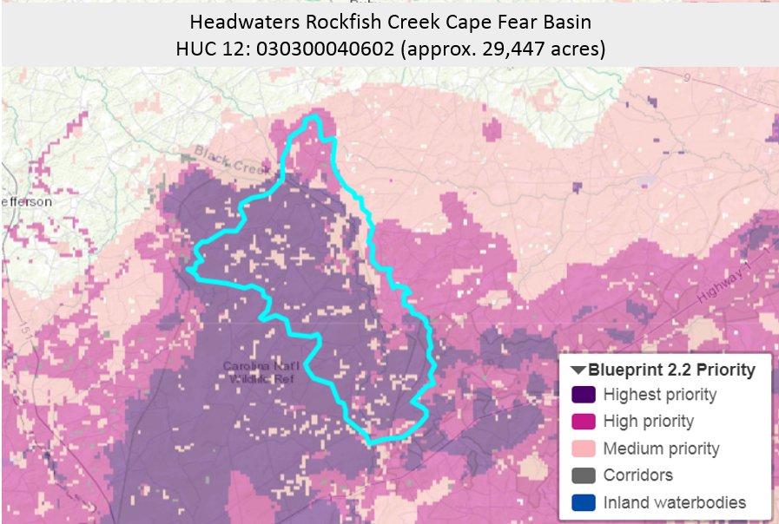

Map of blueprint priorities in Reporting Summary Unit .

## **Priority categories**

* Highest priority for shared action: the most important areas for natural and cultural resources based on indicator condition. This class covers 10% of the South Atlantic geography.
* High priority for shared action: important areas for natural and cultural resources based on indicator condition. This class covers an additional 15% of the South Atlantic geography; together, the highest and high priority categories cover 25%.
* Medium priority for shared action: above-average areas for natural and cultural resources based on indicator condition, capturing potential restoration opportunities. This class covers 20% of the South Atlantic geography; together, the highest, high, and medium priority categories cover 45%.
* Corridors: connections between large patches of highest priority areas and secured lands, optimized for efficiency and indicator condition in a least cost path analysis. This category covers an additional 5% of the South Atlantic geography; in total, the Blueprint covers 50%.
* Inland waterbodies: lakes, reservoirs, and ponds not included in the Blueprint 2.2 priorities.

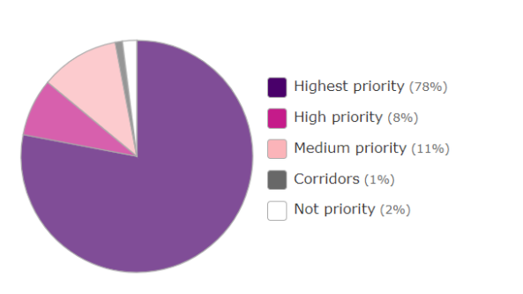

Extent of each blueprint category within the South Atlantic LCC portion of the Reporting Summary Unit geography.

|  |  |  |  |
| --- | --- | --- | --- |
|  | **Priority Category** | **Acres** | **Percent of Area** |
|  | Highest priority for shared action | 22,969 | 78 |
|  | High priority for shared action | 2,356 | 8 |
|  | Medium priority for shared action | 3,239 | 11 |
|  | Corridors | 294 | 1 |
|  | Inland waterbodies (not prioritized) | 0 | 0 |
|  | Not a priority for shared action | 589 | 2 |

# **Indicators**

## **Ecosystem-specific indicators**

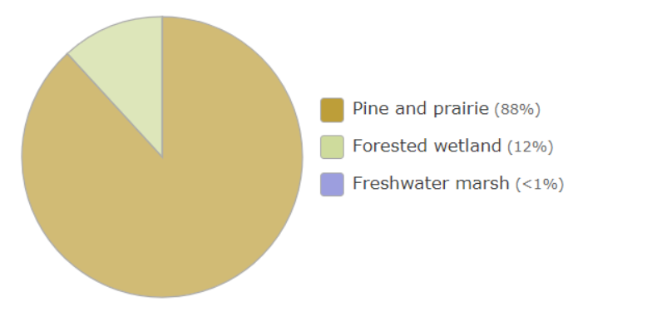

Extent of each ecosystem within the South Atlantic LCC portion of the Reporting Summary Unit geography.

|  |  |  |  |
| --- | --- | --- | --- |
|  | **Ecosystem** | **Acres** | **Percent of Area** |
|  | Pine and prairie | 25,913 | 88 |
|  | Forested wetland | 3,534 | 12 |
|  | Freshwater marsh | <294 | <1 |

### Forested wetland

#### *Forested wetland amphibians*

Forested wetland amphibians draws from the Priority Amphibian and Reptile Conservation Areas (PARCAs) located in forested wetland habitat. PARCA is an expert-driven, nonregulatory designation that captures places capable of supporting viable amphibian and reptile populations. PARCAs include areas where rare or at-risk species have been observed or are likely to occur (like embedded, isolated wetlands).

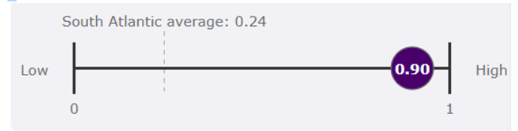

The average value of the indicator in the Reporting Summary Unit, compared to the South Atlantic average. The South Atlantic average is the average of all HUC12 averages in the South Atlantic region.

The area of forested wetland amphibian values as they occur within the forested wetland ecosystem in the Reporting Summary Unit. Indicator ratings for condition have not yet been set for this indicator.

|  |  |  |  |
| --- | --- | --- | --- |
|  | **Indicator values** | **Acres** | **Percent of area** |
|  | **1 (high**) = Priority Amphibian and Reptile Conservation Area (PARCA) within forested wetlands | 3,180 | 90 |
|  | **0 (low)** = Not a Priority Amphibian and Reptile Conservation Area (PARCA) within forested wetlands | 353 | 10 |

*Forested wetland birds*

Forested wetland birds is an index of habitat suitability for six bird species (Northern parula, black- throated green warbler, red-headed woodpecker, Chuck-will's widow, prothonotary warbler, Swainson's warbler) based on patch size and proximity to water. The needs of these species are increasingly restrictive at higher index values, reflecting better quality habitat.

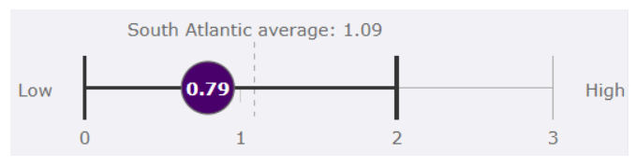

The average value of the indicator in the Reporting Summary Unit, compared to the South Atlantic average. The South Atlantic average is the average of all HUC12 averages in the South Atlantic region.

The area of forested wetland bird values as they occur within the forested wetland ecosystem in the Reporting Summary Unit. Indicator ratings for condition are based on the 2015 State of the South Atlantic calculations.

|  |  |  |  |
| --- | --- | --- | --- |
|  | **Indicator value** | **Acres** | **Percent of Area** |
|  | 3 (high) = Potential for additional presence of Swainson’s warbler |  |  |
|  | 2 = Potential for additional presence of prothonotary warbler |  |  |
|  | 1 = Potential for presence of Northern parula, black-throated green warbler, red-headed woodpecker, or Chuck-will’s widow |  |  |
|  | Total in good condition |  |  |
|  | 0 (low) = Less potential for presence of bird index species |  |  |
|  | Total not in good condition |  |  |

# **Threats**

## **Sea level rise**

Whatever charting option we come up with, appropriately captioned

## **Urban growth**

Whatever charting option we come up with, appropriately captioned

# **Partners**

## **Regional Conservation Plans**

* [Amphibian and reptile conservation](http://www.separc.org/)
* [TNC's conservation priorities](http://www.landscope.org/focus/understand/tnc_portfolio/)
* [ACJV migratory bird priority areas](http://acjv.org/planning/bird-conservation-regions/sambi/)
* [Bobwhite conservation areas](http://bringbackbobwhites.org/)

## **Statewide Conservation Plans**

* [NC Green Growth Toolbox](http://www.ncwildlife.org/Conserving/Programs/GreenGrowthToolbox.aspx)

## **Land Trusts (by county)**

* [Hoke County, North Carolina](http://findalandtrust.org/counties/37093)
* [Moore County, North Carolina](http://findalandtrust.org/counties/37125)

# **Ownership**

## **Conserved lands ownership**

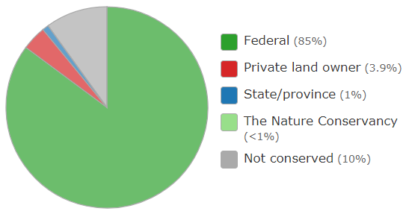

Extent of ownership class within the South Atlantic LCC portion of the Reporting Summary Unit geography. Values derived from [Secured Lands From TNC Eastern Division - 2015 Edition](https://www.conservationgateway.org/ConservationByGeography/NorthAmerica/UnitedStates/edc/reportsdata/terrestrial/secured/Pages/default.aspx)

|  |  |  |  |
| --- | --- | --- | --- |
|  | **Ownership** | **Acres** | **Percent of Area** |
|  | Federal |  | 85 |
|  | Private land owner |  | 3.9 |
|  | State |  | 1 |
|  | The Nature Conservancy |  | <1 |
|  | Not conserved |  | 10 |

## **Land protection status**

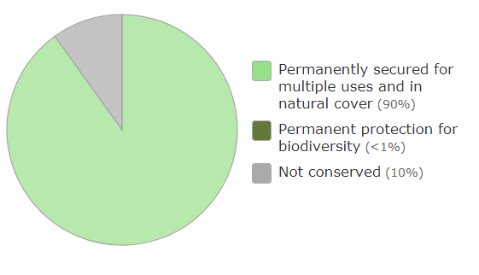

Extent of land protection status within the South Atlantic LCC portion of the Reporting Summary Unit geography. Values derived from [Secured Lands From TNC Eastern Division - 2015 Edition](https://www.conservationgateway.org/ConservationByGeography/NorthAmerica/UnitedStates/edc/reportsdata/terrestrial/secured/Pages/default.aspx)

|  |  |  |  |
| --- | --- | --- | --- |
|  | **Land Protection Status** | **Acres** | **Percent of Area** |
|  | Permanently secured for multiple uses and in natural cover |  | 90 |
|  | Permanent protection for biodiversity |  | < 1 |
|  | Not conserved |  | 10 |