***DO NOT COPY NEWS POSTS DIRECTLY FROM THE SOURCE SITES!!!***

# Create a News blog post

1. Go to the admin panel

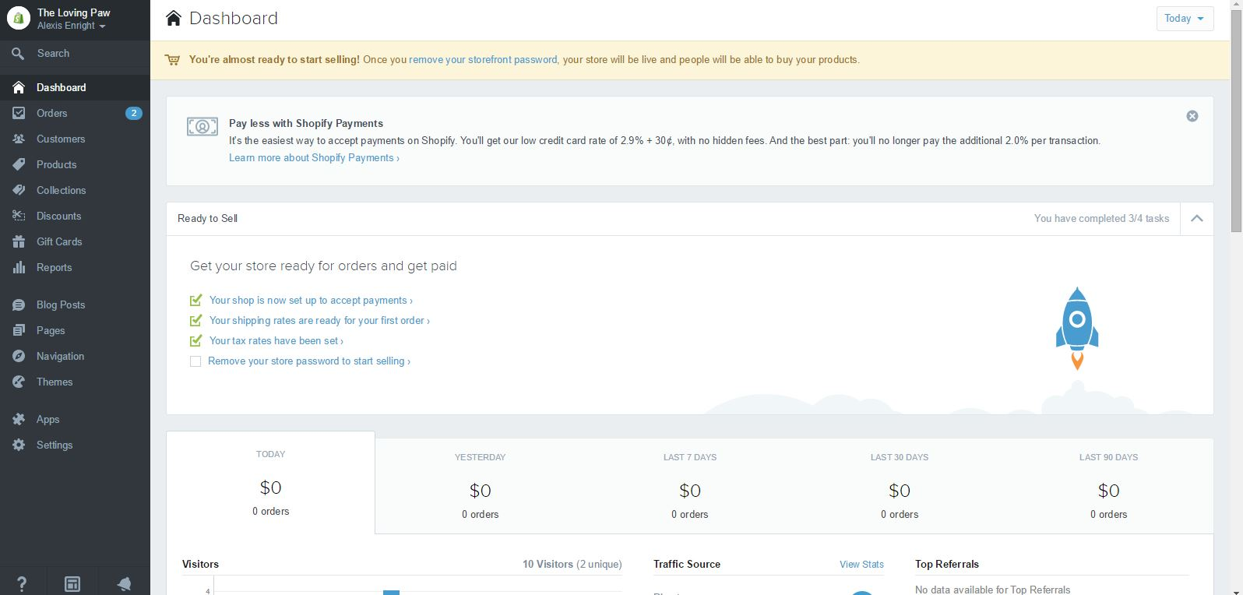

1. Click on “Blog Posts” in the left column
2. Click “Add a Blog Post” in the upper right hand corner
3. In the topmost box on the page, enter an appropriate title for the news item

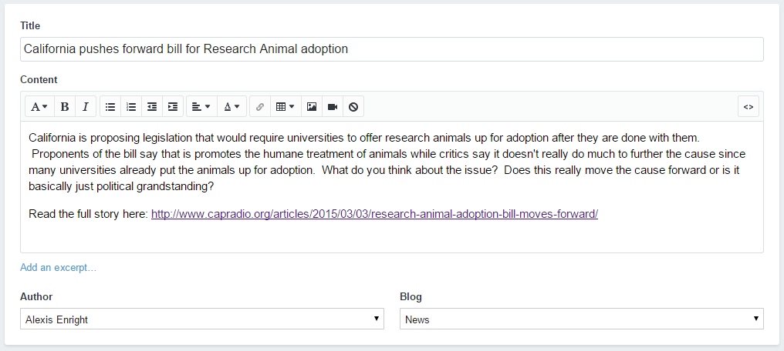

1. In the content box, write a paragraph summarizing the news story as well as any questions you want to pose to your audience. At the end, include the link the original story. As a matter of copyright, do NOT copy the story verbatim from their site to yours. A link to the story with a summarization is acceptable though.
2. Make sure the appropriate author is entered in the author box and that the “News” blog is selected.
3. Add tags as appropriate

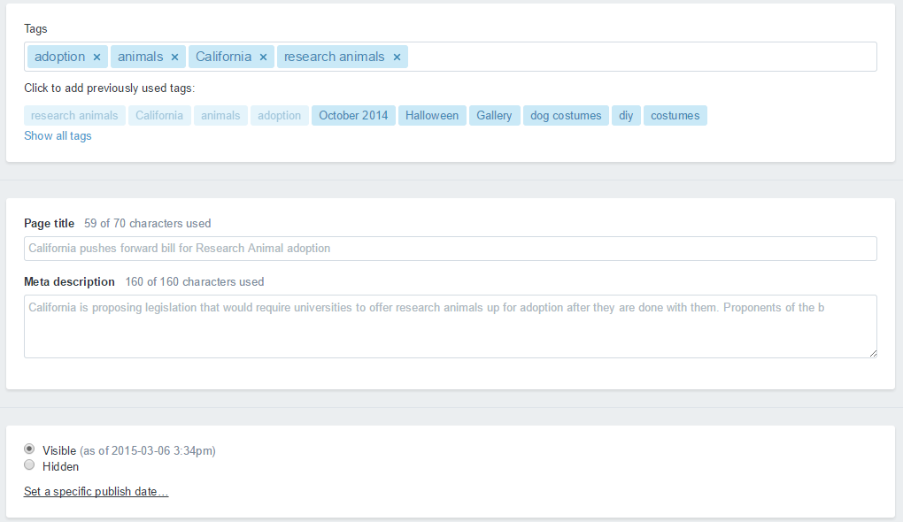

1. Make sure that “Visible” is selected towards the bottom of the page.
2. Click “Save” in the upper right hand corner.

# Remove a News blog post

1. From the blog post management screen, click Delete Blog in the lower left corner of the main panel.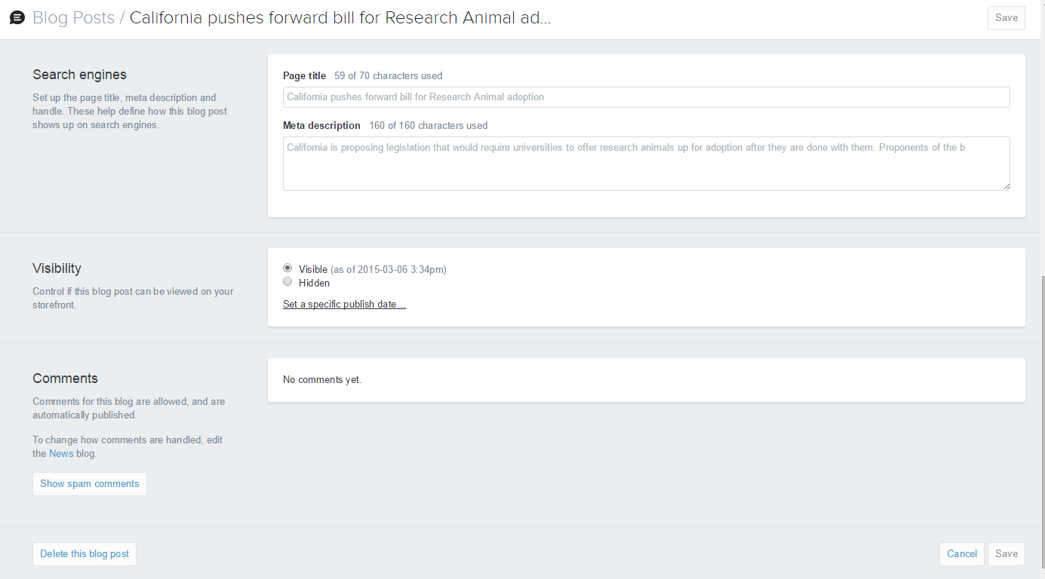
2. A confirmation message will appear asking if you’re sure.

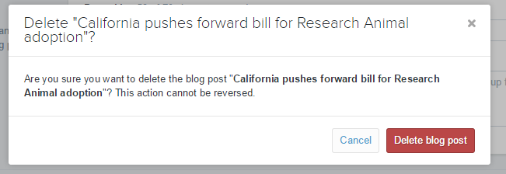

1. Click Delete Blog Post and News item will be permanently removed from your site.